**VETRI IT SYSTEMS PRIVATE LIMITED**

**PROJECT REPORT**

**PROJECT TITLE: VETRI ELECTRONICS**

**1. Project Overview**

**Project Name:** Grocery Store  
**Project Assigned Date:** 03-06-2025  
**Planned Completion Date:** 09-06-2025  
**Delivery Date:** 09-06-2025

**2. Project Team**

* **Project Manager:** Mahesh Samuthiram
* **Designer:** Yoga Varshini
* **Developer(s):** Malathy S
* **Testing Team:** Mahesh Samuthiram

**3. Technology Stack**

* **Frontend Technologies:** HTML, CSS, Javascript, Bootstrap
* **Backend Technologies:**
* **Database**
* **Infrastructure:**

**4. Project Scope**

Develop a fully functional and responsive e-commerce website for selling products online. The platform will support browsing products, user registration/login, shopping cart, secure checkout, and admin features to manage inventory and orders.

**Key Objectives:**

* Develop a user-friendly and responsive website for Vetri Electronics.
* Implement a robust authentication and authorization system.
* Ensure a secure and reliable payment gateway.
* Enable real-time order tracking and inventory management.
* Provide detailed sales reports and analytics.
* Deploy the platform on a secure VPS with high availability.

**5. Project Modules**

* **User Module**
* **Product Module**
* **Order Management System**
* **Payment Integration**
* **Admin Dashboard**
* **Reports & Data Analysis**
* Cart Module

**6. Project Code**

**Home.html:**

<!DOCTYPE html>

<html lang="en">

<head>

  <meta charset="UTF-8" />

  <meta name="viewport" content="width=device-width, initial-scale=1.0" />

  <title>Grocery Navbar</title>

  <!-- Bootstrap CSS -->

  <link href="https://cdn.jsdelivr.net/npm/bootstrap@5.3.3/dist/css/bootstrap.min.css" rel="stylesheet">

  <!-- Font Awesome CDN -->

  <link rel="stylesheet" href="https://cdnjs.cloudflare.com/ajax/libs/font-awesome/6.5.0/css/all.min.css">

  <!--  Open Sans -->

  <link href="https://fonts.googleapis.com/css2?family=Open+Sans&display=swap" rel="stylesheet">

  <!-- Custom CSS -->

  <link rel="stylesheet" href="home.css">

  <link rel="stylesheet" href="headerfooter.css">

</head>

<body>

 <header class="header-section">

  <!-- Top Green Banner -->

  <div class="top-banner text-center py-2">

    <span class="text-white fw-semibold">Fresh & Organic produce from our farmers to your kitchen</span>

  </div>

  <!-- Main Container -->

  <div class="container py-3">

    <div class="row align-items-center text-center text-lg-start">

      <!-- Logo Column -->

      <div class="col-lg-2 mb-3 mb-lg-0 d-flex flex-column align-items-center">

        <img class="logoimg" src="./assets/images/home/logo.png" />

      </div>

      <!-- Search Bar Column -->

      <div class="col-lg-7 mb-3 mb-lg-0">

        <form class="d-flex w-100" role="search">

          <input class="form-control rounded-0 border-end-0" type="search" placeholder="Search for products" aria-label="Search">

          <button class="btn btn-warning rounded-0 border-start-0" type="submit">

            <i class="fas fa-search me-1"></i> Search

          </button>

        </form>

      </div>

      <!-- Empty Column to Align -->

      <div class="col-lg-3 d-none d-lg-block"></div>

    </div>

    <!-- Nav Links Row -->

    <div class="row mt-3">

      <div class="col d-flex justify-content-center gap-4 flex-wrap align-items-center">

        <a href="home.html" class="nav-link fw-semibold">Home</a>

        <a href="category.html" class="nav-link fw-semibold">Categories</a>

        <a href="bestsales.html" class="nav-link fw-semibold">Best Sales</a>

        <a href="blog.html" class="nav-link fw-semibold">Blogs</a>

        <a href="addtocart.html" class="nav-link">

          <img class="logoimg" src="./assets/images/home/cart icon.png" />

        </a>

        <a href="registernow.html" class="btn btn-success text-white fw-semibold px-3">Register Now</a>

      </div>

    </div>

  </div>

  </header>

  <section class="container py-5 text-center">

    <h2 class="fw-bold mb-2">Browse All Categories</h2>

    <p class="text-muted mb-5">Explore a diverse range of categories to find exactly what you need!</p>

    <div class="row g-4 justify-content-center">

      <!-- Category Card -->

      <div class="col-6 col-sm-4 col-md-3 col-lg-2">

        <div class="category-card text-center p-3 bg-white rounded-4 shadow-sm h-100">

          <div class="icon-wrapper bg-success bg-opacity-10 text-success mb-2 mx-auto">

            <img src="./assets/images/home/img3.png" alt="Vegetable" />

          </div>

          <h6 class="fw-bold mb-0">Vegetable</h6>

          <small class="text-muted">20 Items</small>

        </div>

      </div>

      <!-- Repeat similar structure for each category -->

      <div class="col-6 col-sm-4 col-md-3 col-lg-2">

        <div class="category-card text-center p-3 bg-white rounded-4 shadow-sm h-100">

          <div class="icon-wrapper bg-danger bg-opacity-10 text-danger mb-2 mx-auto">

            <img src="./assets/images/home/img4.png" alt="Fresh Fruits" />

          </div>

          <h6 class="fw-bold mb-0">Fresh Fruits</h6>

          <small class="text-muted">12 Items</small>

        </div>

      </div>

      <div class="col-6 col-sm-4 col-md-3 col-lg-2">

        <div class="category-card text-center p-3 bg-white rounded-4 shadow-sm h-100">

          <div class="icon-wrapper bg-warning bg-opacity-10 text-warning mb-2 mx-auto">

            <img src="./assets/images/home/meat icon.png" alt="Meat" />

          </div>

          <h6 class="fw-bold mb-0">Meat</h6>

          <small class="text-muted">7 Items</small>

        </div>

      </div>

      <div class="col-6 col-sm-4 col-md-3 col-lg-2">

        <div class="category-card text-center p-3 bg-white rounded-4 shadow-sm h-100">

          <div class="icon-wrapper bg-primary bg-opacity-10 text-primary mb-2 mx-auto">

            <img src="./assets/images/home/seafood icon.png" alt="Sea Food" />

          </div>

          <h6 class="fw-bold mb-0">Sea Food</h6>

          <small class="text-muted">12 Items</small>

        </div>

      </div>

      <div class="col-6 col-sm-4 col-md-3 col-lg-2">

        <div class="category-card text-center p-3 bg-white rounded-4 shadow-sm h-100">

          <div class="icon-wrapper bg-info bg-opacity-10 text-info mb-2 mx-auto">

            <img src="./assets/images/home/milk & diary icon.png" alt="Milk & Diary" />

          </div>

          <h6 class="fw-bold mb-0">Milk & Diary</h6>

          <small class="text-muted">8 Items</small>

        </div>

      </div>

      <div class="col-6 col-sm-4 col-md-3 col-lg-2">

        <div class="category-card text-center p-3 bg-white rounded-4 shadow-sm h-100">

          <div class="icon-wrapper bg-warning bg-opacity-10 text-warning mb-2 mx-auto">

            <img src="./assets/images/home/fresh bread icon.png" alt="Fresh Bread" />

          </div>

          <h6 class="fw-bold mb-0">Fresh Bread</h6>

          <small class="text-muted">24 Items</small>

        </div>

      </div>

    </div>

  </section>

  <section class="promo-banner d-flex align-items-center justify-content-center text-white text-center ">

    <div class="container">

      <div class="row justify-content-start">

        <div class="col-md-7 col-lg-6">

          <p class="lead mb-2">Enjoy upto 20% off on your first order</p>

          <h2 class="fw-bold mb-3">Fresh Produce, From Farm<br />Products At A Reasonable Price!</h2>

          <a href="#" class="btn btn-warning fw-bold px-4 py-2">Shop Now</a>

        </div>

      </div>

    </div>

  </section>

  <section class="py-5 text-center">

    <h3 class="fw-bold">Featured Products</h3>

    <p class="text-muted mb-5">Each item is carefully selected for quality, freshness, and nutritional benefits.</p>

    <div class="container">

      <div class="row g-4 justify-content-center">

        <!-- Product 1 -->

        <div class="col-md-6 col-lg-3">

          <div class="card h-100 shadow-sm text-center p-3">

            <img src="./assets/images/home/featured pro home 1.png" class="card-img-top" alt="Tomatoes">

            <div class="card-body">

              <h5 class="card-title fw-bold">Organic Tomatoes</h5>

              <p class="card-text fs-5">₹ 80</p>

              <div class="text-warning mb-2">

                <i class="fas fa-star"></i><i class="fas fa-star"></i><i class="fas fa-star"></i><i

                  class="fas fa-star"></i><i class="fas fa-star"></i>

              </div>

              <button class="btn btn-success fw-semibold">Add to cart</button>

            </div>

          </div>

        </div>

        <!-- Product 2 -->

        <div class="col-md-6 col-lg-3">

          <div class="card h-100 shadow-sm text-center p-3">

            <img src="./assets/images/home/featured pro home 2.png" class="card-img-top" alt="Meat">

            <div class="card-body">

              <h5 class="card-title fw-bold">Fresh Meat</h5>

              <p class="card-text fs-5">₹ 420</p>

              <div class="text-warning mb-2">

                <i class="fas fa-star"></i><i class="fas fa-star"></i><i class="fas fa-star"></i><i

                  class="fas fa-star"></i><i class="far fa-star"></i>

              </div>

              <button class="btn btn-success fw-semibold">Add to cart</button>

            </div>

          </div>

        </div>

        <!-- Product 3 -->

        <div class="col-md-6 col-lg-3">

          <div class="card h-100 shadow-sm text-center p-3">

            <img src="./assets/images/home/featured pro home 3.png" class="card-img-top" alt="Mangoes">

            <div class="card-body">

              <h5 class="card-title fw-bold">Seasonal Mangoes</h5>

              <p class="card-text fs-5">₹ 120</p>

              <div class="text-warning mb-2">

                <i class="fas fa-star"></i><i class="fas fa-star"></i><i class="fas fa-star"></i><i

                  class="fas fa-star"></i><i class="fas fa-star"></i>

              </div>

              <button class="btn btn-success fw-semibold">Add to cart</button>

            </div>

          </div>

        </div>

        <!-- Product 4 -->

        <div class="col-md-6 col-lg-3">

          <div class="card h-100 shadow-sm text-center p-3">

            <img src="./assets/images/home/featured pro home 4.png" class="card-img-top" alt="Onions">

            <div class="card-body">

              <h5 class="card-title fw-bold">Green Onions</h5>

              <p class="card-text fs-5">₹ 100</p>

              <div class="text-warning mb-2">

                <i class="fas fa-star"></i><i class="fas fa-star"></i><i class="fas fa-star"></i><i

                  class="fas fa-star"></i><i class="fas fa-star"></i>

              </div>

              <button class="btn btn-success fw-semibold">Add to cart</button>

            </div>

          </div>

        </div>

      </div>

    </div>

  </section>

  <div class="container my-4">

    <div class="row">

      <!-- Sidebar Products -->

      <div class="col-md-6 col-lg-5 mb-4">

        <!-- Tabs -->

        <ul class="nav nav-tabs mb-3" id="productTabs" role="tablist">

          <li class="nav-item" role="presentation">

            <button class="nav-link active" id="new-arrivals-tab" data-bs-toggle="tab" data-bs-target="#new-arrivals"

              type="button" role="tab">New Arrivals</button>

          </li>

          <li class="nav-item" role="presentation">

            <button class="nav-link" id="trending-tab" data-bs-toggle="tab" data-bs-target="#trending" type="button"

              role="tab">Trending Products</button>

          </li>

          <li class="nav-item" role="presentation">

            <button class="nav-link" id="best-savings-tab" data-bs-toggle="tab" data-bs-target="#best-savings"

              type="button" role="tab">Most Savings</button>

          </li>

        </ul>

        <!-- Tab Content -->

        <div class="tab-content" id="productTabsContent">

          <!-- New Arrivals -->

          <div class="tab-pane fade show active" id="new-arrivals" role="tabpanel">

            <div class="product-item">

              <img src="./assets/images/home/new arrivals 1.png" alt="Lemon" />

              <div class="product-info">

                <h6>European Zesty Lemon</h6>

                <p>₹ 80</p>

                <button class="btn btn-add" onclick="addToCart('European Zesty Lemon', 80)">ADD TO CART</button>

              </div>

            </div>

            <div class="product-item">

              <img src="./assets/images/home/new arrivals 2.png" alt="Apples" />

              <div class="product-info">

                <h6>Apples from Kashmir</h6>

                <p>₹ 240</p>

                <button class="btn btn-add" onclick="addToCart('Apples from Kashmir', 240)">ADD TO CART</button>

              </div>

            </div>

            <div class="product-item">

              <img src="./assets/images/home/new arrivals 3.png" alt="Coconuts" />

              <div class="product-info">

                <h6>Coconuts</h6>

                <p>₹ 330</p>

                <button class="btn btn-add" onclick="addToCart('Coconuts', 330)">ADD TO CART</button>

              </div>

            </div>

          </div>

          <!-- Trending Products -->

          <div class="tab-pane fade" id="trending" role="tabpanel">

            <div class="product-item">

              <img src="./assets/images/home/trending 1.png" alt="Mangoes" />

              <div class="product-info">

                <h6>Alphonso Mangoes</h6>

                <p>₹ 500</p>

                <button class="btn btn-add" onclick="addToCart('Alphonso Mangoes', 500)">ADD TO CART</button>

              </div>

            </div>

            <div class="product-item">

              <img src="./assets/images/home/trending 2.png" alt="Bananas" />

              <div class="product-info">

                <h6>Organic Bananas</h6>

                <p>₹ 60</p>

                <button class="btn btn-add" onclick="addToCart('Organic Bananas', 60)">ADD TO CART</button>

              </div>

            </div>

            <div class="product-item">

              <img src="./assets/images/home/trending 3.png" alt="Blueberries" />

              <div class="product-info">

                <h6>Fresh Blueberries</h6>

                <p>₹ 320</p>

                <button class="btn btn-add" onclick="addToCart('Fresh Blueberries', 320)">ADD TO CART</button>

              </div>

            </div>

          </div>

          <!-- Most Savings -->

          <div class="tab-pane fade" id="best-savings" role="tabpanel">

            <div class="product-item">

              <img src="./assets/images/home/best deals 1.png" alt="Tomatoes" />

              <div class="product-info">

                <h6>Farm Fresh Tomatoes</h6>

                <p>₹ 40</p>

                <button class="btn btn-add" onclick="addToCart('Farm Fresh Tomatoes', 40)">ADD TO CART</button>

              </div>

            </div>

            <div class="product-item">

              <img src="./assets/images/home/best deals 2.png" alt="Onions" />

              <div class="product-info">

                <h6>Red Onions</h6>

                <p>₹ 30</p>

                <button class="btn btn-add" onclick="addToCart('Red Onions', 30)">ADD TO CART</button>

              </div>

            </div>

            <div class="product-item">

              <img src="./assets/images/home/best deals 3.png" alt="Potatoes" />

              <div class="product-info">

                <h6>Premium Potatoes</h6>

                <p>₹ 35</p>

                <button class="btn btn-add" onclick="addToCart('Premium Potatoes', 35)">ADD TO CART</button>

              </div>

            </div>

          </div>

        </div>

      </div>

      <!-- Discount Banner -->

      <div class="col-md-6 col-lg-7">

        <div class="discount-section">

          <h2>Get <span>20% Discount</span> on<br>Your First Sale</h2>

          <p>To celebrate your first purchase with us, enjoy a 20% discount on your first order.</p>

          <div class="stats">

            <div>

              <h4>45K+</h4>

              <p>Active Users</p>

            </div>

            <div>

              <h4>45K+</h4>

              <p>Active Users</p>

            </div>

            <div>

              <h4>45K+</h4>

              <p>Active Users</p>

            </div>

          </div>

        </div>

      </div>

    </div>

  </div>

  <section id="home-deals">

    <div class="deal-section position-relative">

      <div class="deal-img">

        <img src="./assets/images/home/poster image 2.png" alt="Deal Banner">

        <div class="deal-para">

          <h2>Best Deals <span>This Week</span></h2>

          <p>Don’t miss out on our incredible deals to help you<br>save while enjoying fresh, high-quality groceries!

          </p>

          <div class="dayhrmin">

            <div class="days">

              <p>7</p>

              <p>Days</p>

            </div>

            <div class="hours">

              <p>168</p>

              <p>Hours</p>

            </div>

            <div class="mins">

              <p>1004</p>

              <p>Minutes</p>

            </div>

          </div>

        </div>

      </div>

    </div>

    <div class="container homeproducts-row">

      <div class="row justify-content-center">

        <!-- Product 1 -->

        <div class="col-12 col-sm-6 col-md-4 col-lg-3">

          <a href="./radish.html" class="button-link3">

            <img src="./assets/images/home/best deals 1.png" class="img-fluid mb-2" alt="Red Chillies">

            <div class="veg3">

              <p>Red Chillies</p>

              <p>₹80</p>

              <div class="text-warning mb-2">

                <i class="fas fa-star"></i>

                <i class="fas fa-star"></i>

                <i class="fas fa-star"></i>

                <i class="fas fa-star"></i>

                <i class="fas fa-star"></i>

              </div>

            </div>

            <button class="addcartbtn">Add to cart</button>

          </a>

        </div>

        <!-- Product 2 -->

        <div class="col-12 col-sm-6 col-md-4 col-lg-3">

          <a href="./dairydes.html" class="button-link3">

            <img src="./assets/images/home/best deals 2.png" class="img-fluid mb-2" alt="Fresh Eggs">

            <div class="veg3">

              <p>Fresh Eggs</p>

              <p>₹120</p>

              <div class="text-warning mb-2">

                <i class="fas fa-star"></i>

                <i class="fas fa-star"></i>

                <i class="fas fa-star"></i>

                <i class="fas fa-star"></i>

                <i class="fas fa-star"></i>

              </div>

            </div>

            <button class="addcartbtn">Add to cart</button>

          </a>

        </div>

        <div class="col-12 col-sm-6 col-md-4 col-lg-3">

          <a href="./dairydes.html" class="button-link3">

            <img src="./assets/images/home/best deals 3.png" class="img-fluid mb-2" alt="Fresh Eggs">

            <div class="veg3">

              <p>Soya Chunks</p>

              <p>₹120</p>

              <div class="text-warning mb-2">

                <i class="fas fa-star"></i>

                <i class="fas fa-star"></i>

                <i class="fas fa-star"></i>

                <i class="fas fa-star"></i>

                <i class="fas fa-star"></i>

              </div>

            </div>

            <button class="addcartbtn">Add to cart</button>

          </a>

        </div>

        <div class="col-12 col-sm-6 col-md-4 col-lg-3">

          <a href="./dairydes.html" class="button-link3">

            <img src="./assets/images/home/best deals 4.png" class="img-fluid mb-2" alt="Fresh Eggs">

            <div class="veg3">

              <p>Dry Beans</p>

              <p>₹130</p>

              <div class="text-warning mb-2">

                <i class="fas fa-star"></i>

                <i class="fas fa-star"></i>

                <i class="fas fa-star"></i>

                <i class="fas fa-star"></i>

                <i class="fas fa-star"></i>

              </div>

            </div>

            <button class="addcartbtn">Add to cart</button>

          </a>

        </div>

  </section>

  <section id="customer-feedback">

    <div class="container-fluid customerfeed">

      <div class="row customer-feedbk justify-content-center">

        <div class="col-12">

          <h2>Our Customer Feedback</h2>

          <p>We value the opinions of our customers that brings improvement in our services</p>

        </div>

        <div class="col-12 col-md-6 col-lg-7 mapimg">

          <img src="./assets/images/home/map home image.png" alt="Map showing customer locations">

        </div>

        <div class="col-12 col-md-6 col-lg-5 reviewcol">

          <div class="review">

            <div class="review-img">

              <img src="./assets/images/home/review image.png" alt="Customer Photo">

            </div>

            <div class="review-name">

              <p class="george">George Stephen</p>

              <div class="text-warning mb-2">

                <i class="fas fa-star"></i>

                <i class="fas fa-star"></i>

                <i class="fas fa-star"></i>

                <i class="fas fa-star"></i>

                <i class="fas fa-star"></i>

              </div>

            </div>

          </div>

          <p class="quote">

            "I love the quality of the produce! Everything is always fresh and tastes amazing. The prices are

            competitive, and the weekly deals are fantastic. I save so much on grocery bills."

          </p>

        </div>

      </div>

    </div>

  </section>

  <!--Footer-->

  <div class="info-strip">

    <!-- Left Orange Contact Banner -->

    <div class="contact-banner">

      Get in Touch with us

      <span>+91 91010 90000</span>

    </div>

    <!-- Right Features Section -->

    <div class="features-container">

      <div class="feature-item">

        <div class="icon-circle">

          <img src="./assets/images/home/free shipping icon.png" alt="Free Shipping">

        </div>

        <div class="feature-text">

          <p>Free Shipping</p>

          <p>For Orders Above 500</p>

        </div>

      </div>

      <div class="feature-item">

        <div class="icon-circle">

          <img src="./assets/images/home/fresh produce icon.png" alt="Fresh Produce">

        </div>

        <div class="feature-text">

          <p>Fresh Produce</p>

          <p>Guaranteed Product Warranty</p>

        </div>

      </div>

      <div class="feature-item">

        <div class="icon-circle">

          <img src="./assets/images/home/safety icon.png" alt="Safety">

        </div>

        <div class="feature-text">

          <p>100% Safety & Security</p>

          <p>Your Data is Highly Secured</p>

        </div>

      </div>

    </div>

  </div>

  <footer class="footer">

    <div class="container">

      <div class="footer-content row gy-4">

        <!-- Logo & Description -->

        <div class="col-md-4 footer-logo">

          <img src="./assets/images/home/logo.png"  alt="Logo">

          <p class="description">

            Fresh groceries, particularly fruits, vegetables,<br>

            whole grains, and lean proteins, play a crucial<br>

            role in nourishing our bodies and promoting<br>

            overall well-being

          </p>

        </div>

        <!-- Navigation -->

        <div class="col-md-4">

          <h5>NAVIGATE</h5>

          <a href="#">Privacy Policy</a>

          <a href="#">Terms & Conditions</a>

          <a href="#">How to Order</a>

          <a href="#">About Us</a>

        </div>

        <!-- G-Store Info -->

        <div class="col-md-4">

          <h5>G-STORE</h5>

          <p>Reg: T21542GST548</p>

          <p>TIN: 14578452884</p>

          <p>Email: groceries at doorstep@gmail.com</p>

        </div>

      </div>

      <!-- Footer Bottom -->

      <div class="footer-bottom mt-4">

        Copyrights 2022© Groceries At Doorstep Ltd

      </div>

    </div>

  </footer>

  <!-- Bootstrap JS -->

  <script src="https://cdn.jsdelivr.net/npm/bootstrap@5.3.0/dist/js/bootstrap.bundle.min.js"></script>

  <!-- Custom JS -->

  <script>

    function addToCart(product, price) {

      alert(product + ' added to cart! Price: ₹' + price);

    }

  </script>

  <script src="https://cdn.jsdelivr.net/npm/bootstrap@5.3.2/dist/js/bootstrap.bundle.min.js"></script>

  <script>

    function addToCart(product, price) {

      alert(product + ' added to cart! Price: ₹' + price);

    }

  </script>

</body

</html>

**Home.css:**

**body {**

**background-color: #f0f0f0; /* Grey background for the rest of the page */**

**font-family: 'Open Sans', sans-serif;**

**margin: 0;**

**padding: 0;**

**}**

**.header-section {**

**background-color: white; /* White background only for header */**

**padding-bottom: 20px;**

**}**

**.promo-box {**

**min-height: 360px;**

**background-size: cover;**

**background-position: center;**

**background-repeat: no-repeat;**

**}**

**#hero-img {**

**margin-top: 3%;**

**margin-left: 6%;**

**}**

**.heroimg {**

**margin-top: 5%;**

**display: flex;**

**flex-direction: row;**

**gap: 10px;**

**}**

**.home-hero1 {**

**position: relative;**

**}**

**.home-heropara1 {**

**position: absolute;**

**top: 100px;**

**left: 40px;**

**}**

**.home-heropara1 p:nth-child(1) {**

**font-size: 18px;**

**color: black;**

**}**

**.home-heropara1 p:nth-child(2) {**

**font-size: 32px;**

**font-weight: bold;**

**color: black;**

**}**

**.home-heropara1 p:nth-child(3) {**

**font-size: 18px;**

**color: black;**

**line-height: normal;**

**}**

**.home-online {**

**color: red;**

**}**

**.fresh {**

**color: #4eb528;**

**}**

**.home-hero2 {**

**position: relative;**

**}**

**.home-heropara2 {**

**position: absolute;**

**top: 100px;**

**left: 40px;**

**}**

**.home-heropara2 p:nth-child(1) {**

**font-size: 18px;**

**color: red;**

**}**

**.home-heropara2 p:nth-child(2) {**

**font-size: 32px;**

**font-weight: bold;**

**color: white;**

**}**

**.ribbon {**

**position: absolute;**

**top: 0px;**

**left: 0px;**

**background: #f44336;**

**color: white;**

**padding: 12px 28px;**

**font-size: 16px;**

**border-top-left-radius: 10px;**

**display: inline-block;**

**clip-path: polygon(0 0, 100% 0, calc(100% - 18px) 50%, 100% 100%, 0 100%);**

**}**

**.shopnow {**

**background-color: #ff7c08;**

**border: none;**

**color: white;**

**width: 100px;**

**height: 40px;**

**border-radius: 10px;**

**font-size: 18px;**

**}**

**/* Custom widths */**

**.custom-80 {**

**flex: 0 0 80%;**

**max-width: 80%;**

**}**

**.custom-20 {**

**flex: 0 0 20%;**

**max-width: 20%;**

**}**

**/* Responsive for mobile */**

**@media (max-width: 768px) {**

**.custom-80, .custom-20 {**

**flex: 0 0 100%;**

**max-width: 100%;**

**}**

**}**

**.icon-wrapper {**

**width: 60px;**

**height: 60px;**

**border-radius: 50%;**

**display: flex;**

**align-items: center;**

**justify-content: center;**

**}**

**.icon-wrapper img {**

**width: 30px;**

**height: 30px;**

**}**

**.category-card:hover {**

**transform: translateY(-5px);**

**transition: 0.3s ease;**

**box-shadow: 0 4px 16px rgba(0, 0, 0, 0.05);**

**}**

**.promo-banner {**

**background-image: url('./assets/images/home/poster\ image\ home.png');**

**background-size: cover;**

**background-position: center;**

**background-repeat: no-repeat;**

**border-radius: 1rem;**

**min-height: 300px;**

**padding: 4rem 1rem;**

**width: 1400px;**

**margin-left: 50px;**

**}**

**.promo-banner h2 {**

**font-size: 1.75rem;**

**}**

**@media (min-width: 768px) {**

**.promo-banner h2 {**

**font-size: 2.25rem;**

**}**

**}**

**.card img {**

**object-fit: cover;**

**height: 200px;**

**border-radius: 0.5rem;**

**}**

**.card-title {**

**font-size: 1.1rem;**

**}**

**.nav-tabs .nav-link.active {**

**color: #ff6600;**

**font-weight: bold;**

**border: none;**

**border-bottom: 2px solid #ff6600;**

**}**

**.product-item {**

**display: flex;**

**align-items: center;**

**margin-bottom: 15px;**

**border-bottom: 1px solid #eee;**

**padding-bottom: 10px;**

**}**

**.product-item img {**

**width: 80px;**

**height: 80px;**

**object-fit: cover;**

**border-radius: 8px;**

**margin-right: 15px;**

**}**

**.product-info h6 {**

**margin: 0;**

**font-size: 16px;**

**font-weight: 600;**

**}**

**.product-info p {**

**margin: 5px 0;**

**font-size: 14px;**

**}**

**.btn-add {**

**background-color: #28a745;**

**color: #fff;**

**font-weight: 600;**

**padding: 3px 8px;**

**font-size: 14px;**

**}**

**.discount-section {**

**background: #fff;**

**border: 1px solid #ddd;**

**border-radius: 8px;**

**padding: 25px;**

**}**

**.discount-section h2 span {**

**color: #ff6600;**

**}**

**.discount-section p {**

**font-size: 16px;**

**margin-bottom: 20px;**

**}**

**.stats {**

**display: flex;**

**justify-content: space-between;**

**}**

**.stats div {**

**text-align: center;**

**flex: 1;**

**border-right: 1px solid #ddd;**

**padding: 10px;**

**}**

**.stats div:last-child {**

**border-right: none;**

**}**

**#home-deals {**

**margin-left: 6%;**

**height: auto;**

**background-color: #f5f5f5;**

**padding-bottom: 100px;**

**}**

**.deal-img img {**

**width: 100%;**

**height: auto;**

**border-radius: 10px;**

**}**

**.deal-para {**

**position: absolute;**

**top: 20%;**

**left: 10%;**

**color: white;**

**max-width: 500px;**

**}**

**.deal-para h2 {**

**font-size: 42px;**

**font-weight: bold;**

**}**

**.deal-para span {**

**color: #ff7c08;**

**}**

**.deal-para p {**

**font-size: 18px;**

**}**

**.dayhrmin {**

**display: flex;**

**gap: 30px;**

**margin-top: 20px;**

**}**

**.days, .hours, .mins {**

**font-size: 20px;**

**font-weight: bold;**

**border: 2px solid white;**

**width: 80px;**

**height: 80px;**

**text-align: center;**

**padding-top: 10px;**

**border-radius: 8px;**

**}**

**.button-link3 {**

**border: none;**

**background-color: white;**

**border-radius: 10px;**

**text-align: center;**

**text-decoration: none;**

**display: block;**

**padding: 20px 10px;**

**margin-bottom: 20px;**

**transition: 0.3s;**

**box-shadow: 0 4px 10px rgba(0, 0, 0, 0.1);**

**}**

**.button-link3:hover {**

**transform: translateY(-5px);**

**}**

**.veg3 p {**

**font-size: 18px;**

**color: black;**

**font-weight: bold;**

**margin: 5px 0;**

**}**

**.addcartbtn {**

**background-color: #4eb528;**

**color: white;**

**padding: 8px 0;**

**border: none;**

**width: 70%;**

**font-size: 18px;**

**border-radius: 10px;**

**margin-top: 10px;**

**}**

**.homeproducts-row {**

**margin-top: -150px;**

**position: relative;**

**z-index: 5;**

**}**

**@media (max-width: 768px) {**

**.deal-para {**

**position: static;**

**padding: 20px;**

**background: rgba(0,0,0,0.5);**

**border-radius: 10px;**

**margin-top: -200px;**

**}**

**.dayhrmin {**

**justify-content: center;**

**}**

**.homeproducts-row {**

**margin-top: 50px;**

**}**

**}**

**.customer-feedbk h2 {**

**font-size: 36px;**

**font-weight: bold;**

**text-align: center;**

**margin-bottom: 10px;**

**}**

**.customer-feedbk p {**

**text-align: center;**

**font-size: 18px;**

**color: #666;**

**margin-bottom: 40px;**

**}**

**.mapimg img {**

**width: 100%;**

**border-radius: 10px;**

**}**

**.reviewcol {**

**display: flex;**

**flex-direction: column;**

**justify-content: center;**

**padding: 20px;**

**}**

**.review {**

**display: flex;**

**align-items: center;**

**gap: 20px;**

**margin-bottom: 15px;**

**}**

**.review-img img {**

**width: 80px;**

**height: 80px;**

**border-radius: 50%;**

**object-fit: cover;**

**border: 3px solid #ff7c08;**

**}**

**.review-name .george {**

**margin: 0;**

**font-weight: bold;**

**font-size: 20px;**

**}**

**.quote {**

**font-size: 16px;**

**font-style: italic;**

**color: #444;**

**margin-top: 10px;**

**}**

**@media (max-width: 768px) {**

**.customer-feedbk h2 {**

**font-size: 28px;**

**}**

**.customer-feedbk p {**

**font-size: 16px;**

**}**

**.review {**

**flex-direction: column;**

**align-items: flex-start;**

**}**

**.review-img img {**

**width: 60px;**

**height: 60px;**

**}**

**.quote {**

**font-size: 15px;**

**}**

**}**

**Output:** 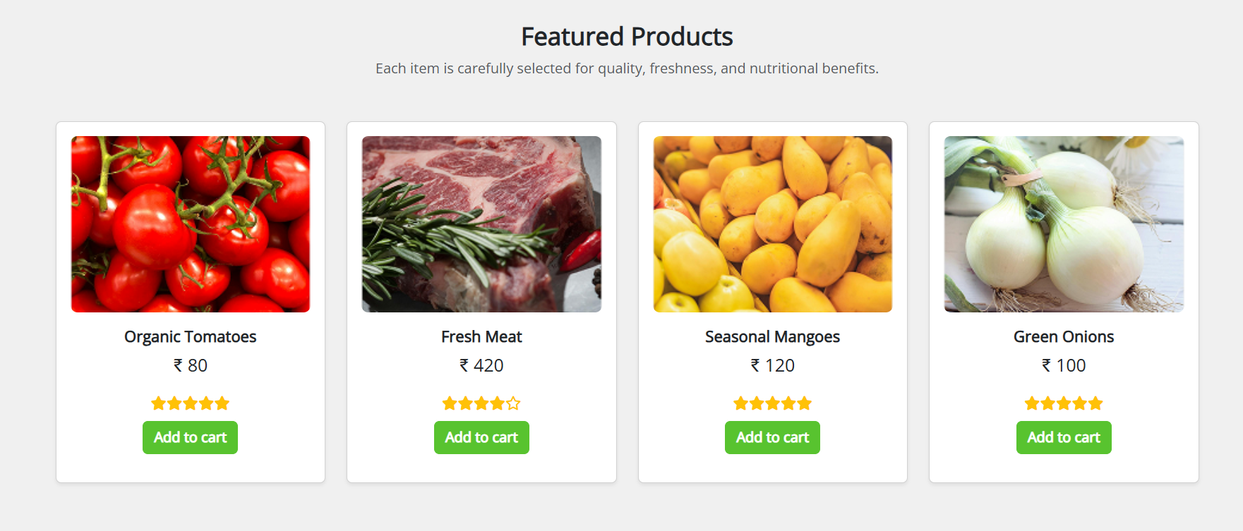

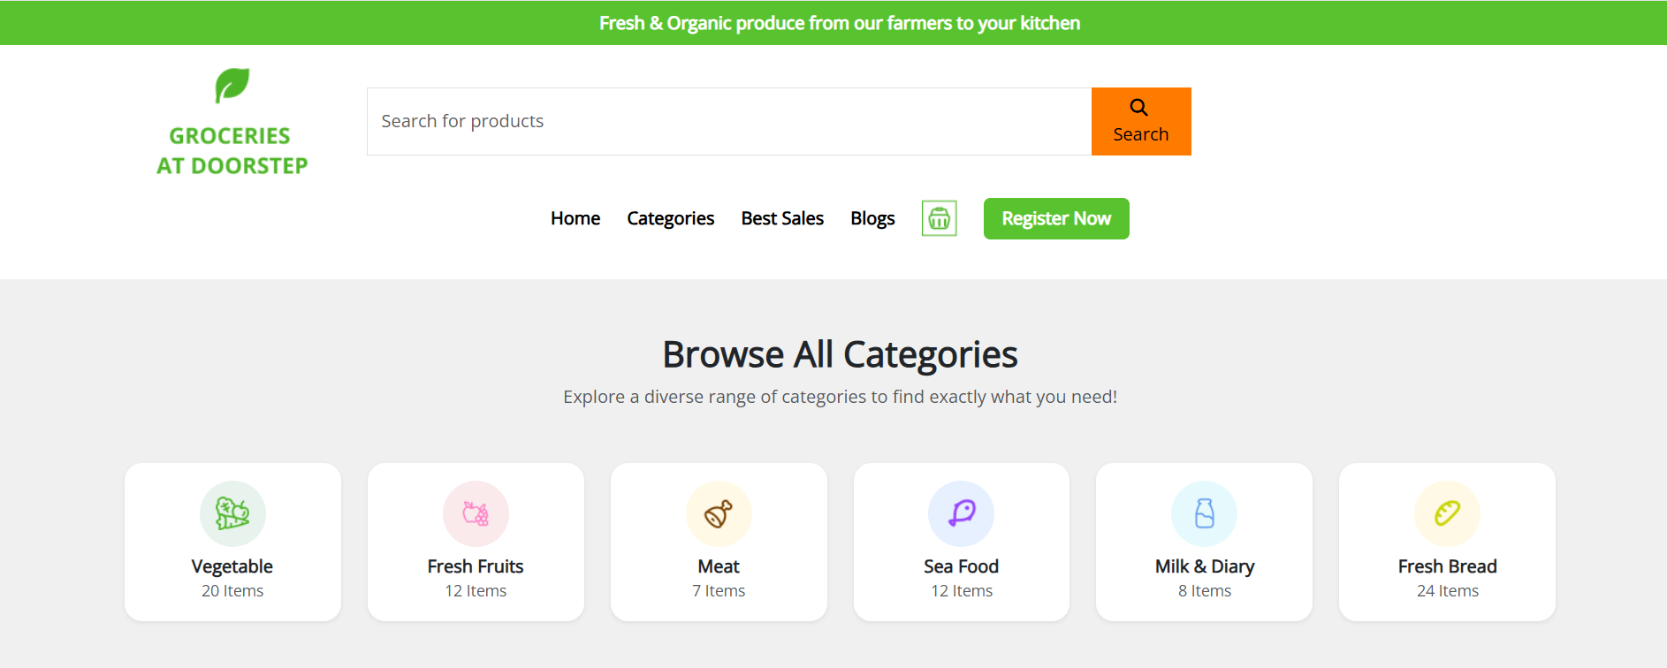

**Categories.html:**

**<!DOCTYPE html>**

**<html lang="en">**

**<head>**

**<meta charset="UTF-8" />**

**<meta name="viewport" content="width=device-width, initial-scale=1.0" />**

**<title>Grocery Navbar</title>**

**<!-- Bootstrap CSS -->**

**<link href="https://cdn.jsdelivr.net/npm/bootstrap@5.3.3/dist/css/bootstrap.min.css" rel="stylesheet">**

**<!-- Font Awesome CDN -->**

**<link rel="stylesheet" href="https://cdnjs.cloudflare.com/ajax/libs/font-awesome/6.5.0/css/all.min.css">**

**<!--  Open Sans -->**

**<link href="https://fonts.googleapis.com/css2?family=Open+Sans&display=swap" rel="stylesheet">**

**<!-- Custom CSS -->**

**<link rel="stylesheet" href="headerfooter.css">**

**<style>**

**body {**

**background-color: #f8f9fa;**

**font-family: 'Segoe UI', Tahoma, Geneva, Verdana, sans-serif;**

**}**

**.category-card img {**

**height: 150px;**

**object-fit: cover;**

**transition: transform 0.3s ease;**

**}**

**.category-card:hover img {**

**transform: scale(1.05);**

**}**

**.category-card h6 {**

**font-weight: 600;**

**}**

**</style>**

**</head>**

**<body>**

**<header class="header-section">**

**<!-- Top Green Banner -->**

**<div class="top-banner text-center py-2">**

**<span class="text-white fw-semibold">Fresh & Organic produce from our farmers to your kitchen</span>**

**</div>**

**<!-- Main Container -->**

**<div class="container py-3">**

**<div class="row align-items-center text-center text-lg-start">**

**<!-- Logo Column -->**

**<div class="col-lg-2 mb-3 mb-lg-0 d-flex flex-column align-items-center">**

**<img class="logoimg" src="./assets/images/home/logo.png" />**

**</div>**

**<!-- Search Bar Column -->**

**<div class="col-lg-7 mb-3 mb-lg-0">**

**<form class="d-flex w-100" role="search">**

**<input class="form-control rounded-0 border-end-0" type="search" placeholder="Search for products" aria-label="Search">**

**<button class="btn btn-warning rounded-0 border-start-0" type="submit">**

**<i class="fas fa-search me-1"></i> Search**

**</button>**

**</form>**

**</div>**

**<!-- Empty Column to Align -->**

**<div class="col-lg-3 d-none d-lg-block"></div>**

**</div>**

**<!-- Nav Links Row -->**

**<div class="row mt-3">**

**<div class="col d-flex justify-content-center gap-4 flex-wrap align-items-center">**

**<a href="home.html" class="nav-link fw-semibold">Home</a>**

**<a href="category.html" class="nav-link fw-semibold">Categories</a>**

**<a href="bestsales.html" class="nav-link fw-semibold">Best Sales</a>**

**<a href="blog.html" class="nav-link fw-semibold">Blogs</a>**

**<a href="addtocart.html" class="nav-link">**

**<img class="logoimg" src="./assets/images/home/cart icon.png" />**

**</a>**

**<a href="registernow.html" class="btn btn-success text-white fw-semibold px-3">Register Now</a>**

**</div>**

**</div>**

**</div>**

**</header>**

**<div class="container py-5">**

**<h2 class="text-center mb-4">Grocery Categories</h2>**

**<div class="row g-4">**

**<!-- Category Card -->**

**<div class="col-6 col-sm-4 col-md-3">**

**<a href="fruits.html" class="text-decoration-none text-dark">**

**<div class="category-card text-center">**

**<img src="./assets/images/category/fruits cate.png" class="img-fluid rounded" alt="Fruits">**

**<h6 class="mt-2">Fruits</h6>**

**</div>**

**</a>**

**</div>**

**<div class="col-6 col-sm-4 col-md-3">**

**<a href="vegetables.html" class="text-decoration-none text-dark">**

**<div class="category-card text-center">**

**<img src="./assets/images/category/vege cate.png" class="img-fluid rounded" alt="Vegetables">**

**<h6 class="mt-2">Vegetables</h6>**

**</div>**

**</a>**

**</div>**

**<div class="col-6 col-sm-4 col-md-3">**

**<a href="dairy.html" class="text-decoration-none text-dark">**

**<div class="category-card text-center">**

**<img src="./assets/images/category/eggs cate.png" class="img-fluid rounded" alt="Dairy & Eggs">**

**<h6 class="mt-2">Dairy & Eggs</h6>**

**</div>**

**</a>**

**</div>**

**<div class="col-6 col-sm-4 col-md-3">**

**<a href="meat.html" class="text-decoration-none text-dark">**

**<div class="category-card text-center">**

**<img src="./assets/images/category/meat & sea food cate.png" class="img-fluid rounded" alt="Meat & Seafood">**

**<h6 class="mt-2">Meat & Seafood</h6>**

**</div>**

**</a>**

**</div>**

**<div class="col-6 col-sm-4 col-md-3">**

**<a href="bakery.html" class="text-decoration-none text-dark">**

**<div class="category-card text-center">**

**<img src="./assets/images/category/bakery cate.png" class="img-fluid rounded" alt="Bakery">**

**<h6 class="mt-2">Bakery</h6>**

**</div>**

**</a>**

**</div>**

**<div class="col-6 col-sm-4 col-md-3">**

**<a href="pantry.html" class="text-decoration-none text-dark">**

**<div class="category-card text-center">**

**<img src="./assets/images/category/pantry cate.png" class="img-fluid rounded" alt="Pantry Staples">**

**<h6 class="mt-2">Pantry Staples</h6>**

**</div>**

**</a>**

**</div>**

**<div class="col-6 col-sm-4 col-md-3">**

**<a href="snacks.html" class="text-decoration-none text-dark">**

**<div class="category-card text-center">**

**<img src="./assets/images/category/snack cate.png" class="img-fluid rounded" alt="Snacks & Beverage">**

**<h6 class="mt-2">Snacks & Beverage</h6>**

**</div>**

**</a>**

**</div>**

**<div class="col-6 col-sm-4 col-md-3">**

**<a href="frozenfood.html" class="text-decoration-none text-dark">**

**<div class="category-card text-center">**

**<img src="./assets/images/category/frozen cate.png" class="img-fluid rounded" alt="Frozen Food">**

**<h6 class="mt-2">Frozen Food</h6>**

**</div>**

**</a>**

**</div>**

**<!--Footer-->**

**<div class="info-strip">**

**<!-- Left Orange Contact Banner -->**

**<div class="contact-banner">**

**Get in Touch with us**

**<span>+91 91010 90000</span>**

**</div>**

**<!-- Right Features Section -->**

**<div class="features-container">**

**<div class="feature-item">**

**<div class="icon-circle">**

**<img src="./assets/images/home/free shipping icon.png" alt="Free Shipping">**

**</div>**

**<div class="feature-text">**

**<p>Free Shipping</p>**

**<p>For Orders Above 500</p>**

**</div>**

**</div>**

**<div class="feature-item">**

**<div class="icon-circle">**

**<img src="./assets/images/home/fresh produce icon.png" alt="Fresh Produce">**

**</div>**

**<div class="feature-text">**

**<p>Fresh Produce</p>**

**<p>Guaranteed Product Warranty</p>**

**</div>**

**</div>**

**<div class="feature-item">**

**<div class="icon-circle">**

**<img src="./assets/images/home/safety icon.png" alt="Safety">**

**</div>**

**<div class="feature-text">**

**<p>100% Safety & Security</p>**

**<p>Your Data is Highly Secured</p>**

**</div>**

**</div>**

**</div>**

**</div>**

**<footer class="footer">**

**<div class="container">**

**<div class="footer-content row gy-4">**

**<!-- Logo & Description -->**

**<div class="col-md-4 footer-logo">**

**<img src="./assets/images/home/logo.png"  alt="Logo">**

**<p class="description">**

**Fresh groceries, particularly fruits, vegetables,<br>**

**whole grains, and lean proteins, play a crucial<br>**

**role in nourishing our bodies and promoting<br>**

**overall well-being**

**</p>**

**</div>**

**<!-- Navigation -->**

**<div class="col-md-4">**

**<h5>NAVIGATE</h5>**

**<a href="#">Privacy Policy</a>**

**<a href="#">Terms & Conditions</a>**

**<a href="#">How to Order</a>**

**<a href="#">About Us</a>**

**</div>**

**<!-- G-Store Info -->**

**<div class="col-md-4">**

**<h5>G-STORE</h5>**

**<p>Reg: T21542GST548</p>**

**<p>TIN: 14578452884</p>**

**<p>Email: groceries at doorstep@gmail.com</p>**

**</div>**

**</div>**

**<!-- Footer Bottom -->**

**<div class="footer-bottom mt-4">**

**Copyrights 2022© Groceries At Doorstep Ltd**

**</div>**

**</div>**

**</footer>**

**<script src="https://cdn.jsdelivr.net/npm/bootstrap@5.3.3/dist/js/bootstrap.bundle.min.js"></script>**

**<script src="script.js"></script>**

**</body>**

**</html>**

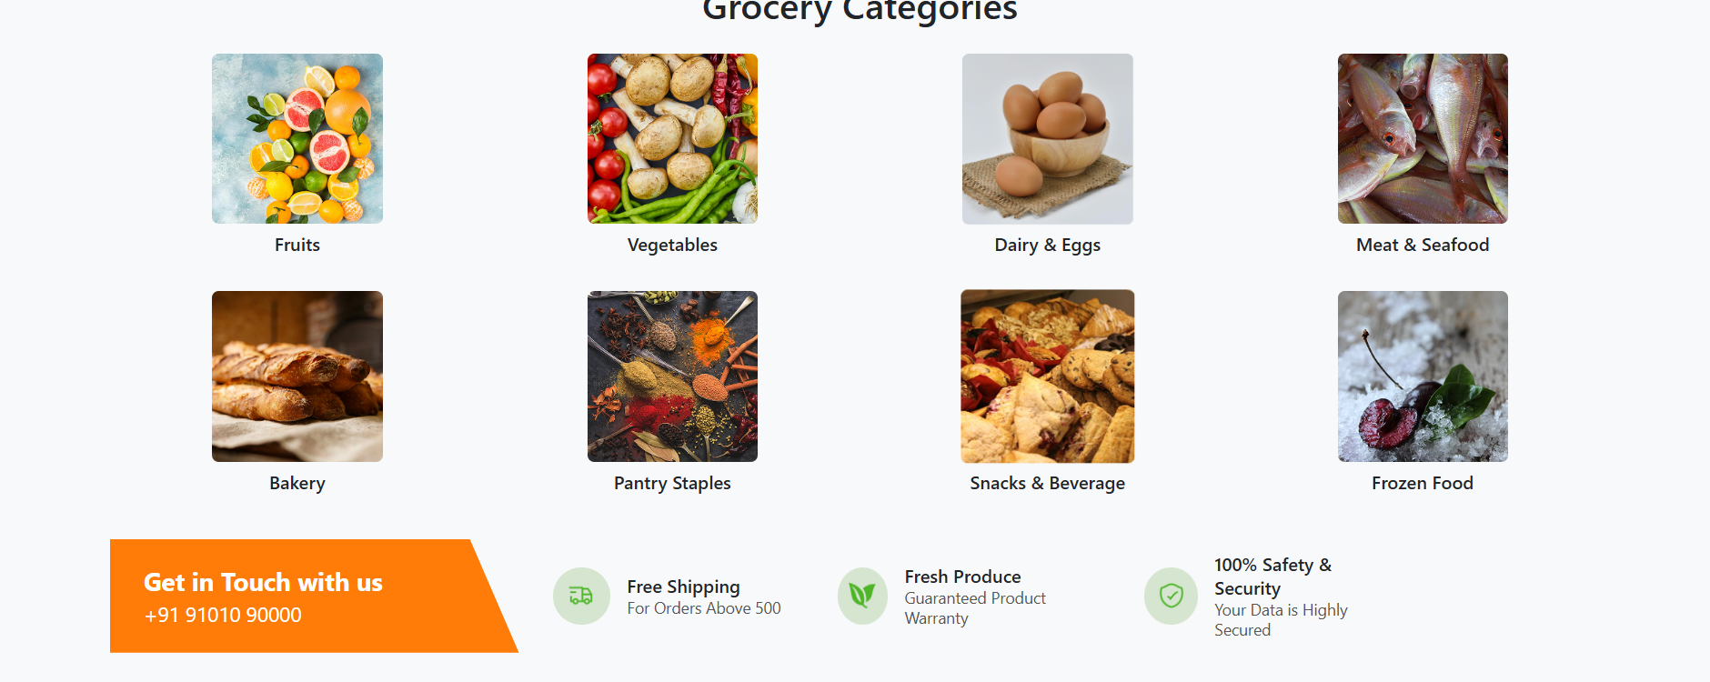

**Vegetables.html:**

**<!DOCTYPE html>**

**<html lang="en">**

**<head>**

**<meta charset="UTF-8" />**

**<meta name="viewport" content="width=device-width, initial-scale=1.0"/>**

**<title>Vegetables Shop</title>**

**<link href="https://cdn.jsdelivr.net/npm/bootstrap@5.3.3/dist/css/bootstrap.min.css" rel="stylesheet">**

**<link rel="stylesheet" href="https://cdnjs.cloudflare.com/ajax/libs/font-awesome/6.5.0/css/all.min.css" /><!DOCTYPE html>**

**<html lang="en">**

**<head>**

**<meta charset="UTF-8" />**

**<meta name="viewport" content="width=device-width, initial-scale=1.0" />**

**<title>Grocery Navbar</title>**

**<!-- Bootstrap CSS -->**

**<link href="https://cdn.jsdelivr.net/npm/bootstrap@5.3.3/dist/css/bootstrap.min.css" rel="stylesheet">**

**<!-- Font Awesome CDN -->**

**<link rel="stylesheet" href="https://cdnjs.cloudflare.com/ajax/libs/font-awesome/6.5.0/css/all.min.css">**

**<!--  Open Sans -->**

**<link href="https://fonts.googleapis.com/css2?family=Open+Sans&display=swap" rel="stylesheet">**

**<!-- Custom CSS -->**

**<link rel="stylesheet" href="headerfooter.css">**

**<style>**

**body {**

**background-color: #f8f9fa;**

**}**

**.product-card {**

**border: 1px solid #ddd;**

**border-radius: 8px;**

**padding: 10px;**

**text-align: center;**

**transition: transform 0.3s ease;**

**}**

**.product-card:hover {**

**transform: scale(1.03);**

**}**

**.product-img {**

**height: 150px;**

**object-fit: cover;**

**border-radius: 6px;**

**margin-bottom: 10px;**

**}**

**.star-rating {**

**color: #ffc107;**

**}**

**.filter-container {**

**padding: 20px;**

**background-color: white;**

**border-radius: 10px;**

**}**

**.sort-select {**

**max-width: 200px;**

**margin-bottom: 20px;**

**}**

**.green-btn {**

**background-color: #28a745;**

**color: white;**

**border: none;**

**}**

**.green-btn:hover {**

**background-color: #218838;**

**}**

**</style>**

**</head>**

**<body>**

**<!-- header -->**

**<header class="header-section">**

**<!-- Top Green Banner -->**

**<div class="top-banner text-center py-2">**

**<span class="text-white fw-semibold">Fresh & Organic produce from our farmers to your kitchen</span>**

**</div>**

**<!-- Main Container -->**

**<div class="container py-3">**

**<div class="row align-items-center text-center text-lg-start">**

**<!-- Logo Column -->**

**<div class="col-lg-2 mb-3 mb-lg-0 d-flex flex-column align-items-center">**

**<img class="logoimg" src="./assets/images/home/logo.png" />**

**</div>**

**<!-- Search Bar Column -->**

**<div class="col-lg-7 mb-3 mb-lg-0">**

**<form class="d-flex w-100" role="search">**

**<input class="form-control rounded-0 border-end-0" type="search" placeholder="Search for products" aria-label="Search">**

**<button class="btn btn-warning rounded-0 border-start-0" type="submit">**

**<i class="fas fa-search me-1"></i> Search**

**</button>**

**</form>**

**</div>**

**<!-- Empty Column to Align -->**

**<div class="col-lg-3 d-none d-lg-block"></div>**

**</div>**

**<!-- Nav Links Row -->**

**<div class="row mt-3">**

**<div class="col d-flex justify-content-center gap-4 flex-wrap align-items-center">**

**<a href="home.html" class="nav-link fw-semibold">Home</a>**

**<a href="category.html" class="nav-link fw-semibold">Categories</a>**

**<a href="bestsales.html" class="nav-link fw-semibold">Best Sales</a>**

**<a href="blog.html" class="nav-link fw-semibold">Blogs</a>**

**<a href="addtocart.html" class="nav-link">**

**<img class="logoimg" src="./assets/images/home/cart icon.png" />**

**</a>**

**<a href="registernow.html" class="btn btn-success text-white fw-semibold px-3">Register Now</a>**

**</div>**

**</div>**

**</div>**

**</header>**

**<div class="container my-4">**

**<h2 class="text-center text-success mb-4">Vegetables</h2>**

**<div class="row mb-3">**

**<div class="col-md-3 filter-container">**

**<label for="priceRange" class="form-label">Sort by Price</label>**

**<input type="range" class="form-range" min="0" max="100" id="priceRange" oninput="filterProducts()" />**

**<p>Below ₹<span id="priceValue">100</span></p>**

**</div>**

**<div class="col-md-9">**

**<div class="d-flex justify-content-end mb-3">**

**<select id="sortOptions" class="form-select sort-select" onchange="sortProducts()">**

**<option value="featured">Sort by: Featured</option>**

**<option value="lowToHigh">Price: Low to High</option>**

**<option value="highToLow">Price: High to Low</option>**

**</select>**

**</div>**

**<div class="row" id="productGrid">**

**<!-- Products will be rendered here -->**

**</div>**

**</div>**

**</div>**

**</div>**

**<!--Footer-->**

**<div class="info-strip">**

**<!-- Left Orange Contact Banner -->**

**<div class="contact-banner">**

**Get in Touch with us**

**<span>+91 91010 90000</span>**

**</div>**

**<!-- Right Features Section -->**

**<div class="features-container">**

**<div class="feature-item">**

**<div class="icon-circle">**

**<img src="./assets/images/home/free shipping icon.png" alt="Free Shipping">**

**</div>**

**<div class="feature-text">**

**<p>Free Shipping</p>**

**<p>For Orders Above 500</p>**

**</div>**

**</div>**

**<div class="feature-item">**

**<div class="icon-circle">**

**<img src="./assets/images/home/fresh produce icon.png" alt="Fresh Produce">**

**</div>**

**<div class="feature-text">**

**<p>Fresh Produce</p>**

**<p>Guaranteed Product Warranty</p>**

**</div>**

**</div>**

**<div class="feature-item">**

**<div class="icon-circle">**

**<img src="./assets/images/home/safety icon.png" alt="Safety">**

**</div>**

**<div class="feature-text">**

**<p>100% Safety & Security</p>**

**<p>Your Data is Highly Secured</p>**

**</div>**

**</div>**

**</div>**

**</div>**

**<footer class="footer">**

**<div class="container">**

**<div class="footer-content row gy-4">**

**<!-- Logo & Description -->**

**<div class="col-md-4 footer-logo">**

**<img src="./assets/images/home/logo.png"  alt="Logo">**

**<p class="description">**

**Fresh groceries, particularly fruits, vegetables,<br>**

**whole grains, and lean proteins, play a crucial<br>**

**role in nourishing our bodies and promoting<br>**

**overall well-being**

**</p>**

**</div>**

**<!-- Navigation -->**

**<div class="col-md-4">**

**<h5>NAVIGATE</h5>**

**<a href="#">Privacy Policy</a>**

**<a href="#">Terms & Conditions</a>**

**<a href="#">How to Order</a>**

**<a href="#">About Us</a>**

**</div>**

**<!-- G-Store Info -->**

**<div class="col-md-4">**

**<h5>G-STORE</h5>**

**<p>Reg: T21542GST548</p>**

**<p>TIN: 14578452884</p>**

**<p>Email: groceries at doorstep@gmail.com</p>**

**</div>**

**</div>**

**<!-- Footer Bottom -->**

**<div class="footer-bottom mt-4">**

**Copyrights 2022© Groceries At Doorstep Ltd**

**</div>**

**</div>**

**</footer>**

**<script>**

**const products = [**

**{ id: 1, name: "Organic Tomatoes", price: 80, image: "./assets/images/vegetables/img (1).png", rating: 5 },**

**{ id: 2, name: "Carrots", price: 60, image: "./assets/images/vegetables/img (2).png", rating: 4 },**

**{ id: 3, name: "Garlic", price: 40, image: "./assets/images/vegetables/img (3).png", rating: 4 },**

**{ id: 4, name: "Corn", price: 50, image: "./assets/images/vegetables/img (4).png", rating: 5 },**

**{ id: 5, name: "Spinach", price: 30, image: "./assets/images/vegetables/img (5).png", rating: 3 },**

**{ id: 6, name: "Red Peppers", price: 70, image: "./assets/images/vegetables/img (6).png", rating: 5 },**

**{ id: 7, name: "Green Beans", price: 65, image: "./assets/images/vegetables/img (7).png", rating: 4 },**

**{ id: 8, name: "Purple Cabbage", price: 55, image: "./assets/images/vegetables/img (8).png", rating: 3 },**

**];**

**let currentProducts = [...products];**

**function renderProducts(data) {**

**const grid = document.getElementById("productGrid");**

**grid.innerHTML = '';**

**data.forEach(product => {**

**grid.innerHTML += `**

**<div class="col-sm-6 col-md-4 col-lg-3 mb-4">**

**<div class="product-card bg-white shadow-sm">**

**<a href="radish.html" class="text-decoration-none text-dark d-block">**

**<img src="${product.image}" class="product-img w-100" alt="${product.name}">**

**<h6 class="mt-2">${product.name}</h6>**

**<p><strong>₹ ${product.price}</strong></p>**

**<div class="star-rating mb-2">**

**${'★'.repeat(product.rating)}${'☆'.repeat(5 - product.rating)}**

**</div>**

**</a>**

**<a href="addtocart.html" class="btn green-btn w-100">Add to cart</a>**

**</div>**

**</div>**

**`;**

**});**

**}**

**function filterProducts() {**

**const maxPrice = parseInt(document.getElementById("priceRange").value);**

**document.getElementById("priceValue").innerText = maxPrice;**

**const filtered = products.filter(product => product.price <= maxPrice);**

**currentProducts = filtered;**

**renderProducts(currentProducts);**

**}**

**function sortProducts() {**

**const option = document.getElementById("sortOptions").value;**

**let sorted = [...currentProducts];**

**if (option === "lowToHigh") {**

**sorted.sort((a, b) => a.price - b.price);**

**} else if (option === "highToLow") {**

**sorted.sort((a, b) => b.price - a.price);**

**}**

**renderProducts(sorted);**

**}**

**// Initial load**

**renderProducts(products);**

**</script>**

**</body>**

**</html>**

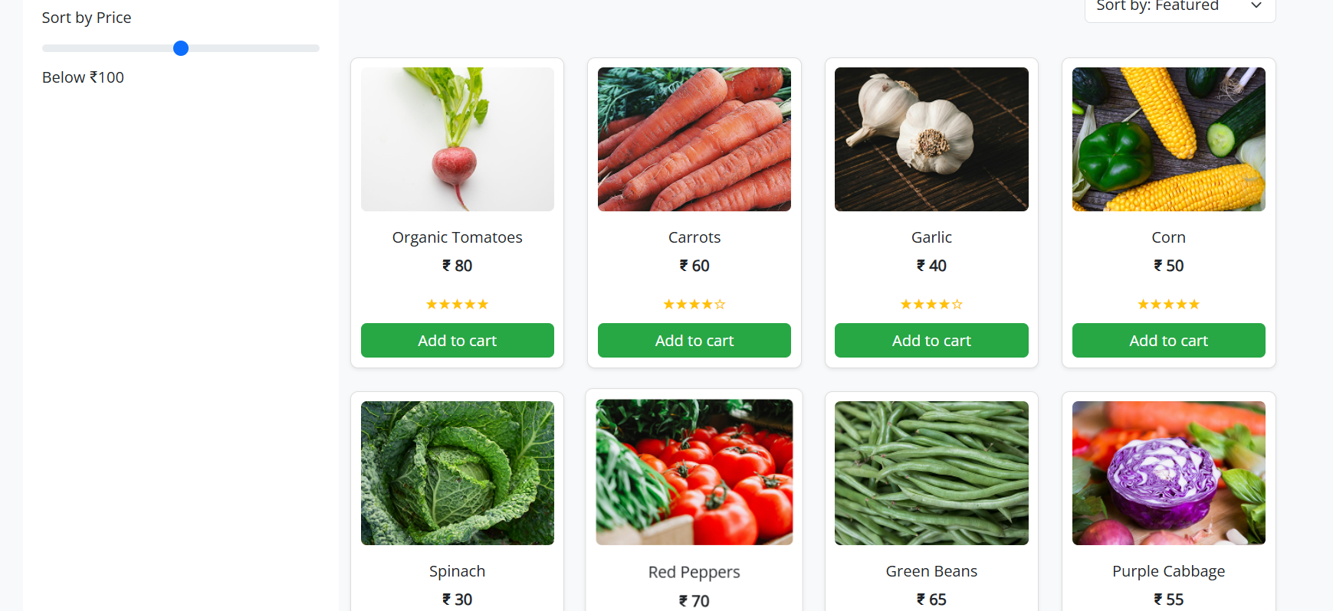

**Fruits.html:**

**<!DOCTYPE html>**

**<html lang="en">**

**<head>**

**<meta charset="UTF-8" />**

**<meta name="viewport" content="width=device-width, initial-scale=1.0" />**

**<title>Grocery Navbar</title>**

**<!-- Bootstrap CSS -->**

**<link href="https://cdn.jsdelivr.net/npm/bootstrap@5.3.3/dist/css/bootstrap.min.css" rel="stylesheet">**

**<!-- Font Awesome CDN -->**

**<link rel="stylesheet" href="https://cdnjs.cloudflare.com/ajax/libs/font-awesome/6.5.0/css/all.min.css">**

**<!--  Open Sans -->**

**<link href="https://fonts.googleapis.com/css2?family=Open+Sans&display=swap" rel="stylesheet">**

**<!-- Custom CSS -->**

**<link rel="stylesheet" href="headerfooter.css">**

**<style>**

**body {**

**background-color: #f8f9fa;**

**}**

**.product-card {**

**border: 1px solid #ddd;**

**border-radius: 8px;**

**padding: 10px;**

**text-align: center;**

**transition: transform 0.3s ease;**

**}**

**.product-card:hover {**

**transform: scale(1.03);**

**}**

**.product-img {**

**height: 150px;**

**object-fit: cover;**

**border-radius: 6px;**

**margin-bottom: 10px;**

**}**

**.star-rating {**

**color: #ffc107;**

**}**

**.filter-container {**

**padding: 20px;**

**background-color: white;**

**border-radius: 10px;**

**}**

**.sort-select {**

**max-width: 200px;**

**margin-bottom: 20px;**

**}**

**.green-btn {**

**background-color: #28a745;**

**color: white;**

**border: none;**

**}**

**.green-btn:hover {**

**background-color: #218838;**

**}**

**</style>**

**</head>**

**<body>**

**<!-- header -->**

**<header class="header-section">**

**<!-- Top Green Banner -->**

**<div class="top-banner text-center py-2">**

**<span class="text-white fw-semibold">Fresh & Organic produce from our farmers to your kitchen</span>**

**</div>**

**<!-- Main Container -->**

**<div class="container py-3">**

**<div class="row align-items-center text-center text-lg-start">**

**<!-- Logo Column -->**

**<div class="col-lg-2 mb-3 mb-lg-0 d-flex flex-column align-items-center">**

**<img class="logoimg" src="./assets/images/home/logo.png" />**

**</div>**

**<!-- Search Bar Column -->**

**<div class="col-lg-7 mb-3 mb-lg-0">**

**<form class="d-flex w-100" role="search">**

**<input class="form-control rounded-0 border-end-0" type="search" placeholder="Search for products" aria-label="Search">**

**<button class="btn btn-warning rounded-0 border-start-0" type="submit">**

**<i class="fas fa-search me-1"></i> Search**

**</button>**

**</form>**

**</div>**

**<!-- Empty Column to Align -->**

**<div class="col-lg-3 d-none d-lg-block"></div>**

**</div>**

**<!-- Nav Links Row -->**

**<div class="row mt-3">**

**<div class="col d-flex justify-content-center gap-4 flex-wrap align-items-center">**

**<a href="home.html" class="nav-link fw-semibold">Home</a>**

**<a href="category.html" class="nav-link fw-semibold">Categories</a>**

**<a href="bestsales.html" class="nav-link fw-semibold">Best Sales</a>**

**<a href="blog.html" class="nav-link fw-semibold">Blogs</a>**

**<a href="addtocart.html" class="nav-link">**

**<img class="logoimg" src="./assets/images/home/cart icon.png" />**

**</a>**

**<a href="registernow.html" class="btn btn-success text-white fw-semibold px-3">Register Now</a>**

**</div>**

**</div>**

**</div>**

**</header>**

**<div class="container my-4">**

**<h2 class="text-center text-success mb-4">Fruits</h2>**

**<div class="row mb-3">**

**<div class="col-md-3 filter-container">**

**<label for="priceRange" class="form-label">Sort by Price</label>**

**<input type="range" class="form-range" min="0" max="100" id="priceRange" oninput="filterProducts()" />**

**<p>Below ₹<span id="priceValue">100</span></p>**

**</div>**

**<div class="col-md-9">**

**<div class="d-flex justify-content-end mb-3">**

**<select id="sortOptions" class="form-select sort-select" onchange="sortProducts()">**

**<option value="featured">Sort by: Featured</option>**

**<option value="lowToHigh">Price: Low to High</option>**

**<option value="highToLow">Price: High to Low</option>**

**</select>**

**</div>**

**<div class="row" id="productGrid">**

**<!-- Products will be rendered here -->**

**</div>**

**</div>**

**</div>**

**</div>**

**<!--Footer-->**

**<div class="info-strip">**

**<!-- Left Orange Contact Banner -->**

**<div class="contact-banner">**

**Get in Touch with us**

**<span>+91 91010 90000</span>**

**</div>**

**<!-- Right Features Section -->**

**<div class="features-container">**

**<div class="feature-item">**

**<div class="icon-circle">**

**<img src="./assets/images/home/free shipping icon.png" alt="Free Shipping">**

**</div>**

**<div class="feature-text">**

**<p>Free Shipping</p>**

**<p>For Orders Above 500</p>**

**</div>**

**</div>**

**<div class="feature-item">**

**<div class="icon-circle">**

**<img src="./assets/images/home/fresh produce icon.png" alt="Fresh Produce">**

**</div>**

**<div class="feature-text">**

**<p>Fresh Produce</p>**

**<p>Guaranteed Product Warranty</p>**

**</div>**

**</div>**

**<div class="feature-item">**

**<div class="icon-circle">**

**<img src="./assets/images/home/safety icon.png" alt="Safety">**

**</div>**

**<div class="feature-text">**

**<p>100% Safety & Security</p>**

**<p>Your Data is Highly Secured</p>**

**</div>**

**</div>**

**</div>**

**</div>**

**<footer class="footer">**

**<div class="container">**

**<div class="footer-content row gy-4">**

**<!-- Logo & Description -->**

**<div class="col-md-4 footer-logo">**

**<img src="./assets/images/home/logo.png"  alt="Logo">**

**<p class="description">**

**Fresh groceries, particularly fruits, vegetables,<br>**

**whole grains, and lean proteins, play a crucial<br>**

**role in nourishing our bodies and promoting<br>**

**overall well-being**

**</p>**

**</div>**

**<!-- Navigation -->**

**<div class="col-md-4">**

**<h5>NAVIGATE</h5>**

**<a href="#">Privacy Policy</a>**

**<a href="#">Terms & Conditions</a>**

**<a href="#">How to Order</a>**

**<a href="#">About Us</a>**

**</div>**

**<!-- G-Store Info -->**

**<div class="col-md-4">**

**<h5>G-STORE</h5>**

**<p>Reg: T21542GST548</p>**

**<p>TIN: 14578452884</p>**

**<p>Email: groceries at doorstep@gmail.com</p>**

**</div>**

**</div>**

**<!-- Footer Bottom -->**

**<div class="footer-bottom mt-4">**

**Copyrights 2022© Groceries At Doorstep Ltd**

**</div>**

**</div>**

**</footer>**

**<script>**

**const products = [**

**{ id: 1, name: "Organic Tomatoes", price: 80, image: "./assets/images/fruits/img (1).png", rating: 5 },**

**{ id: 2, name: "Carrots", price: 60, image: "./assets/images/fruits/img (2).png", rating: 4 },**

**{ id: 3, name: "Garlic", price: 40, image: "./assets/images/fruits/img (3).png", rating: 4 },**

**{ id: 4, name: "Corn", price: 50, image: "./assets/images/fruits/img (4).png", rating: 5 },**

**{ id: 5, name: "Spinach", price: 30, image: "./assets/images/fruits/img (5).png", rating: 3 },**

**{ id: 6, name: "Red Peppers", price: 70, image: "./assets/images/fruits/img (6).png", rating: 5 },**

**{ id: 7, name: "Green Beans", price: 65, image: "./assets/images/fruits/img (7).png", rating: 4 },**

**{ id: 8, name: "Purple Cabbage", price: 55, image: "./assets/images/fruits/img (8).png", rating: 3 },**

**];**

**let currentProducts = [...products];**

**function renderProducts(data) {**

**const grid = document.getElementById("productGrid");**

**grid.innerHTML = '';**

**data.forEach(product => {**

**grid.innerHTML += `**

**<div class="col-sm-6 col-md-4 col-lg-3 mb-4">**

**<div class="product-card bg-white shadow-sm">**

**<a href="fruitsdes.html" class="text-decoration-none text-dark d-block">**

**<img src="${product.image}" class="product-img w-100" alt="${product.name}">**

**<h6 class="mt-2">${product.name}</h6>**

**<p><strong>₹ ${product.price}</strong></p>**

**<div class="star-rating mb-2">**

**${'★'.repeat(product.rating)}${'☆'.repeat(5 - product.rating)}**

**</div>**

**</a>**

**<a href="addtocart.html" class="btn green-btn w-100">Add to cart</a>**

**</div>**

**</div>**

**`;**

**});**

**}**

**function filterProducts() {**

**const maxPrice = parseInt(document.getElementById("priceRange").value);**

**document.getElementById("priceValue").innerText = maxPrice;**

**const filtered = products.filter(product => product.price <= maxPrice);**

**currentProducts = filtered;**

**renderProducts(currentProducts);**

**}**

**function sortProducts() {**

**const option = document.getElementById("sortOptions").value;**

**let sorted = [...currentProducts];**

**if (option === "lowToHigh") {**

**sorted.sort((a, b) => a.price - b.price);**

**} else if (option === "highToLow") {**

**sorted.sort((a, b) => b.price - a.price);**

**}**

**renderProducts(sorted);**

**}**

**// Initial load**

**renderProducts(products);**

**</script>**

**</body>**

**</html>**

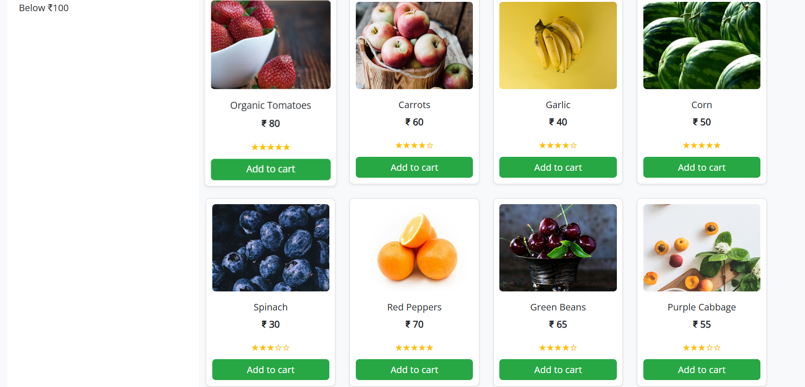

**Snacks.html:**

**<!DOCTYPE html>**

**<html lang="en">**

**<head>**

**<meta charset="UTF-8" />**

**<meta name="viewport" content="width=device-width, initial-scale=1.0" />**

**<title>Grocery Navbar</title>**

**<!-- Bootstrap CSS -->**

**<link href="https://cdn.jsdelivr.net/npm/bootstrap@5.3.3/dist/css/bootstrap.min.css" rel="stylesheet">**

**<!-- Font Awesome CDN -->**

**<link rel="stylesheet" href="https://cdnjs.cloudflare.com/ajax/libs/font-awesome/6.5.0/css/all.min.css">**

**<!--  Open Sans -->**

**<link href="https://fonts.googleapis.com/css2?family=Open+Sans&display=swap" rel="stylesheet">**

**<!-- Custom CSS -->**

**<link rel="stylesheet" href="headerfooter.css">**

**<style>**

**body {**

**background-color: #f8f9fa;**

**}**

**.product-card {**

**border: 1px solid #ddd;**

**border-radius: 8px;**

**padding: 10px;**

**text-align: center;**

**transition: transform 0.3s ease;**

**}**

**.product-card:hover {**

**transform: scale(1.03);**

**}**

**.product-img {**

**height: 150px;**

**object-fit: cover;**

**border-radius: 6px;**

**margin-bottom: 10px;**

**}**

**.star-rating {**

**color: #ffc107;**

**}**

**.filter-container {**

**padding: 20px;**

**background-color: white;**

**border-radius: 10px;**

**}**

**.sort-select {**

**max-width: 200px;**

**margin-bottom: 20px;**

**}**

**.green-btn {**

**background-color: #28a745;**

**color: white;**

**border: none;**

**}**

**.green-btn:hover {**

**background-color: #218838;**

**}**

**</style>**

**</head>**

**<body>**

**<!-- header -->**

**<header class="header-section">**

**<!-- Top Green Banner -->**

**<div class="top-banner text-center py-2">**

**<span class="text-white fw-semibold">Fresh & Organic produce from our farmers to your kitchen</span>**

**</div>**

**<!-- Main Container -->**

**<div class="container py-3">**

**<div class="row align-items-center text-center text-lg-start">**

**<!-- Logo Column -->**

**<div class="col-lg-2 mb-3 mb-lg-0 d-flex flex-column align-items-center">**

**<img class="logoimg" src="./assets/images/home/logo.png" />**

**</div>**

**<!-- Search Bar Column -->**

**<div class="col-lg-7 mb-3 mb-lg-0">**

**<form class="d-flex w-100" role="search">**

**<input class="form-control rounded-0 border-end-0" type="search" placeholder="Search for products" aria-label="Search">**

**<button class="btn btn-warning rounded-0 border-start-0" type="submit">**

**<i class="fas fa-search me-1"></i> Search**

**</button>**

**</form>**

**</div>**

**<!-- Empty Column to Align -->**

**<div class="col-lg-3 d-none d-lg-block"></div>**

**</div>**

**<!-- Nav Links Row -->**

**<div class="row mt-3">**

**<div class="col d-flex justify-content-center gap-4 flex-wrap align-items-center">**

**<a href="home.html" class="nav-link fw-semibold">Home</a>**

**<a href="category.html" class="nav-link fw-semibold">Categories</a>**

**<a href="bestsales.html" class="nav-link fw-semibold">Best Sales</a>**

**<a href="blog.html" class="nav-link fw-semibold">Blogs</a>**

**<a href="addtocart.html" class="nav-link">**

**<img class="logoimg" src="./assets/images/home/cart icon.png" />**

**</a>**

**<a href="registernow.html" class="btn btn-success text-white fw-semibold px-3">Register Now</a>**

**</div>**

**</div>**

**</div>**

**</header>**

**<div class="container my-4">**

**<h2 class="text-center text-success mb-4">Snacks & Beverages</h2>**

**<div class="row mb-3">**

**<div class="col-md-3 filter-container">**

**<label for="priceRange" class="form-label">Sort by Price</label>**

**<input type="range" class="form-range" min="0" max="100" id="priceRange" oninput="filterProducts()" />**

**<p>Below ₹<span id="priceValue">100</span></p>**

**</div>**

**<div class="col-md-9">**

**<div class="d-flex justify-content-end mb-3">**

**<select id="sortOptions" class="form-select sort-select" onchange="sortProducts()">**

**<option value="featured">Sort by: Featured</option>**

**<option value="lowToHigh">Price: Low to High</option>**

**<option value="highToLow">Price: High to Low</option>**

**</select>**

**</div>**

**<div class="row" id="productGrid">**

**<!-- Products will be rendered here -->**

**</div>**

**</div>**

**</div>**

**</div>**

**<!--Footer-->**

**<div class="info-strip">**

**<!-- Left Orange Contact Banner -->**

**<div class="contact-banner">**

**Get in Touch with us**

**<span>+91 91010 90000</span>**

**</div>**

**<!-- Right Features Section -->**

**<div class="features-container">**

**<div class="feature-item">**

**<div class="icon-circle">**

**<img src="./assets/images/home/free shipping icon.png" alt="Free Shipping">**

**</div>**

**<div class="feature-text">**

**<p>Free Shipping</p>**

**<p>For Orders Above 500</p>**

**</div>**

**</div>**

**<div class="feature-item">**

**<div class="icon-circle">**

**<img src="./assets/images/home/fresh produce icon.png" alt="Fresh Produce">**

**</div>**

**<div class="feature-text">**

**<p>Fresh Produce</p>**

**<p>Guaranteed Product Warranty</p>**

**</div>**

**</div>**

**<div class="feature-item">**

**<div class="icon-circle">**

**<img src="./assets/images/home/safety icon.png" alt="Safety">**

**</div>**

**<div class="feature-text">**

**<p>100% Safety & Security</p>**

**<p>Your Data is Highly Secured</p>**

**</div>**

**</div>**

**</div>**

**</div>**

**<footer class="footer">**

**<div class="container">**

**<div class="footer-content row gy-4">**

**<!-- Logo & Description -->**

**<div class="col-md-4 footer-logo">**

**<img src="./assets/images/home/logo.png"  alt="Logo">**

**<p class="description">**

**Fresh groceries, particularly fruits, vegetables,<br>**

**whole grains, and lean proteins, play a crucial<br>**

**role in nourishing our bodies and promoting<br>**

**overall well-being**

**</p>**

**</div>**

**<!-- Navigation -->**

**<div class="col-md-4">**

**<h5>NAVIGATE</h5>**

**<a href="#">Privacy Policy</a>**

**<a href="#">Terms & Conditions</a>**

**<a href="#">How to Order</a>**

**<a href="#">About Us</a>**

**</div>**

**<!-- G-Store Info -->**

**<div class="col-md-4">**

**<h5>G-STORE</h5>**

**<p>Reg: T21542GST548</p>**

**<p>TIN: 14578452884</p>**

**<p>Email: groceries at doorstep@gmail.com</p>**

**</div>**

**</div>**

**<!-- Footer Bottom -->**

**<div class="footer-bottom mt-4">**

**Copyrights 2022© Groceries At Doorstep Ltd**

**</div>**

**</div>**

**</footer>**

**<script>**

**const products = [**

**{ id: 1, name: "Organic Tomatoes", price: 80, image: "./assets/images/snacks/img (1).png", rating: 5 },**

**{ id: 2, name: "Carrots", price: 60, image: "./assets/images/vegetables/img (2).png", rating: 4 },**

**{ id: 3, name: "Garlic", price: 40, image: "./assets/images/vegetables/img (3).png", rating: 4 },**

**{ id: 4, name: "Corn", price: 50, image: "./assets/images/vegetables/img (4).png", rating: 5 },**

**{ id: 5, name: "Spinach", price: 30, image: "./assets/images/vegetables/img (5).png", rating: 3 },**

**{ id: 6, name: "Red Peppers", price: 70, image: "./assets/images/vegetables/img (6).png", rating: 5 },**

**{ id: 7, name: "Green Beans", price: 65, image: "./assets/images/vegetables/img (7).png", rating: 4 },**

**{ id: 8, name: "Purple Cabbage", price: 55, image: "./assets/images/vegetables/img (8).png", rating: 3 },**

**];**

**let currentProducts = [...products];**

**function renderProducts(data) {**

**const grid = document.getElementById("productGrid");**

**grid.innerHTML = '';**

**data.forEach(product => {**

**grid.innerHTML += `**

**<div class="col-sm-6 col-md-4 col-lg-3 mb-4">**

**<div class="product-card bg-white shadow-sm">**

**<a href="snacksdes.html" class="text-decoration-none text-dark d-block">**

**<img src="${product.image}" class="product-img w-100" alt="${product.name}">**

**<h6 class="mt-2">${product.name}</h6>**

**<p><strong>₹ ${product.price}</strong></p>**

**<div class="star-rating mb-2">**

**${'★'.repeat(product.rating)}${'☆'.repeat(5 - product.rating)}**

**</div>**

**</a>**

**<a href="addtocart.html" class="btn green-btn w-100">Add to cart</a>**

**</div>**

**</div>**

**`;**

**});**

**}**

**function filterProducts() {**

**const maxPrice = parseInt(document.getElementById("priceRange").value);**

**document.getElementById("priceValue").innerText = maxPrice;**

**const filtered = products.filter(product => product.price <= maxPrice);**

**currentProducts = filtered;**

**renderProducts(currentProducts);**

**}**

**function sortProducts() {**

**const option = document.getElementById("sortOptions").value;**

**let sorted = [...currentProducts];**

**if (option === "lowToHigh") {**

**sorted.sort((a, b) => a.price - b.price);**

**} else if (option === "highToLow") {**

**sorted.sort((a, b) => b.price - a.price);**

**}**

**renderProducts(sorted);**

**}**

**// Initial load**

**renderProducts(products);**

**</script>**

**</body>**

**</html>**

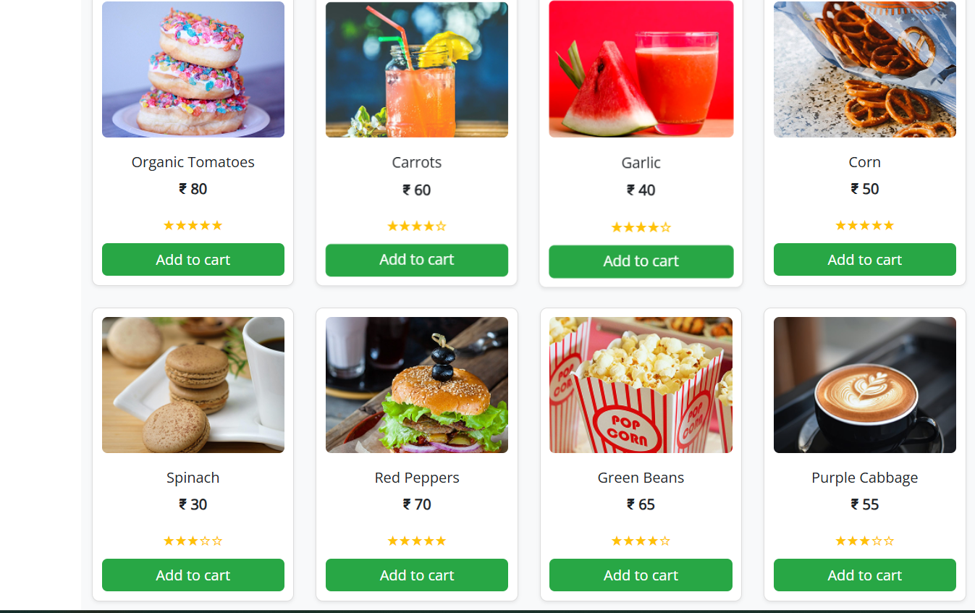

**Dairy.html:**

**<!DOCTYPE html>**

**<html lang="en">**

**<head>**

**<meta charset="UTF-8" />**

**<meta name="viewport" content="width=device-width, initial-scale=1.0" />**

**<title>Grocery Navbar</title>**

**<!-- Bootstrap CSS -->**

**<link href="https://cdn.jsdelivr.net/npm/bootstrap@5.3.3/dist/css/bootstrap.min.css" rel="stylesheet">**

**<!-- Font Awesome CDN -->**

**<link rel="stylesheet" href="https://cdnjs.cloudflare.com/ajax/libs/font-awesome/6.5.0/css/all.min.css">**

**<!--  Open Sans -->**

**<link href="https://fonts.googleapis.com/css2?family=Open+Sans&display=swap" rel="stylesheet">**

**<!-- Custom CSS -->**

**<link rel="stylesheet" href="headerfooter.css">**

**<style>**

**body {**

**background-color: #f8f9fa;**

**}**

**.product-card {**

**border: 1px solid #ddd;**

**border-radius: 8px;**

**padding: 10px;**

**text-align: center;**

**transition: transform 0.3s ease;**

**}**

**.product-card:hover {**

**transform: scale(1.03);**

**}**

**.product-img {**

**height: 150px;**

**object-fit: cover;**

**border-radius: 6px;**

**margin-bottom: 10px;**

**}**

**.star-rating {**

**color: #ffc107;**

**}**

**.filter-container {**

**padding: 20px;**

**background-color: white;**

**border-radius: 10px;**

**}**

**.sort-select {**

**max-width: 200px;**

**margin-bottom: 20px;**

**}**

**.green-btn {**

**background-color: #28a745;**

**color: white;**

**border: none;**

**}**

**.green-btn:hover {**

**background-color: #218838;**

**}**

**</style>**

**</head>**

**<body>**

**<header class="header-section">**

**<!-- Top Green Banner -->**

**<div class="top-banner text-center py-2">**

**<span class="text-white fw-semibold">Fresh & Organic produce from our farmers to your kitchen</span>**

**</div>**

**<!-- Main Container -->**

**<div class="container py-3">**

**<div class="row align-items-center text-center text-lg-start">**

**<!-- Logo Column -->**

**<div class="col-lg-2 mb-3 mb-lg-0 d-flex flex-column align-items-center">**

**<img class="logoimg" src="./assets/images/home/logo.png" />**

**</div>**

**<!-- Search Bar Column -->**

**<div class="col-lg-7 mb-3 mb-lg-0">**

**<form class="d-flex w-100" role="search">**

**<input class="form-control rounded-0 border-end-0" type="search" placeholder="Search for products" aria-label="Search">**

**<button class="btn btn-warning rounded-0 border-start-0" type="submit">**

**<i class="fas fa-search me-1"></i> Search**

**</button>**

**</form>**

**</div>**

**<!-- Empty Column to Align -->**

**<div class="col-lg-3 d-none d-lg-block"></div>**

**</div>**

**<!-- Nav Links Row -->**

**<div class="row mt-3">**

**<div class="col d-flex justify-content-center gap-4 flex-wrap align-items-center">**

**<a href="home.html" class="nav-link fw-semibold">Home</a>**

**<a href="category.html" class="nav-link fw-semibold">Categories</a>**

**<a href="bestsales.html" class="nav-link fw-semibold">Best Sales</a>**

**<a href="blog.html" class="nav-link fw-semibold">Blogs</a>**

**<a href="addtocart.html" class="nav-link">**

**<img class="logoimg" src="./assets/images/home/cart icon.png" />**

**</a>**

**<a href="registernow.html" class="btn btn-success text-white fw-semibold px-3">Register Now</a>**

**</div>**

**</div>**

**</div>**

**</header>**

**<div class="container my-4">**

**<h2 class="text-center text-success mb-4">Dairy & Eggs</h2>**

**<div class="row mb-3">**

**<div class="col-md-3 filter-container">**

**<label for="priceRange" class="form-label">Sort by Price</label>**

**<input type="range" class="form-range" min="0" max="100" id="priceRange" oninput="filterProducts()" />**

**<p>Below ₹<span id="priceValue">100</span></p>**

**</div>**

**<div class="col-md-9">**

**<div class="d-flex justify-content-end mb-3">**

**<select id="sortOptions" class="form-select sort-select" onchange="sortProducts()">**

**<option value="featured">Sort by: Featured</option>**

**<option value="lowToHigh">Price: Low to High</option>**

**<option value="highToLow">Price: High to Low</option>**

**</select>**

**</div>**

**<div class="row" id="productGrid">**

**<!-- Products will be rendered here -->**

**</div>**

**</div>**

**</div>**

**</div>**

**<!--Footer-->**

**<div class="info-strip">**

**<!-- Left Orange Contact Banner -->**

**<div class="contact-banner">**

**Get in Touch with us**

**<span>+91 91010 90000</span>**

**</div>**

**<!-- Right Features Section -->**

**<div class="features-container">**

**<div class="feature-item">**

**<div class="icon-circle">**

**<img src="./assets/images/home/free shipping icon.png" alt="Free Shipping">**

**</div>**

**<div class="feature-text">**

**<p>Free Shipping</p>**

**<p>For Orders Above 500</p>**

**</div>**

**</div>**

**<div class="feature-item">**

**<div class="icon-circle">**

**<img src="./assets/images/home/fresh produce icon.png" alt="Fresh Produce">**

**</div>**

**<div class="feature-text">**

**<p>Fresh Produce</p>**

**<p>Guaranteed Product Warranty</p>**

**</div>**

**</div>**

**<div class="feature-item">**

**<div class="icon-circle">**

**<img src="./assets/images/home/safety icon.png" alt="Safety">**

**</div>**

**<div class="feature-text">**

**<p>100% Safety & Security</p>**

**<p>Your Data is Highly Secured</p>**

**</div>**

**</div>**

**</div>**

**</div>**

**<footer class="footer">**

**<div class="container">**

**<div class="footer-content row gy-4">**

**<!-- Logo & Description -->**

**<div class="col-md-4 footer-logo">**

**<img src="./assets/images/home/logo.png"  alt="Logo">**

**<p class="description">**

**Fresh groceries, particularly fruits, vegetables,<br>**

**whole grains, and lean proteins, play a crucial<br>**

**role in nourishing our bodies and promoting<br>**

**overall well-being**

**</p>**

**</div>**

**<!-- Navigation -->**

**<div class="col-md-4">**

**<h5>NAVIGATE</h5>**

**<a href="#">Privacy Policy</a>**

**<a href="#">Terms & Conditions</a>**

**<a href="#">How to Order</a>**

**<a href="#">About Us</a>**

**</div>**

**<!-- G-Store Info -->**

**<div class="col-md-4">**

**<h5>G-STORE</h5>**

**<p>Reg: T21542GST548</p>**

**<p>TIN: 14578452884</p>**

**<p>Email: groceries at doorstep@gmail.com</p>**

**</div>**

**</div>**

**<!-- Footer Bottom -->**

**<div class="footer-bottom mt-4">**

**Copyrights 2022© Groceries At Doorstep Ltd**

**</div>**

**</div>**

**</footer>**

**<script>**

**const products = [**

**{ id: 1, name: "Organic Tomatoes", price: 80, image: "./assets/images/dairy/img (1).png", rating: 5 },**

**{ id: 2, name: "Carrots", price: 60, image: "./assets/images/dairy/img (2).png", rating: 4 },**

**{ id: 3, name: "Garlic", price: 40, image: "./assets/images/dairy/img (3).png", rating: 4 },**

**{ id: 4, name: "Corn", price: 50, image: "./assets/images/dairy/img (4).png", rating: 5 },**

**{ id: 5, name: "Spinach", price: 30, image: "./assets/images/dairy/img (5).png", rating: 3 },**

**{ id: 6, name: "Red Peppers", price: 70, image: "./assets/images/dairy/img (6).png", rating: 5 },**

**{ id: 7, name: "Green Beans", price: 65, image: "./assets/images/dairy/img (7).png", rating: 4 },**

**{ id: 8, name: "Purple Cabbage", price: 55, image: "./assets/images/dairy/img (8).png", rating: 3 },**

**];**

**let currentProducts = [...products];**

**function renderProducts(data) {**

**const grid = document.getElementById("productGrid");**

**grid.innerHTML = '';**

**data.forEach(product => {**

**grid.innerHTML += `**

**<div class="col-sm-6 col-md-4 col-lg-3 mb-4">**

**<div class="product-card bg-white shadow-sm">**

**<a href="dairydes.html" class="text-decoration-none text-dark d-block">**

**<img src="${product.image}" class="product-img w-100" alt="${product.name}">**

**<h6 class="mt-2">${product.name}</h6>**

**<p><strong>₹ ${product.price}</strong></p>**

**<div class="star-rating mb-2">**

**${'★'.repeat(product.rating)}${'☆'.repeat(5 - product.rating)}**

**</div>**

**</a>**

**<a href="addtocart.html" class="btn green-btn w-100">Add to cart</a>**

**</div>**

**</div>**

**`;**

**});**

**}**

**function filterProducts() {**

**const maxPrice = parseInt(document.getElementById("priceRange").value);**

**document.getElementById("priceValue").innerText = maxPrice;**

**const filtered = products.filter(product => product.price <= maxPrice);**

**currentProducts = filtered;**

**renderProducts(currentProducts);**

**}**

**function sortProducts() {**

**const option = document.getElementById("sortOptions").value;**

**let sorted = [...currentProducts];**

**if (option === "lowToHigh") {**

**sorted.sort((a, b) => a.price - b.price);**

**} else if (option === "highToLow") {**

**sorted.sort((a, b) => b.price - a.price);**

**}**

**renderProducts(sorted);**

**}**

**// Initial load**

**renderProducts(products);**

**</script>**

**</body>**

**</html>**

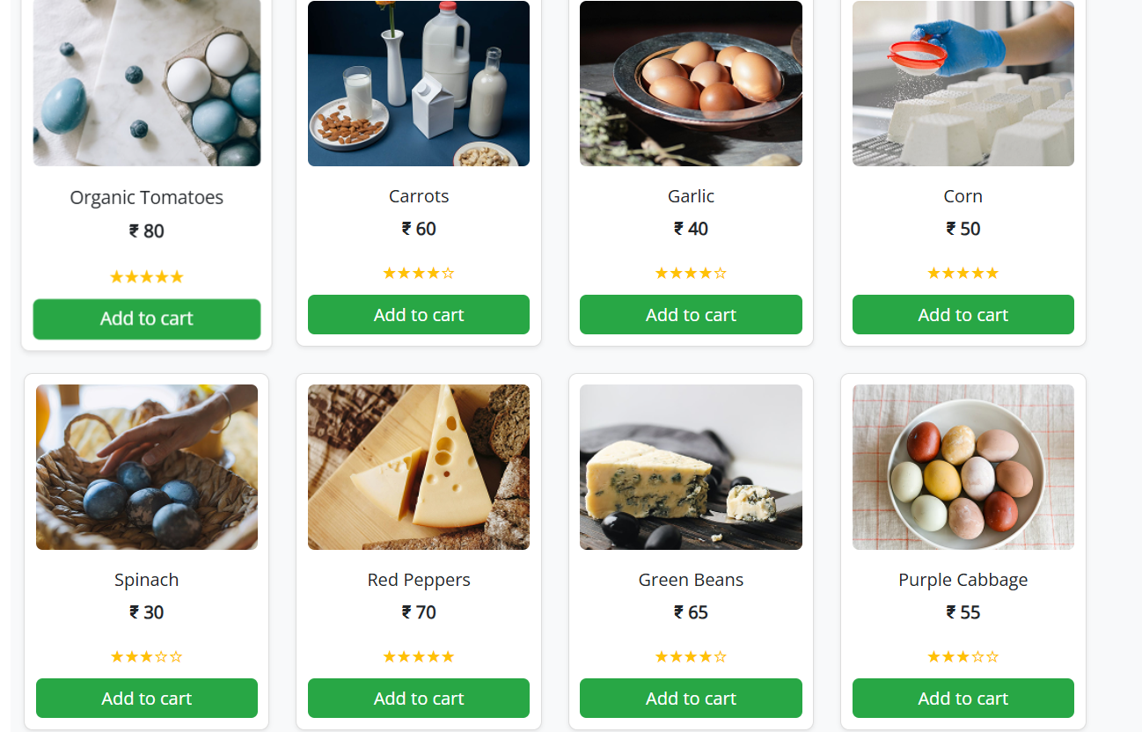

**Pantry and Staples.html:**

**<!DOCTYPE html>**

**<html lang="en">**

**<head>**

**<meta charset="UTF-8" />**

**<meta name="viewport" content="width=device-width, initial-scale=1.0" />**

**<title>Grocery Navbar</title>**

**<!-- Bootstrap CSS -->**

**<link href="https://cdn.jsdelivr.net/npm/bootstrap@5.3.3/dist/css/bootstrap.min.css" rel="stylesheet">**

**<!-- Font Awesome CDN -->**

**<link rel="stylesheet" href="https://cdnjs.cloudflare.com/ajax/libs/font-awesome/6.5.0/css/all.min.css">**

**<!--  Open Sans -->**

**<link href="https://fonts.googleapis.com/css2?family=Open+Sans&display=swap" rel="stylesheet">**

**<!-- Custom CSS -->**

**<link rel="stylesheet" href="headerfooter.css">  <style>**

**body {**

**background-color: #f8f9fa;**

**}**

**.product-card {**

**border: 1px solid #ddd;**

**border-radius: 8px;**

**padding: 10px;**

**text-align: center;**

**transition: transform 0.3s ease;**

**}**

**.product-card:hover {**

**transform: scale(1.03);**

**}**

**.product-img {**

**height: 150px;**

**object-fit: cover;**

**border-radius: 6px;**

**margin-bottom: 10px;**

**}**

**.star-rating {**

**color: #ffc107;**

**}**

**.filter-container {**

**padding: 20px;**

**background-color: white;**

**border-radius: 10px;**

**}**

**.sort-select {**

**max-width: 200px;**

**margin-bottom: 20px;**

**}**

**.green-btn {**

**background-color: #28a745;**

**color: white;**

**border: none;**

**}**

**.green-btn:hover {**

**background-color: #218838;**

**}**

**</style>**

**</head>**

**<body>**

**<!-- header -->**

**<header class="header-section">**

**<!-- Top Green Banner -->**

**<div class="top-banner text-center py-2">**

**<span class="text-white fw-semibold">Fresh & Organic produce from our farmers to your kitchen</span>**

**</div>**

**<!-- Main Container -->**

**<div class="container py-3">**

**<div class="row align-items-center text-center text-lg-start">**

**<!-- Logo Column -->**

**<div class="col-lg-2 mb-3 mb-lg-0 d-flex flex-column align-items-center">**

**<img class="logoimg" src="./assets/images/home/logo.png" />**

**</div>**

**<!-- Search Bar Column -->**

**<div class="col-lg-7 mb-3 mb-lg-0">**

**<form class="d-flex w-100" role="search">**

**<input class="form-control rounded-0 border-end-0" type="search" placeholder="Search for products" aria-label="Search">**

**<button class="btn btn-warning rounded-0 border-start-0" type="submit">**

**<i class="fas fa-search me-1"></i> Search**

**</button>**

**</form>**

**</div>**

**<!-- Empty Column to Align -->**

**<div class="col-lg-3 d-none d-lg-block"></div>**

**</div>**

**<!-- Nav Links Row -->**

**<div class="row mt-3">**

**<div class="col d-flex justify-content-center gap-4 flex-wrap align-items-center">**

**<a href="home.html" class="nav-link fw-semibold">Home</a>**

**<a href="category.html" class="nav-link fw-semibold">Categories</a>**

**<a href="bestsales.html" class="nav-link fw-semibold">Best Sales</a>**

**<a href="blog.html" class="nav-link fw-semibold">Blogs</a>**

**<a href="addtocart.html" class="nav-link">**

**<img class="logoimg" src="./assets/images/home/cart icon.png" />**

**</a>**

**<a href="registernow.html" class="btn btn-success text-white fw-semibold px-3">Register Now</a>**

**</div>**

**</div>**

**</div>**

**</header>**

**<div class="container my-4">**

**<h2 class="text-center text-success mb-4">Pantry Staples</h2>**

**<div class="row mb-3">**

**<div class="col-md-3 filter-container">**

**<label for="priceRange" class="form-label">Sort by Price</label>**

**<input type="range" class="form-range" min="0" max="100" id="priceRange" oninput="filterProducts()" />**

**<p>Below ₹<span id="priceValue">100</span></p>**

**</div>**

**<div class="col-md-9">**

**<div class="d-flex justify-content-end mb-3">**

**<select id="sortOptions" class="form-select sort-select" onchange="sortProducts()">**

**<option value="featured">Sort by: Featured</option>**

**<option value="lowToHigh">Price: Low to High</option>**

**<option value="highToLow">Price: High to Low</option>**

**</select>**

**</div>**

**<div class="row" id="productGrid">**

**<!-- Products will be rendered here -->**

**</div>**

**</div>**

**</div>**

**</div>**

**<!--Footer-->**

**<div class="info-strip">**

**<!-- Left Orange Contact Banner -->**

**<div class="contact-banner">**

**Get in Touch with us**

**<span>+91 91010 90000</span>**

**</div>**

**<!-- Right Features Section -->**

**<div class="features-container">**

**<div class="feature-item">**

**<div class="icon-circle">**

**<img src="./assets/images/home/free shipping icon.png" alt="Free Shipping">**

**</div>**

**<div class="feature-text">**

**<p>Free Shipping</p>**

**<p>For Orders Above 500</p>**

**</div>**

**</div>**

**<div class="feature-item">**

**<div class="icon-circle">**

**<img src="./assets/images/home/fresh produce icon.png" alt="Fresh Produce">**

**</div>**

**<div class="feature-text">**

**<p>Fresh Produce</p>**

**<p>Guaranteed Product Warranty</p>**

**</div>**

**</div>**

**<div class="feature-item">**

**<div class="icon-circle">**

**<img src="./assets/images/home/safety icon.png" alt="Safety">**

**</div>**

**<div class="feature-text">**

**<p>100% Safety & Security</p>**

**<p>Your Data is Highly Secured</p>**

**</div>**

**</div>**

**</div>**

**</div>**

**<footer class="footer">**

**<div class="container">**

**<div class="footer-content row gy-4">**

**<!-- Logo & Description -->**

**<div class="col-md-4 footer-logo">**

**<img src="./assets/images/home/logo.png"  alt="Logo">**

**<p class="description">**

**Fresh groceries, particularly fruits, vegetables,<br>**

**whole grains, and lean proteins, play a crucial<br>**

**role in nourishing our bodies and promoting<br>**

**overall well-being**

**</p>**

**</div>**

**<!-- Navigation -->**

**<div class="col-md-4">**

**<h5>NAVIGATE</h5>**

**<a href="#">Privacy Policy</a>**

**<a href="#">Terms & Conditions</a>**

**<a href="#">How to Order</a>**

**<a href="#">About Us</a>**

**</div>**

**<!-- G-Store Info -->**

**<div class="col-md-4">**

**<h5>G-STORE</h5>**

**<p>Reg: T21542GST548</p>**

**<p>TIN: 14578452884</p>**

**<p>Email: groceries at doorstep@gmail.com</p>**

**</div>**

**</div>**

**<!-- Footer Bottom -->**

**<div class="footer-bottom mt-4">**

**Copyrights 2022© Groceries At Doorstep Ltd**

**</div>**

**</div>**

**</footer>**

**<script>**

**const products = [**

**{ id: 1, name: "Organic Tomatoes", price: 80, image: "./assets/images/pantry/img (1).png", rating: 5 },**

**{ id: 2, name: "Carrots", price: 60, image: "./assets/images/pantry/img (2).png", rating: 4 },**

**{ id: 3, name: "Garlic", price: 40, image: "./assets/images/pantry/img (3).png", rating: 4 },**

**{ id: 4, name: "Corn", price: 50, image: "./assets/images/pantry/img (4).png", rating: 5 },**

**{ id: 5, name: "Spinach", price: 30, image: "./assets/images/pantry/img (5).png", rating: 3 },**

**{ id: 6, name: "Red Peppers", price: 70, image: "./assets/images/pantry/img (6).png", rating: 5 },**

**{ id: 7, name: "Green Beans", price: 65, image: "./assets/images/pantry/img (7).png", rating: 4 },**

**{ id: 8, name: "Purple Cabbage", price: 55, image: "./assets/images/pantry/img (8).png", rating: 3 },**

**];**

**let currentProducts = [...products];**

**function renderProducts(data) {**

**const grid = document.getElementById("productGrid");**

**grid.innerHTML = '';**

**data.forEach(product => {**

**grid.innerHTML += `**

**<div class="col-sm-6 col-md-4 col-lg-3 mb-4">**

**<div class="product-card bg-white shadow-sm">**

**<a href="pantrydes.html" class="text-decoration-none text-dark d-block">**

**<img src="${product.image}" class="product-img w-100" alt="${product.name}">**

**<h6 class="mt-2">${product.name}</h6>**

**<p><strong>₹ ${product.price}</strong></p>**

**<div class="star-rating mb-2">**

**${'★'.repeat(product.rating)}${'☆'.repeat(5 - product.rating)}**

**</div>**

**</a>**

**<a href="addtocart.html" class="btn green-btn w-100">Add to cart</a>**

**</div>**

**</div>**

**`;**

**});**

**}**

**function filterProducts() {**

**const maxPrice = parseInt(document.getElementById("priceRange").value);**

**document.getElementById("priceValue").innerText = maxPrice;**

**const filtered = products.filter(product => product.price <= maxPrice);**

**currentProducts = filtered;**

**renderProducts(currentProducts);**

**}**

**function sortProducts() {**

**const option = document.getElementById("sortOptions").value;**

**let sorted = [...currentProducts];**

**if (option === "lowToHigh") {**

**sorted.sort((a, b) => a.price - b.price);**

**} else if (option === "highToLow") {**

**sorted.sort((a, b) => b.price - a.price);**

**}**

**renderProducts(sorted);**

**}**

**// Initial load**

**renderProducts(products);**

**</script>**

**</body>**

**</html>**

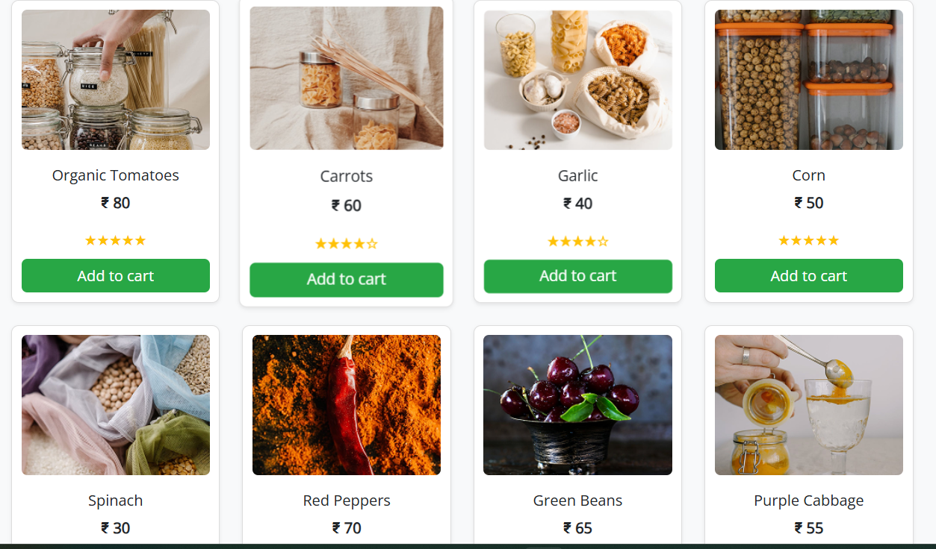

**Meat and seafood.html:**

**<!DOCTYPE html>**

**<html lang="en">**

**<head>**

**<meta charset="UTF-8" />**

**<meta name="viewport" content="width=device-width, initial-scale=1.0" />**

**<title>Grocery Navbar</title>**

**<!-- Bootstrap CSS -->**

**<link href="https://cdn.jsdelivr.net/npm/bootstrap@5.3.3/dist/css/bootstrap.min.css" rel="stylesheet">**

**<!-- Font Awesome CDN -->**

**<link rel="stylesheet" href="https://cdnjs.cloudflare.com/ajax/libs/font-awesome/6.5.0/css/all.min.css">**

**<!--  Open Sans -->**

**<link href="https://fonts.googleapis.com/css2?family=Open+Sans&display=swap" rel="stylesheet">**

**<!-- Custom CSS -->**

**<link rel="stylesheet" href="headerfooter.css">**

**<style>**

**body {**

**background-color: #f8f9fa;**

**}**

**.product-card {**

**border: 1px solid #ddd;**

**border-radius: 8px;**

**padding: 10px;**

**text-align: center;**

**transition: transform 0.3s ease;**

**}**

**.product-card:hover {**

**transform: scale(1.03);**

**}**

**.product-img {**

**height: 150px;**

**object-fit: cover;**

**border-radius: 6px;**

**margin-bottom: 10px;**

**}**

**.star-rating {**

**color: #ffc107;**

**}**

**.filter-container {**

**padding: 20px;**

**background-color: white;**

**border-radius: 10px;**

**}**

**.sort-select {**

**max-width: 200px;**

**margin-bottom: 20px;**

**}**

**.green-btn {**

**background-color: #28a745;**

**color: white;**

**border: none;**

**}**

**.green-btn:hover {**

**background-color: #218838;**

**}**

**</style>**

**</head>**

**<body>**

**<!-- header -->**

**<header class="header-section">**

**<!-- Top Green Banner -->**

**<div class="top-banner text-center py-2">**

**<span class="text-white fw-semibold">Fresh & Organic produce from our farmers to your kitchen</span>**

**</div>**

**<!-- Main Container -->**

**<div class="container py-3">**

**<div class="row align-items-center text-center text-lg-start">**

**<!-- Logo Column -->**

**<div class="col-lg-2 mb-3 mb-lg-0 d-flex flex-column align-items-center">**

**<img class="logoimg" src="./assets/images/home/logo.png" />**

**</div>**

**<!-- Search Bar Column -->**

**<div class="col-lg-7 mb-3 mb-lg-0">**

**<form class="d-flex w-100" role="search">**

**<input class="form-control rounded-0 border-end-0" type="search" placeholder="Search for products" aria-label="Search">**

**<button class="btn btn-warning rounded-0 border-start-0" type="submit">**

**<i class="fas fa-search me-1"></i> Search**

**</button>**

**</form>**

**</div>**

**<!-- Empty Column to Align -->**

**<div class="col-lg-3 d-none d-lg-block"></div>**

**</div>**

**<!-- Nav Links Row -->**

**<div class="row mt-3">**

**<div class="col d-flex justify-content-center gap-4 flex-wrap align-items-center">**

**<a href="home.html" class="nav-link fw-semibold">Home</a>**

**<a href="category.html" class="nav-link fw-semibold">Categories</a>**

**<a href="bestsales.html" class="nav-link fw-semibold">Best Sales</a>**

**<a href="blog.html" class="nav-link fw-semibold">Blogs</a>**

**<a href="addtocart.html" class="nav-link">**

**<img class="logoimg" src="./assets/images/home/cart icon.png" />**

**</a>**

**<a href="registernow.html" class="btn btn-success text-white fw-semibold px-3">Register Now</a>**

**</div>**

**</div>**

**</div>**

**</header>**

**<div class="container my-4">**

**<h2 class="text-center text-success mb-4">Meat & Seafoods</h2>**

**<div class="row mb-3">**

**<div class="col-md-3 filter-container">**

**<label for="priceRange" class="form-label">Sort by Price</label>**

**<input type="range" class="form-range" min="0" max="100" id="priceRange" oninput="filterProducts()" />**

**<p>Below ₹<span id="priceValue">100</span></p>**

**</div>**

**<div class="col-md-9">**

**<div class="d-flex justify-content-end mb-3">**

**<select id="sortOptions" class="form-select sort-select" onchange="sortProducts()">**

**<option value="featured">Sort by: Featured</option>**

**<option value="lowToHigh">Price: Low to High</option>**

**<option value="highToLow">Price: High to Low</option>**

**</select>**

**</div>**

**<div class="row" id="productGrid">**

**<!-- Products will be rendered here -->**

**</div>**

**</div>**

**</div>**

**</div>**

**<!--Footer-->**

**<div class="info-strip">**

**<!-- Left Orange Contact Banner -->**

**<div class="contact-banner">**

**Get in Touch with us**

**<span>+91 91010 90000</span>**

**</div>**

**<!-- Right Features Section -->**

**<div class="features-container">**

**<div class="feature-item">**

**<div class="icon-circle">**

**<img src="./assets/images/home/free shipping icon.png" alt="Free Shipping">**

**</div>**

**<div class="feature-text">**

**<p>Free Shipping</p>**

**<p>For Orders Above 500</p>**

**</div>**

**</div>**

**<div class="feature-item">**

**<div class="icon-circle">**

**<img src="./assets/images/home/fresh produce icon.png" alt="Fresh Produce">**

**</div>**

**<div class="feature-text">**

**<p>Fresh Produce</p>**

**<p>Guaranteed Product Warranty</p>**

**</div>**

**</div>**

**<div class="feature-item">**

**<div class="icon-circle">**

**<img src="./assets/images/home/safety icon.png" alt="Safety">**

**</div>**

**<div class="feature-text">**

**<p>100% Safety & Security</p>**

**<p>Your Data is Highly Secured</p>**

**</div>**

**</div>**

**</div>**

**</div>**

**<footer class="footer">**

**<div class="container">**

**<div class="footer-content row gy-4">**

**<!-- Logo & Description -->**

**<div class="col-md-4 footer-logo">**

**<img src="./assets/images/home/logo.png"  alt="Logo">**

**<p class="description">**

**Fresh groceries, particularly fruits, vegetables,<br>**

**whole grains, and lean proteins, play a crucial<br>**

**role in nourishing our bodies and promoting<br>**

**overall well-being**

**</p>**

**</div>**

**<!-- Navigation -->**

**<div class="col-md-4">**

**<h5>NAVIGATE</h5>**

**<a href="#">Privacy Policy</a>**

**<a href="#">Terms & Conditions</a>**

**<a href="#">How to Order</a>**

**<a href="#">About Us</a>**

**</div>**

**<!-- G-Store Info -->**

**<div class="col-md-4">**

**<h5>G-STORE</h5>**

**<p>Reg: T21542GST548</p>**

**<p>TIN: 14578452884</p>**

**<p>Email: groceries at doorstep@gmail.com</p>**

**</div>**

**</div>**

**<!-- Footer Bottom -->**

**<div class="footer-bottom mt-4">**

**Copyrights 2022© Groceries At Doorstep Ltd**

**</div>**

**</div>**

**</footer>**

**<script>**

**const products = [**

**{ id: 1, name: "Organic Tomatoes", price: 80, image: "./assets/images/meat/img (1).png", rating: 5 },**

**{ id: 2, name: "Carrots", price: 60, image: "./assets/images/meat/img (2).png", rating: 4 },**

**{ id: 3, name: "Garlic", price: 40, image: "./assets/images/meat/img (3).png", rating: 4 },**

**{ id: 4, name: "Corn", price: 50, image: "./assets/images/meat/img (4).png", rating: 5 },**

**{ id: 5, name: "Spinach", price: 30, image: "./assets/images/meat/img (5).png", rating: 3 },**

**{ id: 6, name: "Red Peppers", price: 70, image: "./assets/images/meat/img (6).png", rating: 5 },**

**{ id: 7, name: "Green Beans", price: 65, image: "./assets/images/meat/img (7).png", rating: 4 },**

**{ id: 8, name: "Purple Cabbage", price: 55, image: "./assets/images/meat/img (8).png", rating: 3 },**

**];**

**let currentProducts = [...products];**

**function renderProducts(data) {**

**const grid = document.getElementById("productGrid");**

**grid.innerHTML = '';**

**data.forEach(product => {**

**grid.innerHTML += `**

**<div class="col-sm-6 col-md-4 col-lg-3 mb-4">**

**<div class="product-card bg-white shadow-sm">**

**<a href="meatdes.html" class="text-decoration-none text-dark d-block">**

**<img src="${product.image}" class="product-img w-100" alt="${product.name}">**

**<h6 class="mt-2">${product.name}</h6>**

**<p><strong>₹ ${product.price}</strong></p>**

**<div class="star-rating mb-2">**

**${'★'.repeat(product.rating)}${'☆'.repeat(5 - product.rating)}**

**</div>**

**</a>**

**<a href="addtocart.html" class="btn green-btn w-100">Add to cart</a>**

**</div>**

**</div>**

**`;**

**});**

**}**

**function filterProducts() {**

**const maxPrice = parseInt(document.getElementById("priceRange").value);**

**document.getElementById("priceValue").innerText = maxPrice;**

**const filtered = products.filter(product => product.price <= maxPrice);**

**currentProducts = filtered;**

**renderProducts(currentProducts);**

**}**

**function sortProducts() {**

**const option = document.getElementById("sortOptions").value;**

**let sorted = [...currentProducts];**

**if (option === "lowToHigh") {**

**sorted.sort((a, b) => a.price - b.price);**

**} else if (option === "highToLow") {**

**sorted.sort((a, b) => b.price - a.price);**

**}**

**renderProducts(sorted);**

**}**

**// Initial load**

**renderProducts(products);**

**</script>**

**</body>**

**</html>**

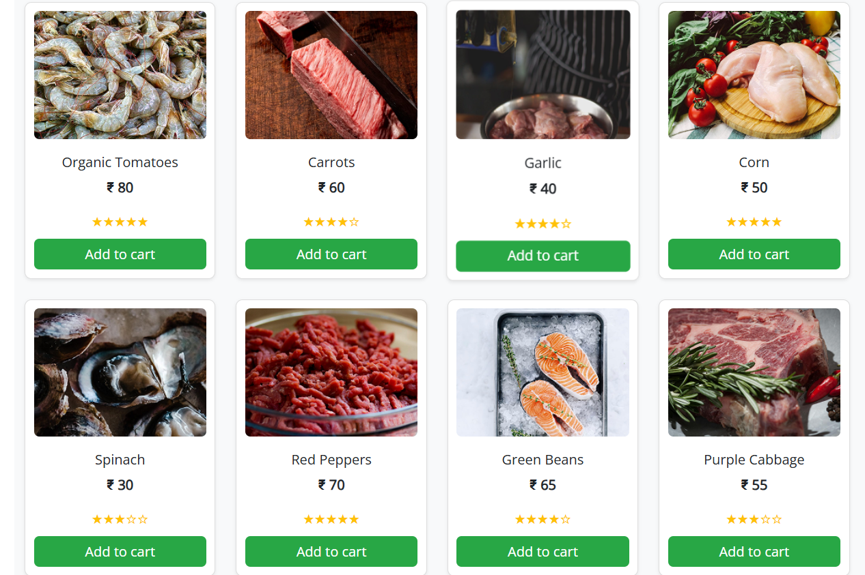

**Frozenfoods.html:**

**<!DOCTYPE html>**

**<html lang="en">**

**<head>**

**<meta charset="UTF-8" />**

**<meta name="viewport" content="width=device-width, initial-scale=1.0" />**

**<title>Grocery Navbar</title>**

**<!-- Bootstrap CSS -->**

**<link href="https://cdn.jsdelivr.net/npm/bootstrap@5.3.3/dist/css/bootstrap.min.css" rel="stylesheet">**

**<!-- Font Awesome CDN -->**

**<link rel="stylesheet" href="https://cdnjs.cloudflare.com/ajax/libs/font-awesome/6.5.0/css/all.min.css">**

**<!--  Open Sans -->**

**<link href="https://fonts.googleapis.com/css2?family=Open+Sans&display=swap" rel="stylesheet">**

**<!-- Custom CSS -->**

**<link rel="stylesheet" href="headerfooter.css">**

**<style>**

**body {**

**background-color: #f8f9fa;**

**}**

**.product-card {**

**border: 1px solid #ddd;**

**border-radius: 8px;**

**padding: 10px;**

**text-align: center;**

**transition: transform 0.3s ease;**

**}**

**.product-card:hover {**

**transform: scale(1.03);**

**}**

**.product-img {**

**height: 150px;**

**object-fit: cover;**

**border-radius: 6px;**

**margin-bottom: 10px;**

**}**

**.star-rating {**

**color: #ffc107;**

**}**

**.filter-container {**

**padding: 20px;**

**background-color: white;**

**border-radius: 10px;**

**}**

**.sort-select {**

**max-width: 200px;**

**margin-bottom: 20px;**

**}**

**.green-btn {**

**background-color: #28a745;**

**color: white;**

**border: none;**

**}**

**.green-btn:hover {**

**background-color: #218838;**

**}**

**</style>**

**</head>**

**<body>**

**<!-- header -->**

**<header class="header-section">**

**<!-- Top Green Banner -->**

**<div class="top-banner text-center py-2">**

**<span class="text-white fw-semibold">Fresh & Organic produce from our farmers to your kitchen</span>**

**</div>**

**<!-- Main Container -->**

**<div class="container py-3">**

**<div class="row align-items-center text-center text-lg-start">**

**<!-- Logo Column -->**

**<div class="col-lg-2 mb-3 mb-lg-0 d-flex flex-column align-items-center">**

**<img class="logoimg" src="./assets/images/home/logo.png" />**

**</div>**

**<!-- Search Bar Column -->**

**<div class="col-lg-7 mb-3 mb-lg-0">**

**<form class="d-flex w-100" role="search">**

**<input class="form-control rounded-0 border-end-0" type="search" placeholder="Search for products" aria-label="Search">**

**<button class="btn btn-warning rounded-0 border-start-0" type="submit">**

**<i class="fas fa-search me-1"></i> Search**

**</button>**

**</form>**

**</div>**

**<!-- Empty Column to Align -->**

**<div class="col-lg-3 d-none d-lg-block"></div>**

**</div>**

**<!-- Nav Links Row -->**

**<div class="row mt-3">**

**<div class="col d-flex justify-content-center gap-4 flex-wrap align-items-center">**

**<a href="home.html" class="nav-link fw-semibold">Home</a>**

**<a href="category.html" class="nav-link fw-semibold">Categories</a>**

**<a href="bestsales.html" class="nav-link fw-semibold">Best Sales</a>**

**<a href="blog.html" class="nav-link fw-semibold">Blogs</a>**

**<a href="addtocart.html" class="nav-link">**

**<img class="logoimg" src="./assets/images/home/cart icon.png" />**

**</a>**

**<a href="registernow.html" class="btn btn-success text-white fw-semibold px-3">Register Now</a>**

**</div>**

**</div>**

**</div>**

**</header>**

**<div class="container my-4">**

**<h2 class="text-center text-success mb-4">Frozen Foods</h2>**

**<div class="row mb-3">**

**<div class="col-md-3 filter-container">**

**<label for="priceRange" class="form-label">Sort by Price</label>**

**<input type="range" class="form-range" min="0" max="100" id="priceRange" oninput="filterProducts()" />**

**<p>Below ₹<span id="priceValue">100</span></p>**

**</div>**

**<div class="col-md-9">**

**<div class="d-flex justify-content-end mb-3">**

**<select id="sortOptions" class="form-select sort-select" onchange="sortProducts()">**

**<option value="featured">Sort by: Featured</option>**

**<option value="lowToHigh">Price: Low to High</option>**

**<option value="highToLow">Price: High to Low</option>**

**</select>**

**</div>**

**<div class="row" id="productGrid">**

**<!-- Products will be rendered here -->**

**</div>**

**</div>**

**</div>**

**</div>**

**<!--Footer-->**

**<div class="info-strip">**

**<!-- Left Orange Contact Banner -->**

**<div class="contact-banner">**

**Get in Touch with us**

**<span>+91 91010 90000</span>**

**</div>**

**<!-- Right Features Section -->**

**<div class="features-container">**

**<div class="feature-item">**

**<div class="icon-circle">**

**<img src="./assets/images/home/free shipping icon.png" alt="Free Shipping">**

**</div>**

**<div class="feature-text">**

**<p>Free Shipping</p>**

**<p>For Orders Above 500</p>**

**</div>**

**</div>**

**<div class="feature-item">**

**<div class="icon-circle">**

**<img src="./assets/images/home/fresh produce icon.png" alt="Fresh Produce">**

**</div>**

**<div class="feature-text">**

**<p>Fresh Produce</p>**

**<p>Guaranteed Product Warranty</p>**

**</div>**

**</div>**

**<div class="feature-item">**

**<div class="icon-circle">**

**<img src="./assets/images/home/safety icon.png" alt="Safety">**

**</div>**

**<div class="feature-text">**

**<p>100% Safety & Security</p>**

**<p>Your Data is Highly Secured</p>**

**</div>**

**</div>**

**</div>**

**</div>**

**<footer class="footer">**

**<div class="container">**

**<div class="footer-content row gy-4">**

**<!-- Logo & Description -->**

**<div class="col-md-4 footer-logo">**

**<img src="./assets/images/home/logo.png"  alt="Logo">**

**<p class="description">**

**Fresh groceries, particularly fruits, vegetables,<br>**

**whole grains, and lean proteins, play a crucial<br>**

**role in nourishing our bodies and promoting<br>**

**overall well-being**

**</p>**

**</div>**

**<!-- Navigation -->**

**<div class="col-md-4">**

**<h5>NAVIGATE</h5>**

**<a href="#">Privacy Policy</a>**

**<a href="#">Terms & Conditions</a>**

**<a href="#">How to Order</a>**

**<a href="#">About Us</a>**

**</div>**

**<!-- G-Store Info -->**

**<div class="col-md-4">**

**<h5>G-STORE</h5>**

**<p>Reg: T21542GST548</p>**

**<p>TIN: 14578452884</p>**

**<p>Email: groceries at doorstep@gmail.com</p>**

**</div>**

**</div>**

**<!-- Footer Bottom -->**

**<div class="footer-bottom mt-4">**

**Copyrights 2022© Groceries At Doorstep Ltd**

**</div>**

**</div>**

**</footer>**

**<script>**

**const products = [**

**{ id: 1, name: "Organic Tomatoes", price: 80, image: "./assets/images/frozen/img (1).png", rating: 5 },**

**{ id: 2, name: "Carrots", price: 60, image: "./assets/images/frozen/img (2).png", rating: 4 },**

**{ id: 3, name: "Garlic", price: 40, image: "./assets/images/frozen/img (3).png", rating: 4 },**

**{ id: 4, name: "Corn", price: 50, image: "./assets/images/frozen/img (4).png", rating: 5 },**

**{ id: 5, name: "Spinach", price: 30, image: "./assets/images/frozen/img (5).png", rating: 3 },**

**{ id: 6, name: "Red Peppers", price: 70, image: "./assets/images/frozen/img (6).png", rating: 5 },**

**{ id: 7, name: "Green Beans", price: 65, image: "./assets/images/frozen/img (7).png", rating: 4 },**

**{ id: 8, name: "Purple Cabbage", price: 55, image: "./assets/images/frozen/img (8).png", rating: 3 },**

**];**

**let currentProducts = [...products];**

**function renderProducts(data) {**

**const grid = document.getElementById("productGrid");**

**grid.innerHTML = '';**

**data.forEach(product => {**

**grid.innerHTML += `**

**<div class="col-sm-6 col-md-4 col-lg-3 mb-4">**

**<div class="product-card bg-white shadow-sm">**

**<a href="frozendes.html" class="text-decoration-none text-dark d-block">**

**<img src="${product.image}" class="product-img w-100" alt="${product.name}">**

**<h6 class="mt-2">${product.name}</h6>**

**<p><strong>₹ ${product.price}</strong></p>**

**<div class="star-rating mb-2">**

**${'★'.repeat(product.rating)}${'☆'.repeat(5 - product.rating)}**

**</div>**

**</a>**

**<a href="addtocart.html" class="btn green-btn w-100">Add to cart</a>**

**</div>**

**</div>**

**`;**

**});**

**}**

**function filterProducts() {**

**const maxPrice = parseInt(document.getElementById("priceRange").value);**

**document.getElementById("priceValue").innerText = maxPrice;**

**const filtered = products.filter(product => product.price <= maxPrice);**

**currentProducts = filtered;**

**renderProducts(currentProducts);**

**}**

**function sortProducts() {**

**const option = document.getElementById("sortOptions").value;**

**let sorted = [...currentProducts];**

**if (option === "lowToHigh") {**

**sorted.sort((a, b) => a.price - b.price);**

**} else if (option === "highToLow") {**

**sorted.sort((a, b) => b.price - a.price);**

**}**

**renderProducts(sorted);**

**}**

**// Initial load**

**renderProducts(products);**

**</script>**

**</body>**

**</html>**

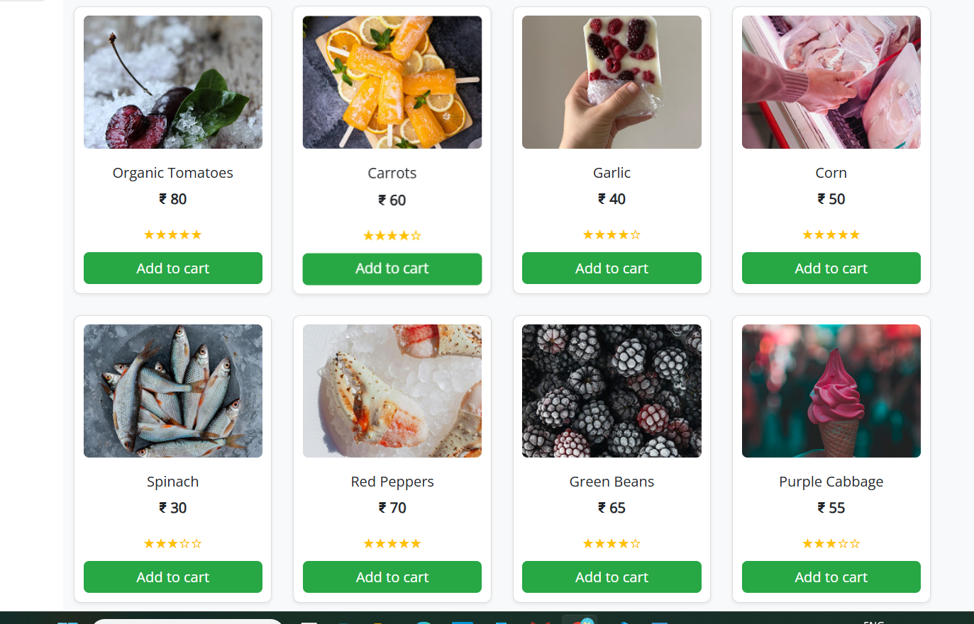

**Snacks.html:**

**<!DOCTYPE html>**

**<html lang="en">**

**<head>**

**<meta charset="UTF-8" />**

**<meta name="viewport" content="width=device-width, initial-scale=1.0" />**

**<title>Grocery Navbar</title>**

**<!-- Bootstrap CSS -->**

**<link href="https://cdn.jsdelivr.net/npm/bootstrap@5.3.3/dist/css/bootstrap.min.css" rel="stylesheet">**

**<!-- Font Awesome CDN -->**

**<link rel="stylesheet" href="https://cdnjs.cloudflare.com/ajax/libs/font-awesome/6.5.0/css/all.min.css">**

**<!--  Open Sans -->**

**<link href="https://fonts.googleapis.com/css2?family=Open+Sans&display=swap" rel="stylesheet">**

**<!-- Custom CSS -->**

**<link rel="stylesheet" href="headerfooter.css">**

**<style>**

**body {**

**background-color: #f8f9fa;**

**}**

**.product-card {**

**border: 1px solid #ddd;**

**border-radius: 8px;**

**padding: 10px;**

**text-align: center;**

**transition: transform 0.3s ease;**

**}**

**.product-card:hover {**

**transform: scale(1.03);**

**}**

**.product-img {**

**height: 150px;**

**object-fit: cover;**

**border-radius: 6px;**

**margin-bottom: 10px;**

**}**

**.star-rating {**

**color: #ffc107;**

**}**

**.filter-container {**

**padding: 20px;**

**background-color: white;**

**border-radius: 10px;**

**}**

**.sort-select {**

**max-width: 200px;**

**margin-bottom: 20px;**

**}**

**.green-btn {**

**background-color: #28a745;**

**color: white;**

**border: none;**

**}**

**.green-btn:hover {**

**background-color: #218838;**

**}**

**</style>**

**</head>**

**<body>**

**<!-- header -->**

**<header class="header-section">**

**<!-- Top Green Banner -->**

**<div class="top-banner text-center py-2">**

**<span class="text-white fw-semibold">Fresh & Organic produce from our farmers to your kitchen</span>**

**</div>**

**<!-- Main Container -->**

**<div class="container py-3">**

**<div class="row align-items-center text-center text-lg-start">**

**<!-- Logo Column -->**

**<div class="col-lg-2 mb-3 mb-lg-0 d-flex flex-column align-items-center">**

**<img class="logoimg" src="./assets/images/home/logo.png" />**

**</div>**

**<!-- Search Bar Column -->**

**<div class="col-lg-7 mb-3 mb-lg-0">**

**<form class="d-flex w-100" role="search">**

**<input class="form-control rounded-0 border-end-0" type="search" placeholder="Search for products" aria-label="Search">**

**<button class="btn btn-warning rounded-0 border-start-0" type="submit">**

**<i class="fas fa-search me-1"></i> Search**

**</button>**

**</form>**

**</div>**

**<!-- Empty Column to Align -->**

**<div class="col-lg-3 d-none d-lg-block"></div>**

**</div>**

**<!-- Nav Links Row -->**

**<div class="row mt-3">**

**<div class="col d-flex justify-content-center gap-4 flex-wrap align-items-center">**

**<a href="home.html" class="nav-link fw-semibold">Home</a>**

**<a href="category.html" class="nav-link fw-semibold">Categories</a>**

**<a href="bestsales.html" class="nav-link fw-semibold">Best Sales</a>**

**<a href="blog.html" class="nav-link fw-semibold">Blogs</a>**

**<a href="addtocart.html" class="nav-link">**

**<img class="logoimg" src="./assets/images/home/cart icon.png" />**

**</a>**

**<a href="registernow.html" class="btn btn-success text-white fw-semibold px-3">Register Now</a>**

**</div>**

**</div>**

**</div>**

**</header>**

**<div class="container my-4">**

**<h2 class="text-center text-success mb-4">Snacks & Beverages</h2>**

**<div class="row mb-3">**

**<div class="col-md-3 filter-container">**

**<label for="priceRange" class="form-label">Sort by Price</label>**

**<input type="range" class="form-range" min="0" max="100" id="priceRange" oninput="filterProducts()" />**

**<p>Below ₹<span id="priceValue">100</span></p>**

**</div>**

**<div class="col-md-9">**

**<div class="d-flex justify-content-end mb-3">**

**<select id="sortOptions" class="form-select sort-select" onchange="sortProducts()">**

**<option value="featured">Sort by: Featured</option>**

**<option value="lowToHigh">Price: Low to High</option>**

**<option value="highToLow">Price: High to Low</option>**

**</select>**

**</div>**

**<div class="row" id="productGrid">**

**<!-- Products will be rendered here -->**

**</div>**

**</div>**

**</div>**

**</div>**

**<!--Footer-->**

**<div class="info-strip">**

**<!-- Left Orange Contact Banner -->**

**<div class="contact-banner">**

**Get in Touch with us**

**<span>+91 91010 90000</span>**

**</div>**

**<!-- Right Features Section -->**

**<div class="features-container">**

**<div class="feature-item">**

**<div class="icon-circle">**

**<img src="./assets/images/home/free shipping icon.png" alt="Free Shipping">**

**</div>**

**<div class="feature-text">**

**<p>Free Shipping</p>**

**<p>For Orders Above 500</p>**

**</div>**

**</div>**

**<div class="feature-item">**

**<div class="icon-circle">**

**<img src="./assets/images/home/fresh produce icon.png" alt="Fresh Produce">**

**</div>**

**<div class="feature-text">**

**<p>Fresh Produce</p>**

**<p>Guaranteed Product Warranty</p>**

**</div>**

**</div>**

**<div class="feature-item">**

**<div class="icon-circle">**

**<img src="./assets/images/home/safety icon.png" alt="Safety">**

**</div>**

**<div class="feature-text">**

**<p>100% Safety & Security</p>**

**<p>Your Data is Highly Secured</p>**

**</div>**

**</div>**

**</div>**

**</div>**

**<footer class="footer">**

**<div class="container">**

**<div class="footer-content row gy-4">**

**<!-- Logo & Description -->**

**<div class="col-md-4 footer-logo">**

**<img src="./assets/images/home/logo.png"  alt="Logo">**

**<p class="description">**

**Fresh groceries, particularly fruits, vegetables,<br>**

**whole grains, and lean proteins, play a crucial<br>**

**role in nourishing our bodies and promoting<br>**

**overall well-being**

**</p>**

**</div>**

**<!-- Navigation -->**

**<div class="col-md-4">**

**<h5>NAVIGATE</h5>**

**<a href="#">Privacy Policy</a>**

**<a href="#">Terms & Conditions</a>**

**<a href="#">How to Order</a>**

**<a href="#">About Us</a>**

**</div>**

**<!-- G-Store Info -->**

**<div class="col-md-4">**

**<h5>G-STORE</h5>**

**<p>Reg: T21542GST548</p>**

**<p>TIN: 14578452884</p>**

**<p>Email: groceries at doorstep@gmail.com</p>**

**</div>**

**</div>**

**<!-- Footer Bottom -->**

**<div class="footer-bottom mt-4">**

**Copyrights 2022© Groceries At Doorstep Ltd**

**</div>**

**</div>**

**</footer>**

**<script>**

**const products = [**

**{ id: 1, name: "Organic Tomatoes", price: 80, image: "./assets/images/snacks/img (1).png", rating: 5 },**

**{ id: 2, name: "Carrots", price: 60, image: "./assets/images/snacks/img (2).png", rating: 4 },**

**{ id: 3, name: "Garlic", price: 40, image: "./assets/images/snacks/img (3).png", rating: 4 },**

**{ id: 4, name: "Corn", price: 50, image: "./assets/images/snacks/img (4).png", rating: 5 },**

**{ id: 5, name: "Spinach", price: 30, image: "./assets/images/snacks/img (5).png", rating: 3 },**

**{ id: 6, name: "Red Peppers", price: 70, image: "./assets/images/snacks/img (6).png", rating: 5 },**

**{ id: 7, name: "Green Beans", price: 65, image: "./assets/images/snacks/img (7).png", rating: 4 },**

**{ id: 8, name: "Purple Cabbage", price: 55, image: "./assets/images/snacks/img (8).png", rating: 3 },**

**];**

**let currentProducts = [...products];**

**function renderProducts(data) {**

**const grid = document.getElementById("productGrid");**

**grid.innerHTML = '';**

**data.forEach(product => {**

**grid.innerHTML += `**

**<div class="col-sm-6 col-md-4 col-lg-3 mb-4">**

**<div class="product-card bg-white shadow-sm">**

**<a href="snacksdes.html" class="text-decoration-none text-dark d-block">**

**<img src="${product.image}" class="product-img w-100" alt="${product.name}">**

**<h6 class="mt-2">${product.name}</h6>**

**<p><strong>₹ ${product.price}</strong></p>**

**<div class="star-rating mb-2">**

**${'★'.repeat(product.rating)}${'☆'.repeat(5 - product.rating)}**

**</div>**

**</a>**

**<a href="addtocart.html" class="btn green-btn w-100">Add to cart</a>**

**</div>**

**</div>**

**`;**

**});**

**}**

**function filterProducts() {**

**const maxPrice = parseInt(document.getElementById("priceRange").value);**

**document.getElementById("priceValue").innerText = maxPrice;**

**const filtered = products.filter(product => product.price <= maxPrice);**

**currentProducts = filtered;**

**renderProducts(currentProducts);**

**}**

**function sortProducts() {**

**const option = document.getElementById("sortOptions").value;**

**let sorted = [...currentProducts];**

**if (option === "lowToHigh") {**

**sorted.sort((a, b) => a.price - b.price);**

**} else if (option === "highToLow") {**

**sorted.sort((a, b) => b.price - a.price);**

**}**

**renderProducts(sorted);**

**}**

**// Initial load**

**renderProducts(products);**

**</script>**

**</body>**

**</html>**

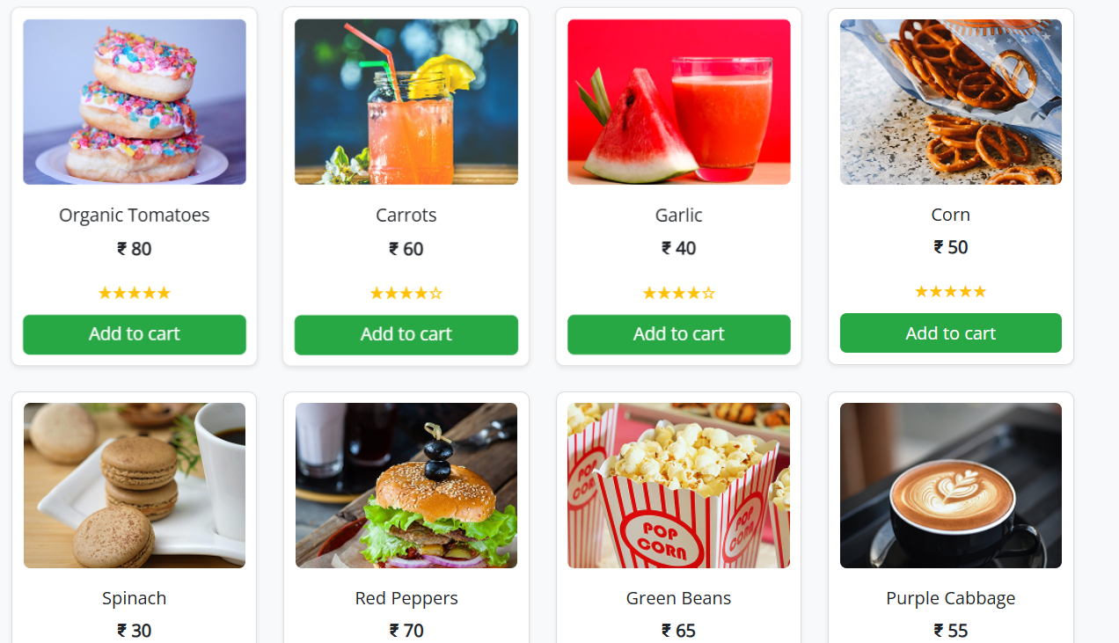

**Bakery.html:**

**<!DOCTYPE html>**

**<html lang="en">**

**<head>**

**<meta charset="UTF-8" />**

**<meta name="viewport" content="width=device-width, initial-scale=1.0" />**

**<title>Grocery Navbar</title>**

**<!-- Bootstrap CSS -->**

**<link href="https://cdn.jsdelivr.net/npm/bootstrap@5.3.3/dist/css/bootstrap.min.css" rel="stylesheet">**

**<!-- Font Awesome CDN -->**

**<link rel="stylesheet" href="https://cdnjs.cloudflare.com/ajax/libs/font-awesome/6.5.0/css/all.min.css">**

**<!--  Open Sans -->**

**<link href="https://fonts.googleapis.com/css2?family=Open+Sans&display=swap" rel="stylesheet">**

**<!-- Custom CSS -->**

**<link rel="stylesheet" href="headerfooter.css">**

**<style>**

**body {**

**background-color: #f8f9fa;**

**}**

**.product-card {**

**border: 1px solid #ddd;**

**border-radius: 8px;**

**padding: 10px;**

**text-align: center;**

**transition: transform 0.3s ease;**

**}**

**.product-card:hover {**

**transform: scale(1.03);**

**}**

**.product-img {**

**height: 150px;**

**object-fit: cover;**

**border-radius: 6px;**

**margin-bottom: 10px;**

**}**

**.star-rating {**

**color: #ffc107;**

**}**

**.filter-container {**

**padding: 20px;**

**background-color: white;**

**border-radius: 10px;**

**}**

**.sort-select {**

**max-width: 200px;**

**margin-bottom: 20px;**

**}**

**.green-btn {**

**background-color: #28a745;**

**color: white;**

**border: none;**

**}**

**.green-btn:hover {**

**background-color: #218838;**

**}**

**</style>**

**</head>**

**<body>**

**<header class="header-section">**

**<!-- Top Green Banner -->**

**<div class="top-banner text-center py-2">**

**<span class="text-white fw-semibold">Fresh & Organic produce from our farmers to your kitchen</span>**

**</div>**

**<!-- Main Container -->**

**<div class="container py-3">**

**<div class="row align-items-center text-center text-lg-start">**

**<!-- Logo Column -->**

**<div class="col-lg-2 mb-3 mb-lg-0 d-flex flex-column align-items-center">**

**<img class="logoimg" src="./assets/images/home/logo.png" />**

**</div>**

**<!-- Search Bar Column -->**

**<div class="col-lg-7 mb-3 mb-lg-0">**

**<form class="d-flex w-100" role="search">**

**<input class="form-control rounded-0 border-end-0" type="search" placeholder="Search for products" aria-label="Search">**

**<button class="btn btn-warning rounded-0 border-start-0" type="submit">**

**<i class="fas fa-search me-1"></i> Search**

**</button>**

**</form>**

**</div>**

**<!-- Empty Column to Align -->**

**<div class="col-lg-3 d-none d-lg-block"></div>**

**</div>**

**<!-- Nav Links Row -->**

**<div class="row mt-3">**

**<div class="col d-flex justify-content-center gap-4 flex-wrap align-items-center">**

**<a href="home.html" class="nav-link fw-semibold">Home</a>**

**<a href="category.html" class="nav-link fw-semibold">Categories</a>**

**<a href="bestsales.html" class="nav-link fw-semibold">Best Sales</a>**

**<a href="blog.html" class="nav-link fw-semibold">Blogs</a>**

**<a href="addtocart.html" class="nav-link">**

**<img class="logoimg" src="./assets/images/home/cart icon.png" />**

**</a>**

**<a href="registernow.html" class="btn btn-success text-white fw-semibold px-3">Register Now</a>**

**</div>**

**</div>**

**</div>**

**</header>**

**<div class="container my-4">**

**<h2 class="text-center text-success mb-4">Vegetables</h2>**

**<div class="row mb-3">**

**<div class="col-md-3 filter-container">**

**<label for="priceRange" class="form-label">Sort by Price</label>**

**<input type="range" class="form-range" min="0" max="100" id="priceRange" oninput="filterProducts()" />**

**<p>Below ₹<span id="priceValue">100</span></p>**

**</div>**

**<div class="col-md-9">**

**<div class="d-flex justify-content-end mb-3">**

**<select id="sortOptions" class="form-select sort-select" onchange="sortProducts()">**

**<option value="featured">Sort by: Featured</option>**

**<option value="lowToHigh">Price: Low to High</option>**

**<option value="highToLow">Price: High to Low</option>**

**</select>**

**</div>**

**<div class="row" id="productGrid">**

**<!-- Products will be rendered here -->**

**</div>**

**</div>**

**</div>**

**</div>**

**<!--Footer-->**

**<div class="info-strip">**

**<!-- Left Orange Contact Banner -->**

**<div class="contact-banner">**

**Get in Touch with us**

**<span>+91 91010 90000</span>**

**</div>**

**<!-- Right Features Section -->**

**<div class="features-container">**

**<div class="feature-item">**

**<div class="icon-circle">**

**<img src="./assets/images/home/free shipping icon.png" alt="Free Shipping">**

**</div>**

**<div class="feature-text">**

**<p>Free Shipping</p>**

**<p>For Orders Above 500</p>**

**</div>**

**</div>**

**<div class="feature-item">**

**<div class="icon-circle">**

**<img src="./assets/images/home/fresh produce icon.png" alt="Fresh Produce">**

**</div>**

**<div class="feature-text">**

**<p>Fresh Produce</p>**

**<p>Guaranteed Product Warranty</p>**

**</div>**

**</div>**

**<div class="feature-item">**

**<div class="icon-circle">**

**<img src="./assets/images/home/safety icon.png" alt="Safety">**

**</div>**

**<div class="feature-text">**

**<p>100% Safety & Security</p>**

**<p>Your Data is Highly Secured</p>**

**</div>**

**</div>**

**</div>**

**</div>**

**<footer class="footer">**

**<div class="container">**

**<div class="footer-content row gy-4">**

**<!-- Logo & Description -->**

**<div class="col-md-4 footer-logo">**

**<img src="./assets/images/home/logo.png"  alt="Logo">**

**<p class="description">**

**Fresh groceries, particularly fruits, vegetables,<br>**

**whole grains, and lean proteins, play a crucial<br>**

**role in nourishing our bodies and promoting<br>**

**overall well-being**

**</p>**

**</div>**

**<!-- Navigation -->**

**<div class="col-md-4">**

**<h5>NAVIGATE</h5>**

**<a href="#">Privacy Policy</a>**

**<a href="#">Terms & Conditions</a>**

**<a href="#">How to Order</a>**

**<a href="#">About Us</a>**

**</div>**

**<!-- G-Store Info -->**

**<div class="col-md-4">**

**<h5>G-STORE</h5>**

**<p>Reg: T21542GST548</p>**

**<p>TIN: 14578452884</p>**

**<p>Email: groceries at doorstep@gmail.com</p>**

**</div>**

**</div>**

**<!-- Footer Bottom -->**

**<div class="footer-bottom mt-4">**

**Copyrights 2022© Groceries At Doorstep Ltd**

**</div>**

**</div>**

**</footer>**

**<script>**

**const products = [**

**{ id: 1, name: "Organic Tomatoes", price: 80, image: "./assets/images/bakery/img (1).png", rating: 5 },**

**{ id: 2, name: "Carrots", price: 60, image: "./assets/images/bakery/img (2).png", rating: 4 },**

**{ id: 3, name: "Garlic", price: 40, image: "./assets/images/bakery/img (3).png", rating: 4 },**

**{ id: 4, name: "Corn", price: 50, image: "./assets/images/bakery/img (4).png", rating: 5 },**

**{ id: 5, name: "Spinach", price: 30, image: "./assets/images/bakery/img (5).png", rating: 3 },**

**{ id: 6, name: "Red Peppers", price: 70, image: "./assets/images/bakery/img (6).png", rating: 5 },**

**{ id: 7, name: "Green Beans", price: 65, image: "./assets/images/bakery/img (7).png", rating: 4 },**

**{ id: 8, name: "Purple Cabbage", price: 55, image: "./assets/images/bakery/img (8).png", rating: 3 },**

**];**

**let currentProducts = [...products];**

**function renderProducts(data) {**

**const grid = document.getElementById("productGrid");**

**grid.innerHTML = '';**

**data.forEach(product => {**

**grid.innerHTML += `**

**<div class="col-sm-6 col-md-4 col-lg-3 mb-4">**

**<div class="product-card bg-white shadow-sm">**

**<a href="bakerydes.html" class="text-decoration-none text-dark d-block">**

**<img src="${product.image}" class="product-img w-100" alt="${product.name}">**

**<h6 class="mt-2">${product.name}</h6>**

**<p><strong>₹ ${product.price}</strong></p>**

**<div class="star-rating mb-2">**

**${'★'.repeat(product.rating)}${'☆'.repeat(5 - product.rating)}**

**</div>**

**</a>**

**<a href="addtocart.html" class="btn green-btn w-100">Add to cart</a>**

**</div>**

**</div>**

**`;**

**});**

**}**

**function filterProducts() {**

**const maxPrice = parseInt(document.getElementById("priceRange").value);**

**document.getElementById("priceValue").innerText = maxPrice;**

**const filtered = products.filter(product => product.price <= maxPrice);**

**currentProducts = filtered;**

**renderProducts(currentProducts);**

**}**

**function sortProducts() {**

**const option = document.getElementById("sortOptions").value;**

**let sorted = [...currentProducts];**

**if (option === "lowToHigh") {**

**sorted.sort((a, b) => a.price - b.price);**

**} else if (option === "highToLow") {**

**sorted.sort((a, b) => b.price - a.price);**

**}**

**renderProducts(sorted);**

**}**

**// Initial load**

**renderProducts(products);**

**</script>**

**</body>**

**</html>**

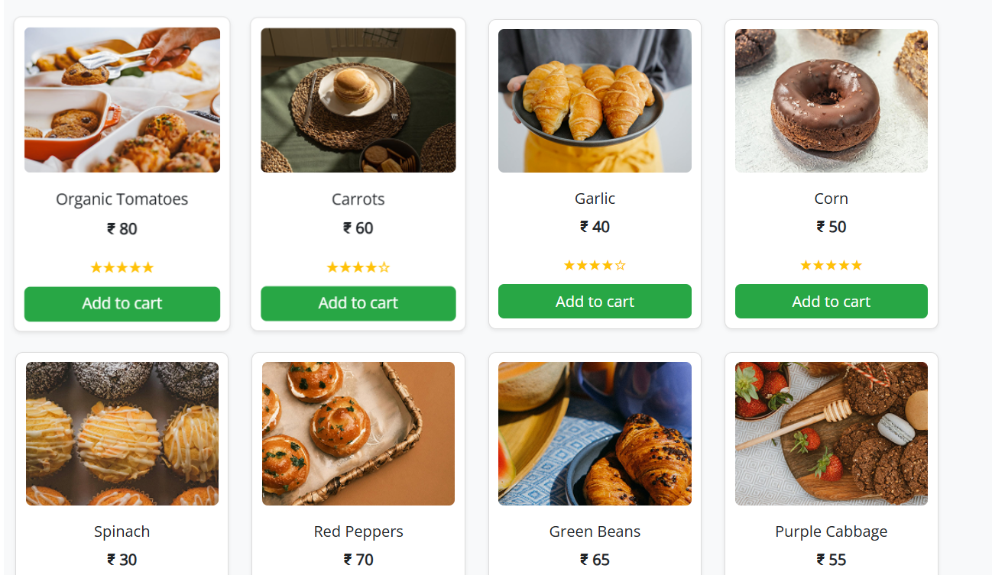

**Fruits description:**

**<!DOCTYPE html>**

**<html lang="en">**

**<head>**

**<meta charset="UTF-8" />**

**<meta name="viewport" content="width=device-width, initial-scale=1.0" />**

**<title>Grocery Navbar</title>**

**<!-- Bootstrap CSS -->**

**<link href="https://cdn.jsdelivr.net/npm/bootstrap@5.3.3/dist/css/bootstrap.min.css" rel="stylesheet">**

**<!-- Font Awesome CDN -->**

**<link rel="stylesheet" href="https://cdnjs.cloudflare.com/ajax/libs/font-awesome/6.5.0/css/all.min.css">**

**<!--  Open Sans -->**

**<link href="https://fonts.googleapis.com/css2?family=Open+Sans&display=swap" rel="stylesheet">**

**<!-- Custom CSS -->**

**<link rel="stylesheet" href="headerfooter.css">**

**<style>**

**body {**

**background-color: #f5f7fa;**

**font-family: 'Open Sans', sans-serif;**

**font-weight: bolder;**

**font-size:larger;**

**padding: 20px;**

**color: #222;**

**}**

**.product-card {**

**background: white;**

**border-radius: 12px;**

**box-shadow: 0 6px 16px rgba(0, 0, 0, 0.1);**

**padding: 20px;**

**margin-bottom: 30px;**

**}**

**.product-image {**

**width: 100%;**

**border-radius: 8px;**

**object-fit: cover;**

**}**

**.thumbnail {**

**cursor: pointer;**

**border: 2px solid transparent;**

**border-radius: 8px;**

**transition: border 0.3s ease, transform 0.3s ease;**

**width: 180px;**

**height: 180px;**

**object-fit: cover;**

**box-shadow: 0 2px 5px rgba(0, 0, 0, 0.1);**

**}**

**.thumbnail.active {**

**border-color: #28a745;**

**transform: scale(1.05);**

**}**

**.quantity-selector {**

**display: flex;**

**align-items: center;**

**gap: 10px;**

**margin-bottom: 15px;**

**}**

**.quantity-selector input {**

**width: 60px;**

**text-align: center;**

**}**

**.add-to-cart {**

**background-color: #28a745;**

**color: white;**

**padding: 12px 20px;**

**font-size: 1rem;**

**border: none;**

**border-radius: 25px;**

**transition: background-color 0.3s ease;**

**}**

**.add-to-cart:hover {**

**background-color: #218838;**

**}**

**.shipping-info {**

**font-size: 0.9rem;**

**color: #555;**

**margin-top: 15px;**

**}**

**.shipping-info i {**

**color: #28a745;**

**margin-right: 8px;**

**}**

**.policy-link {**

**color: #28a745;**

**font-size: 0.9rem;**

**text-decoration: underline;**

**cursor: pointer;**

**}**

**/* Description styles matching your example */**

**.description-section {**

**max-width: 700px;**

**margin-top: 20px;**

**color: #222;**

**}**

**.description-section h5 {**

**font-size: 1rem;**

**font-weight: bold;**

**margin-top: 16px;**

**margin-bottom: 8px;**

**}**

**.description-section ul {**

**padding-left: 1.2rem;**

**margin-bottom: 0;**

**}**

**.description-section ul li {**

**margin-bottom: 8px;**

**}**

**.description-title {**

**font-weight: bold;**

**font-size: 0.95rem;**

**margin-bottom: 12px;**

**text-transform: uppercase;**

**color: #222;**

**border-bottom: 1px solid #aaa;**

**display: inline-block;**

**padding-bottom: 2px;**

**}**

**</style>**

**</head>**

**<body>**

**<!-- header -->**

**<header class="header-section">**

**<!-- Top Green Banner -->**

**<div class="top-banner text-center py-2">**

**<span class="text-white fw-semibold">Fresh & Organic produce from our farmers to your kitchen</span>**

**</div>**

**<!-- Main Container -->**

**<div class="container py-3">**

**<div class="row align-items-center text-center text-lg-start">**

**<!-- Logo Column -->**

**<div class="col-lg-2 mb-3 mb-lg-0 d-flex flex-column align-items-center">**

**<img class="logoimg" src="./assets/images/home/logo.png" />**

**</div>**

**<!-- Search Bar Column -->**

**<div class="col-lg-7 mb-3 mb-lg-0">**

**<form class="d-flex w-100" role="search">**

**<input class="form-control rounded-0 border-end-0" type="search" placeholder="Search for products" aria-label="Search">**

**<button class="btn btn-warning rounded-0 border-start-0" type="submit">**

**<i class="fas fa-search me-1"></i> Search**

**</button>**

**</form>**

**</div>**

**<!-- Empty Column to Align -->**

**<div class="col-lg-3 d-none d-lg-block"></div>**

**</div>**

**<!-- Nav Links Row -->**

**<div class="row mt-3">**

**<div class="col d-flex justify-content-center gap-4 flex-wrap align-items-center">**

**<a href="home.html" class="nav-link fw-semibold">Home</a>**

**<a href="category.html" class="nav-link fw-semibold">Categories</a>**

**<a href="bestsales.html" class="nav-link fw-semibold">Best Sales</a>**

**<a href="blog.html" class="nav-link fw-semibold">Blogs</a>**

**<a href="addtocart.html" class="nav-link">**

**<img class="logoimg" src="./assets/images/home/cart icon.png" />**

**</a>**

**<a href="registernow.html" class="btn btn-success text-white fw-semibold px-3">Register Now</a>**

**</div>**

**</div>**

**</div>**

**</header>**

**<div class="container">**

**<!-- Product Card -->**

**<div class="row product-card">**

**<!-- Left Column -->**

**<div class="col-md-6">**

**<img id="mainImage" src="./assets/images/fruits/fruit des 3.png" class="product-image mb-3" alt="Radish">**

**<!-- Thumbnails -->**

**<div class="d-flex align-items-center mt-3 flex-wrap gap-2">**

**<img src="./assets/images/fruits/fruit des 1.png" class="thumbnail active" alt="Radish Thumbnail">**

**<img src="./assets/images/fruits/fruit des 2.png" class="thumbnail" alt="Radish Thumbnail 2">**

**<img src="./assets/images/fruits/fruit des 3.png" class="thumbnail" alt="Radish Thumbnail 3">**

**</div>**

**</div>**

**<!-- Right Column -->**

**<div class="col-md-6">**

**<h3 class="mb-2">Radish</h3>**

**<p>Each of our products are hand-selected from the local farmers and helps you improve good health</p>**

**<h4 class="text-success mb-3">₹ 120</h4>**

**<p><strong>TAX INCLUDED | SHIPPING CALCULATED AT CHECKOUT</strong></p>**

**<!-- Quantity Selector -->**

**<div class="quantity-selector mb-3">**

**<label for="quantity" class="form-label mb-0">Quantity:</label>**

**<button class="btn btn-outline-secondary btn-sm" id="decreaseQty">-</button>**

**<input type="number" id="quantity" value="1" min="1" />**

**<button class="btn btn-outline-secondary btn-sm" id="increaseQty">+</button>**

**</div>**

**<!-- Size / Weight Selector -->**

**<div class="mb-3">**

**<label class="form-label mb-1">Quantity:</label>**

**<div class="form-check form-check-inline">**

**<input class="form-check-input" type="radio" name="size" id="size250" value="250g" checked>**

**<label class="form-check-label" for="size250">250g</label>**

**</div>**

**<div class="form-check form-check-inline">**

**<input class="form-check-input" type="radio" name="size" id="size500" value="500g">**

**<label class="form-check-label" for="size500">500g</label>**

**</div>**

**<div class="form-check form-check-inline">**

**<input class="form-check-input" type="radio" name="size" id="size1kg" value="1kg">**

**<label class="form-check-label" for="size1kg">1kg</label>**

**</div>**

**</div>**

**<!-- Add to Cart -->**

**<button class="add-to-cart mb-3" id="addToCart">Add to Cart</button>**

**<!-- Shipping Info -->**

**<div class="shipping-info">**

**<p><i class="bi bi-truck"></i> Free shipping on all orders over 450 rupees</p>**

**<p><i class="bi bi-clock"></i> Delivery in 3-4 working days shipping & return</p>**

**<p class="policy-link">See delivery and return policies</p>**

**</div>**

**</div>**

**</div>**

**<!-- Description Section -->**

**<div class="description-section">**

**<div class="description-title">DESCRIPTION</div>**

**<p>**

**Strawberries are often described as sweet, juicy, and bright red berries with a fragrant, fruity aroma.**

**They are typically sold fresh in containers or boxes and are a popular addition to various recipes and snacks.**

**</p>**

**<p>**

**Here’s a more detailed look at how strawberries might be described in a grocery store setting:**

**</p>**

**<h5>Appearance:</h5>**

**<ul>**

**<li>Color: Bright red, with variations depending on the variety.</li>**

**<li>Shape: Typically round or oval, with a smooth surface.</li>**

**<li>Seeds: The seeds are small, whitish or brownish specks that cover the surface of the fruit.</li>**

**<li>Freshness: Shiny, firm, and free from blemishes or mold.</li>**

**</ul>**

**<h5>Taste and Aroma:</h5>**

**<ul>**

**<li>Flavor: Sweet and juicy, with a slightly tart or sour note in some varieties.</li>**

**<li>Aroma: A pleasant, fruity, and fragrant aroma.</li>**

**</ul>**

**<h5>Nutrition:</h5>**

**<ul>**

**<li>Vitamin C: Rich in vitamin C, an important antioxidant.</li>**

**<li>Fiber: A good source of fiber.</li>**

**<li>Other nutrients: Contains other vitamins, minerals, and antioxidants.</li>**

**<li>Low in calories: A healthy and low-calorie fruit.</li>**

**</ul>**

**<h5>Uses:</h5>**

**<ul>**

**<li>Fresh consumption: Enjoyed as a snack or added to salads, desserts, or smoothies.</li>**

**<li>Culinary applications: Used in jams, sauces, desserts, and other dishes.</li>**

**</ul>**

**<h5>Storage:</h5>**

**<ul>**

**<li>Refrigeration: Should be refrigerated to maintain freshness.</li>**

**<li>Humidity: Best stored in the refrigerator at high humidity.</li>**

**</ul>**

**</div>**

**</div>**

**<!--Footer-->**

**<div class="info-strip">**

**<!-- Left Orange Contact Banner -->**

**<div class="contact-banner">**

**Get in Touch with us**

**<span>+91 91010 90000</span>**

**</div>**

**<!-- Right Features Section -->**

**<div class="features-container">**

**<div class="feature-item">**

**<div class="icon-circle">**

**<img src="./assets/images/home/free shipping icon.png" alt="Free Shipping">**

**</div>**

**<div class="feature-text">**

**<p>Free Shipping</p>**

**<p>For Orders Above 500</p>**

**</div>**

**</div>**

**<div class="feature-item">**

**<div class="icon-circle">**

**<img src="./assets/images/home/fresh produce icon.png" alt="Fresh Produce">**

**</div>**

**<div class="feature-text">**

**<p>Fresh Produce</p>**

**<p>Guaranteed Product Warranty</p>**

**</div>**

**</div>**

**<div class="feature-item">**

**<div class="icon-circle">**

**<img src="./assets/images/home/safety icon.png" alt="Safety">**

**</div>**

**<div class="feature-text">**

**<p>100% Safety & Security</p>**

**<p>Your Data is Highly Secured</p>**

**</div>**

**</div>**

**</div>**

**</div>**

**<footer class="footer">**

**<div class="container">**

**<div class="footer-content row gy-4">**

**<!-- Logo & Description -->**

**<div class="col-md-4 footer-logo">**

**<img src="./assets/images/home/logo.png"  alt="Logo">**

**<p class="description">**

**Fresh groceries, particularly fruits, vegetables,<br>**

**whole grains, and lean proteins, play a crucial<br>**

**role in nourishing our bodies and promoting<br>**

**overall well-being**

**</p>**

**</div>**

**<!-- Navigation -->**

**<div class="col-md-4">**

**<h5>NAVIGATE</h5>**

**<a href="#">Privacy Policy</a>**

**<a href="#">Terms & Conditions</a>**

**<a href="#">How to Order</a>**

**<a href="#">About Us</a>**

**</div>**

**<!-- G-Store Info -->**

**<div class="col-md-4">**

**<h5>G-STORE</h5>**

**<p>Reg: T21542GST548</p>**

**<p>TIN: 14578452884</p>**

**<p>Email: groceries at doorstep@gmail.com</p>**

**</div>**

**</div>**

**<!-- Footer Bottom -->**

**<div class="footer-bottom mt-4">**

**Copyrights 2022© Groceries At Doorstep Ltd**

**</div>**

**</div>**

**</footer>**

**<!-- Bootstrap JS -->**

**<script src="https://cdn.jsdelivr.net/npm/bootstrap@5.3.0/dist/js/bootstrap.bundle.min.js"></script>**

**<!-- Icons (Optional, for truck and clock icons) -->**

**<link href="https://cdn.jsdelivr.net/npm/bootstrap-icons@1.10.5/font/bootstrap-icons.css" rel="stylesheet">**

**<!-- Custom JS -->**

**<script>**

**// Quantity Increase/Decrease**

**document.getElementById('increaseQty').addEventListener('click', function() {**

**const qtyInput = document.getElementById('quantity');**

**qtyInput.value = parseInt(qtyInput.value) + 1;**

**});**

**document.getElementById('decreaseQty').addEventListener('click', function() {**

**const qtyInput = document.getElementById('quantity');**

**if (parseInt(qtyInput.value) > 1) {**

**qtyInput.value = parseInt(qtyInput.value) - 1;**

**}**

**});**

**// Add to Cart Button**

**document.getElementById('addToCart').addEventListener('click', function() {**

**const qty = document.getElementById('quantity').value;**

**const size = document.querySelector('input[name="size"]:checked').value;**

**alert(`Added to cart:\nRadish - ${qty} item(s), Size: ${size}`);**

**});**

**// Thumbnail click to change main image**

**const thumbnails = document.querySelectorAll('.thumbnail');**

**const mainImage = document.getElementById('mainImage');**

**thumbnails.forEach(thumbnail => {**

**thumbnail.addEventListener('click', function() {**

**thumbnails.forEach(t => t.classList.remove('active'));**

**this.classList.add('active');**

**mainImage.src = this.src;**

**});**

**});**

**</script>**

**</body>**

**</html>**

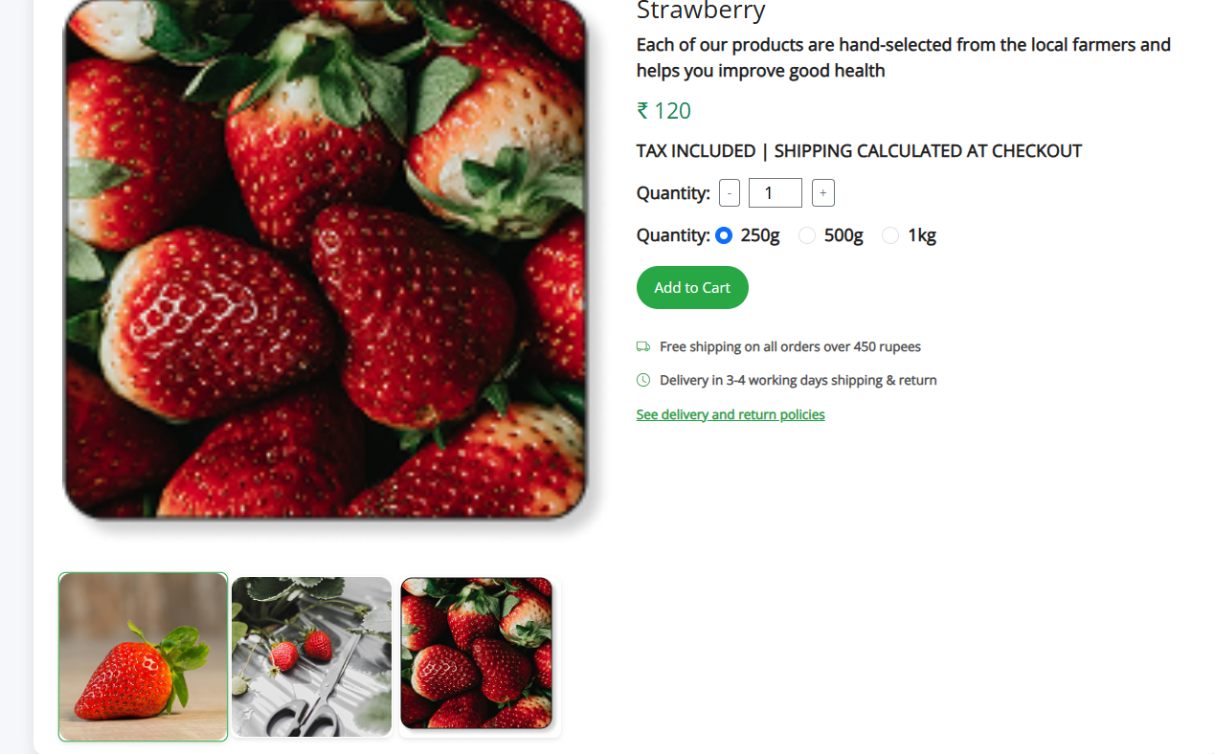

**Radish.html:**

**<!DOCTYPE html>**

**<html lang="en">**

**<head>**

**<meta charset="UTF-8" />**

**<meta name="viewport" content="width=device-width, initial-scale=1.0" />**

**<title>Grocery Navbar</title>**

**<!-- Bootstrap CSS -->**

**<link href="https://cdn.jsdelivr.net/npm/bootstrap@5.3.3/dist/css/bootstrap.min.css" rel="stylesheet">**

**<!-- Font Awesome CDN -->**

**<link rel="stylesheet" href="https://cdnjs.cloudflare.com/ajax/libs/font-awesome/6.5.0/css/all.min.css">**

**<!--  Open Sans -->**

**<link href="https://fonts.googleapis.com/css2?family=Open+Sans&display=swap" rel="stylesheet">**

**<!-- Custom CSS -->**

**<link rel="stylesheet" href="headerfooter.css">**

**<style>**

**body {**

**background-color: #f5f7fa;**

**font-family: 'Open Sans', sans-serif;**

**font-weight: bolder;**

**font-size:larger;**

**padding: 20px;**

**color: #222;**

**}**

**.product-card {**

**background: white;**

**border-radius: 12px;**

**box-shadow: 0 6px 16px rgba(0, 0, 0, 0.1);**

**padding: 20px;**

**margin-bottom: 30px;**

**}**

**.product-image {**

**width: 100%;**

**border-radius: 8px;**

**object-fit: cover;**

**}**

**.thumbnail {**

**cursor: pointer;**

**border: 2px solid transparent;**

**border-radius: 8px;**

**transition: border 0.3s ease, transform 0.3s ease;**

**width: 180px;**

**height: 180px;**

**object-fit: cover;**

**box-shadow: 0 2px 5px rgba(0, 0, 0, 0.1);**

**}**

**.thumbnail.active {**

**border-color: #28a745;**

**transform: scale(1.05);**

**}**

**.quantity-selector {**

**display: flex;**

**align-items: center;**

**gap: 10px;**

**margin-bottom: 15px;**

**}**

**.quantity-selector input {**

**width: 60px;**

**text-align: center;**

**}**

**.add-to-cart {**

**background-color: #28a745;**

**color: white;**

**padding: 12px 20px;**

**font-size: 1rem;**

**border: none;**

**border-radius: 25px;**

**transition: background-color 0.3s ease;**

**}**

**.add-to-cart:hover {**

**background-color: #218838;**

**}**

**.shipping-info {**

**font-size: 0.9rem;**

**color: #555;**

**margin-top: 15px;**

**}**

**.shipping-info i {**

**color: #28a745;**

**margin-right: 8px;**

**}**

**.policy-link {**

**color: #28a745;**

**font-size: 0.9rem;**

**text-decoration: underline;**

**cursor: pointer;**

**}**

**/* Description styles matching your example */**

**.description-section {**

**max-width: 700px;**

**margin-top: 20px;**

**color: #222;**

**}**

**.description-section h5 {**

**font-size: 1rem;**

**font-weight: bold;**

**margin-top: 16px;**

**margin-bottom: 8px;**

**}**

**.description-section ul {**

**padding-left: 1.2rem;**

**margin-bottom: 0;**

**}**

**.description-section ul li {**

**margin-bottom: 8px;**

**}**

**.description-title {**

**font-weight: bold;**

**font-size: 0.95rem;**

**margin-bottom: 12px;**

**text-transform: uppercase;**

**color: #222;**

**border-bottom: 1px solid #aaa;**

**display: inline-block;**

**padding-bottom: 2px;**

**}**

**</style>**

**</head>**

**<body>**

**<!-- header -->**

**<header class="header-section">**

**<!-- Top Green Banner -->**

**<div class="top-banner text-center py-2">**

**<span class="text-white fw-semibold">Fresh & Organic produce from our farmers to your kitchen</span>**

**</div>**

**<!-- Main Container -->**

**<div class="container py-3">**

**<div class="row align-items-center text-center text-lg-start">**

**<!-- Logo Column -->**

**<div class="col-lg-2 mb-3 mb-lg-0 d-flex flex-column align-items-center">**

**<img class="logoimg" src="./assets/images/home/logo.png" />**

**</div>**

**<!-- Search Bar Column -->**

**<div class="col-lg-7 mb-3 mb-lg-0">**

**<form class="d-flex w-100" role="search">**

**<input class="form-control rounded-0 border-end-0" type="search" placeholder="Search for products" aria-label="Search">**

**<button class="btn btn-warning rounded-0 border-start-0" type="submit">**

**<i class="fas fa-search me-1"></i> Search**

**</button>**

**</form>**

**</div>**

**<!-- Empty Column to Align -->**

**<div class="col-lg-3 d-none d-lg-block"></div>**

**</div>**

**<!-- Nav Links Row -->**

**<div class="row mt-3">**

**<div class="col d-flex justify-content-center gap-4 flex-wrap align-items-center">**

**<a href="home.html" class="nav-link fw-semibold">Home</a>**

**<a href="category.html" class="nav-link fw-semibold">Categories</a>**

**<a href="bestsales.html" class="nav-link fw-semibold">Best Sales</a>**

**<a href="blog.html" class="nav-link fw-semibold">Blogs</a>**

**<a href="addtocart.html" class="nav-link">**

**<img class="logoimg" src="./assets/images/home/cart icon.png" />**

**</a>**

**<a href="registernow.html" class="btn btn-success text-white fw-semibold px-3">Register Now</a>**

**</div>**

**</div>**

**</div>**

**</header>**

**<div class="container">**

**<!-- Product Card -->**

**<div class="row product-card">**

**<!-- Left Column -->**

**<div class="col-md-6">**

**<img id="mainImage" src="./assets/images/radish/veg des 3.png" class="product-image mb-3" alt="Radish">**

**<!-- Thumbnails -->**

**<div class="d-flex align-items-center mt-3 flex-wrap gap-2">**

**<img src="./assets/images/vegetables/veg des 3.png" class="thumbnail active" alt="Radish Thumbnail">**

**<img src="./assets/images/vegetables/veg des 2.png" class="thumbnail" alt="Radish Thumbnail 2">**

**<img src="./assets/images/vegetables/veg des 1.png" class="thumbnail" alt="Radish Thumbnail 3">**

**</div>**

**</div>**

**<!-- Right Column -->**

**<div class="col-md-6">**

**<h3 class="mb-2">Radish</h3>**

**<p>Each of our products are hand-selected from the local farmers and helps you improve good health</p>**

**<h4 class="text-success mb-3">₹ 120</h4>**

**<p><strong>TAX INCLUDED | SHIPPING CALCULATED AT CHECKOUT</strong></p>**

**<!-- Quantity Selector -->**

**<div class="quantity-selector mb-3">**

**<label for="quantity" class="form-label mb-0">Quantity:</label>**

**<button class="btn btn-outline-secondary btn-sm" id="decreaseQty">-</button>**

**<input type="number" id="quantity" value="1" min="1" />**

**<button class="btn btn-outline-secondary btn-sm" id="increaseQty">+</button>**

**</div>**

**<!-- Size / Weight Selector -->**

**<div class="mb-3">**

**<label class="form-label mb-1">Quantity:</label>**

**<div class="form-check form-check-inline">**

**<input class="form-check-input" type="radio" name="size" id="size250" value="250g" checked>**

**<label class="form-check-label" for="size250">250g</label>**

**</div>**

**<div class="form-check form-check-inline">**

**<input class="form-check-input" type="radio" name="size" id="size500" value="500g">**

**<label class="form-check-label" for="size500">500g</label>**

**</div>**

**<div class="form-check form-check-inline">**

**<input class="form-check-input" type="radio" name="size" id="size1kg" value="1kg">**

**<label class="form-check-label" for="size1kg">1kg</label>**

**</div>**

**</div>**

**<!-- Add to Cart -->**

**<button class="add-to-cart mb-3" id="addToCart">Add to Cart</button>**

**<!-- Shipping Info -->**

**<div class="shipping-info">**

**<p><i class="bi bi-truck"></i> Free shipping on all orders over 450 rupees</p>**

**<p><i class="bi bi-clock"></i> Delivery in 3-4 working days shipping & return</p>**

**<p class="policy-link">See delivery and return policies</p>**

**</div>**

**</div>**

**</div>**

**<!-- Description Section -->**

**<div class="description-section">**

**<div class="description-title">DESCRIPTION</div>**

**<p>**

**Strawberries are often described as sweet, juicy, and bright red berries with a fragrant, fruity aroma.**

**They are typically sold fresh in containers or boxes and are a popular addition to various recipes and snacks.**

**</p>**

**<p>**

**Here’s a more detailed look at how strawberries might be described in a grocery store setting:**

**</p>**

**<h5>Appearance:</h5>**

**<ul>**

**<li>Color: Bright red, with variations depending on the variety.</li>**

**<li>Shape: Typically round or oval, with a smooth surface.</li>**

**<li>Seeds: The seeds are small, whitish or brownish specks that cover the surface of the fruit.</li>**

**<li>Freshness: Shiny, firm, and free from blemishes or mold.</li>**

**</ul>**

**<h5>Taste and Aroma:</h5>**

**<ul>**

**<li>Flavor: Sweet and juicy, with a slightly tart or sour note in some varieties.</li>**

**<li>Aroma: A pleasant, fruity, and fragrant aroma.</li>**

**</ul>**

**<h5>Nutrition:</h5>**

**<ul>**

**<li>Vitamin C: Rich in vitamin C, an important antioxidant.</li>**

**<li>Fiber: A good source of fiber.</li>**

**<li>Other nutrients: Contains other vitamins, minerals, and antioxidants.</li>**

**<li>Low in calories: A healthy and low-calorie fruit.</li>**

**</ul>**

**<h5>Uses:</h5>**

**<ul>**

**<li>Fresh consumption: Enjoyed as a snack or added to salads, desserts, or smoothies.</li>**

**<li>Culinary applications: Used in jams, sauces, desserts, and other dishes.</li>**

**</ul>**

**<h5>Storage:</h5>**

**<ul>**

**<li>Refrigeration: Should be refrigerated to maintain freshness.</li>**

**<li>Humidity: Best stored in the refrigerator at high humidity.</li>**

**</ul>**

**</div>**

**</div>**

**<!--Footer-->**

**<div class="info-strip">**

**<!-- Left Orange Contact Banner -->**

**<div class="contact-banner">**

**Get in Touch with us**

**<span>+91 91010 90000</span>**

**</div>**

**<!-- Right Features Section -->**

**<div class="features-container">**

**<div class="feature-item">**

**<div class="icon-circle">**

**<img src="./assets/images/home/free shipping icon.png" alt="Free Shipping">**

**</div>**

**<div class="feature-text">**

**<p>Free Shipping</p>**

**<p>For Orders Above 500</p>**

**</div>**

**</div>**

**<div class="feature-item">**

**<div class="icon-circle">**

**<img src="./assets/images/home/fresh produce icon.png" alt="Fresh Produce">**

**</div>**

**<div class="feature-text">**

**<p>Fresh Produce</p>**

**<p>Guaranteed Product Warranty</p>**

**</div>**

**</div>**

**<div class="feature-item">**

**<div class="icon-circle">**

**<img src="./assets/images/home/safety icon.png" alt="Safety">**

**</div>**

**<div class="feature-text">**

**<p>100% Safety & Security</p>**

**<p>Your Data is Highly Secured</p>**

**</div>**

**</div>**

**</div>**

**</div>**

**<footer class="footer">**

**<div class="container">**

**<div class="footer-content row gy-4">**

**<!-- Logo & Description -->**

**<div class="col-md-4 footer-logo">**

**<img src="./assets/images/home/logo.png"  alt="Logo">**

**<p class="description">**

**Fresh groceries, particularly fruits, vegetables,<br>**

**whole grains, and lean proteins, play a crucial<br>**

**role in nourishing our bodies and promoting<br>**

**overall well-being**

**</p>**

**</div>**

**<!-- Navigation -->**

**<div class="col-md-4">**

**<h5>NAVIGATE</h5>**

**<a href="#">Privacy Policy</a>**

**<a href="#">Terms & Conditions</a>**

**<a href="#">How to Order</a>**

**<a href="#">About Us</a>**

**</div>**

**<!-- G-Store Info -->**

**<div class="col-md-4">**

**<h5>G-STORE</h5>**

**<p>Reg: T21542GST548</p>**

**<p>TIN: 14578452884</p>**

**<p>Email: groceries at doorstep@gmail.com</p>**

**</div>**

**</div>**

**<!-- Footer Bottom -->**

**<div class="footer-bottom mt-4">**

**Copyrights 2022© Groceries At Doorstep Ltd**

**</div>**

**</div>**

**</footer>**

**<!-- Bootstrap JS -->**

**<script src="https://cdn.jsdelivr.net/npm/bootstrap@5.3.0/dist/js/bootstrap.bundle.min.js"></script>**

**<!-- Icons (Optional, for truck and clock icons) -->**

**<link href="https://cdn.jsdelivr.net/npm/bootstrap-icons@1.10.5/font/bootstrap-icons.css" rel="stylesheet">**

**<!-- Custom JS -->**

**<script>**

**// Quantity Increase/Decrease**

**document.getElementById('increaseQty').addEventListener('click', function() {**

**const qtyInput = document.getElementById('quantity');**

**qtyInput.value = parseInt(qtyInput.value) + 1;**

**});**

**document.getElementById('decreaseQty').addEventListener('click', function() {**

**const qtyInput = document.getElementById('quantity');**

**if (parseInt(qtyInput.value) > 1) {**

**qtyInput.value = parseInt(qtyInput.value) - 1;**

**}**

**});**

**// Add to Cart Button**

**document.getElementById('addToCart').addEventListener('click', function() {**

**const qty = document.getElementById('quantity').value;**

**const size = document.querySelector('input[name="size"]:checked').value;**

**alert(`Added to cart:\nRadish - ${qty} item(s), Size: ${size}`);**

**});**

**// Thumbnail click to change main image**

**const thumbnails = document.querySelectorAll('.thumbnail');**

**const mainImage = document.getElementById('mainImage');**

**thumbnails.forEach(thumbnail => {**

**thumbnail.addEventListener('click', function() {**

**thumbnails.forEach(t => t.classList.remove('active'));**

**this.classList.add('active');**

**mainImage.src = this.src;**

**});**

**});**

**</script>**

**</body>**

**</html>**

**Bakerydescription.html:**

**<!DOCTYPE html>**

**<html lang="en">**

**<head>**

**<meta charset="UTF-8" />**

**<meta name="viewport" content="width=device-width, initial-scale=1.0" />**

**<title>Grocery Navbar</title>**

**<!-- Bootstrap CSS -->**

**<link href="https://cdn.jsdelivr.net/npm/bootstrap@5.3.3/dist/css/bootstrap.min.css" rel="stylesheet">**

**<!-- Font Awesome CDN -->**

**<link rel="stylesheet" href="https://cdnjs.cloudflare.com/ajax/libs/font-awesome/6.5.0/css/all.min.css">**

**<!-- Custom CSS -->**

**<link rel="stylesheet" href="headerfooter.css">**

**<style>**

**body {**

**background-color: #f5f7fa;**

**font-family: 'Open Sans', sans-serif;**

**font-weight: bolder;**

**font-size:larger;**

**padding: 20px;**

**color: #222;**

**}**

**.product-card {**

**background: white;**

**border-radius: 12px;**

**box-shadow: 0 6px 16px rgba(0, 0, 0, 0.1);**

**padding: 20px;**

**margin-bottom: 30px;**

**}**

**.product-image {**

**width: 100%;**

**border-radius: 8px;**

**object-fit: cover;**

**}**

**.thumbnail {**

**cursor: pointer;**

**border: 2px solid transparent;**

**border-radius: 8px;**

**transition: border 0.3s ease, transform 0.3s ease;**

**width: 180px;**

**height: 180px;**

**object-fit: cover;**

**box-shadow: 0 2px 5px rgba(0, 0, 0, 0.1);**

**}**

**.thumbnail.active {**

**border-color: #28a745;**

**transform: scale(1.05);**

**}**

**.quantity-selector {**

**display: flex;**

**align-items: center;**

**gap: 10px;**

**margin-bottom: 15px;**

**}**

**.quantity-selector input {**

**width: 60px;**

**text-align: center;**

**}**

**.add-to-cart {**

**background-color: #28a745;**

**color: white;**

**padding: 12px 20px;**

**font-size: 1rem;**

**border: none;**

**border-radius: 25px;**

**transition: background-color 0.3s ease;**

**}**

**.add-to-cart:hover {**

**background-color: #218838;**

**}**

**.shipping-info {**

**font-size: 0.9rem;**

**color: #555;**

**margin-top: 15px;**

**}**

**.shipping-info i {**

**color: #28a745;**

**margin-right: 8px;**

**}**

**.policy-link {**

**color: #28a745;**

**font-size: 0.9rem;**

**text-decoration: underline;**

**cursor: pointer;**

**}**

**/* Description styles matching your example */**

**.description-section {**

**max-width: 700px;**

**margin-top: 20px;**

**color: #222;**

**}**

**.description-section h5 {**

**font-size: 1rem;**

**font-weight: bold;**

**margin-top: 16px;**

**margin-bottom: 8px;**

**}**

**.description-section ul {**

**padding-left: 1.2rem;**

**margin-bottom: 0;**

**}**

**.description-section ul li {**

**margin-bottom: 8px;**

**}**

**.description-title {**

**font-weight: bold;**

**font-size: 0.95rem;**

**margin-bottom: 12px;**

**text-transform: uppercase;**

**color: #222;**

**border-bottom: 1px solid #aaa;**

**display: inline-block;**

**padding-bottom: 2px;**

**}**

**</style>**

**</head>**

**<body>**

**<header class="header-section">**

**<!-- Top Green Banner -->**

**<div class="top-banner text-center py-2">**

**<span class="text-white fw-semibold">Fresh & Organic produce from our farmers to your kitchen</span>**

**</div>**

**<!-- Main Container -->**

**<div class="container py-3">**

**<div class="row align-items-center text-center text-lg-start">**

**<!-- Logo Column -->**

**<div class="col-lg-2 mb-3 mb-lg-0 d-flex flex-column align-items-center">**

**<img class="logoimg" src="./assets/images/home/logo.png" />**

**</div>**

**<!-- Search Bar Column -->**

**<div class="col-lg-7 mb-3 mb-lg-0">**

**<form class="d-flex w-100" role="search">**

**<input class="form-control rounded-0 border-end-0" type="search" placeholder="Search for products" aria-label="Search">**

**<button class="btn btn-warning rounded-0 border-start-0" type="submit">**

**<i class="fas fa-search me-1"></i> Search**

**</button>**

**</form>**

**</div>**

**<!-- Empty Column to Align -->**

**<div class="col-lg-3 d-none d-lg-block"></div>**

**</div>**

**<!-- Nav Links Row -->**

**<div class="row mt-3">**

**<div class="col d-flex justify-content-center gap-4 flex-wrap align-items-center">**

**<a href="home.html" class="nav-link fw-semibold">Home</a>**

**<a href="category.html" class="nav-link fw-semibold">Categories</a>**

**<a href="bestsales.html" class="nav-link fw-semibold">Best Sales</a>**

**<a href="blog.html" class="nav-link fw-semibold">Blogs</a>**

**<a href="addtocart.html" class="nav-link">**

**<img class="logoimg" src="./assets/images/home/cart icon.png" />**

**</a>**

**<a href="registernow.html" class="btn btn-success text-white fw-semibold px-3">Register Now</a>**

**</div>**

**</div>**

**</div>**

**</header>**

**<div class="container">**

**<!-- Product Card -->**

**<div class="row product-card">**

**<!-- Left Column -->**

**<div class="col-md-6">**

**<img id="mainImage" src="./assets/images/radish/veg des 3.png" class="product-image mb-3" alt="Radish">**

**<!-- Thumbnails -->**

**<div class="d-flex align-items-center mt-3 flex-wrap gap-2">**

**<img src="./assets/images/vegetables/veg des 3.png" class="thumbnail active" alt="Radish Thumbnail">**

**<img src="./assets/images/vegetables/veg des 2.png" class="thumbnail" alt="Radish Thumbnail 2">**

**<img src="./assets/images/vegetables/veg des 1.png" class="thumbnail" alt="Radish Thumbnail 3">**

**</div>**

**</div>**

**<!-- Right Column -->**

**<div class="col-md-6">**

**<h3 class="mb-2">Radish</h3>**

**<p>Each of our products are hand-selected from the local farmers and helps you improve good health</p>**

**<h4 class="text-success mb-3">₹ 120</h4>**

**<p><strong>TAX INCLUDED | SHIPPING CALCULATED AT CHECKOUT</strong></p>**

**<!-- Quantity Selector -->**

**<div class="quantity-selector mb-3">**

**<label for="quantity" class="form-label mb-0">Quantity:</label>**

**<button class="btn btn-outline-secondary btn-sm" id="decreaseQty">-</button>**

**<input type="number" id="quantity" value="1" min="1" />**

**<button class="btn btn-outline-secondary btn-sm" id="increaseQty">+</button>**

**</div>**

**<!-- Size / Weight Selector -->**

**<div class="mb-3">**

**<label class="form-label mb-1">Quantity:</label>**

**<div class="form-check form-check-inline">**

**<input class="form-check-input" type="radio" name="size" id="size250" value="250g" checked>**

**<label class="form-check-label" for="size250">250g</label>**

**</div>**

**<div class="form-check form-check-inline">**

**<input class="form-check-input" type="radio" name="size" id="size500" value="500g">**

**<label class="form-check-label" for="size500">500g</label>**

**</div>**

**<div class="form-check form-check-inline">**

**<input class="form-check-input" type="radio" name="size" id="size1kg" value="1kg">**

**<label class="form-check-label" for="size1kg">1kg</label>**

**</div>**

**</div>**

**<!-- Add to Cart -->**

**<button class="add-to-cart mb-3" id="addToCart">Add to Cart</button>**

**<!-- Shipping Info -->**

**<div class="shipping-info">**

**<p><i class="bi bi-truck"></i> Free shipping on all orders over 450 rupees</p>**

**<p><i class="bi bi-clock"></i> Delivery in 3-4 working days shipping & return</p>**

**<p class="policy-link">See delivery and return policies</p>**

**</div>**

**</div>**

**</div>**

**<!-- Description Section -->**

**<div class="description-section">**

**<div class="description-title">DESCRIPTION</div>**

**<p>**

**Strawberries are often described as sweet, juicy, and bright red berries with a fragrant, fruity aroma.**

**They are typically sold fresh in containers or boxes and are a popular addition to various recipes and snacks.**

**</p>**

**<p>**

**Here’s a more detailed look at how strawberries might be described in a grocery store setting:**

**</p>**

**<h5>Appearance:</h5>**

**<ul>**

**<li>Color: Bright red, with variations depending on the variety.</li>**

**<li>Shape: Typically round or oval, with a smooth surface.</li>**

**<li>Seeds: The seeds are small, whitish or brownish specks that cover the surface of the fruit.</li>**

**<li>Freshness: Shiny, firm, and free from blemishes or mold.</li>**

**</ul>**

**<h5>Taste and Aroma:</h5>**

**<ul>**

**<li>Flavor: Sweet and juicy, with a slightly tart or sour note in some varieties.</li>**

**<li>Aroma: A pleasant, fruity, and fragrant aroma.</li>**

**</ul>**

**<h5>Nutrition:</h5>**

**<ul>**

**<li>Vitamin C: Rich in vitamin C, an important antioxidant.</li>**

**<li>Fiber: A good source of fiber.</li>**

**<li>Other nutrients: Contains other vitamins, minerals, and antioxidants.</li>**

**<li>Low in calories: A healthy and low-calorie fruit.</li>**

**</ul>**

**<h5>Uses:</h5>**

**<ul>**

**<li>Fresh consumption: Enjoyed as a snack or added to salads, desserts, or smoothies.</li>**

**<li>Culinary applications: Used in jams, sauces, desserts, and other dishes.</li>**

**</ul>**

**<h5>Storage:</h5>**

**<ul>**

**<li>Refrigeration: Should be refrigerated to maintain freshness.</li>**

**<li>Humidity: Best stored in the refrigerator at high humidity.</li>**

**</ul>**

**</div>**

**</div>**

**<!--Footer-->**

**<div class="info-strip">**

**<!-- Left Orange Contact Banner -->**

**<div class="contact-banner">**

**Get in Touch with us**

**<span>+91 91010 90000</span>**

**</div>**

**<!-- Right Features Section -->**

**<div class="features-container">**

**<div class="feature-item">**

**<div class="icon-circle">**

**<img src="./assets/images/home/free shipping icon.png" alt="Free Shipping">**

**</div>**

**<div class="feature-text">**

**<p>Free Shipping</p>**

**<p>For Orders Above 500</p>**

**</div>**

**</div>**

**<div class="feature-item">**

**<div class="icon-circle">**

**<img src="./assets/images/home/fresh produce icon.png" alt="Fresh Produce">**

**</div>**

**<div class="feature-text">**

**<p>Fresh Produce</p>**

**<p>Guaranteed Product Warranty</p>**

**</div>**

**</div>**

**<div class="feature-item">**

**<div class="icon-circle">**

**<img src="./assets/images/home/safety icon.png" alt="Safety">**

**</div>**

**<div class="feature-text">**

**<p>100% Safety & Security</p>**

**<p>Your Data is Highly Secured</p>**

**</div>**

**</div>**

**</div>**

**</div>**

**<footer class="footer">**

**<div class="container">**

**<div class="footer-content row gy-4">**

**<!-- Logo & Description -->**

**<div class="col-md-4 footer-logo">**

**<img src="./assets/images/home/logo.png"  alt="Logo">**

**<p class="description">**

**Fresh groceries, particularly fruits, vegetables,<br>**

**whole grains, and lean proteins, play a crucial<br>**

**role in nourishing our bodies and promoting<br>**

**overall well-being**

**</p>**

**</div>**

**<!-- Navigation -->**

**<div class="col-md-4">**

**<h5>NAVIGATE</h5>**

**<a href="#">Privacy Policy</a>**

**<a href="#">Terms & Conditions</a>**

**<a href="#">How to Order</a>**

**<a href="#">About Us</a>**

**</div>**

**<!-- G-Store Info -->**

**<div class="col-md-4">**

**<h5>G-STORE</h5>**

**<p>Reg: T21542GST548</p>**

**<p>TIN: 14578452884</p>**

**<p>Email: groceries at doorstep@gmail.com</p>**

**</div>**

**</div>**

**<!-- Footer Bottom -->**

**<div class="footer-bottom mt-4">**

**Copyrights 2022© Groceries At Doorstep Ltd**

**</div>**

**</div>**

**</footer>**

**<!-- Bootstrap JS -->**

**<script src="https://cdn.jsdelivr.net/npm/bootstrap@5.3.0/dist/js/bootstrap.bundle.min.js"></script>**

**<!-- Icons (Optional, for truck and clock icons) -->**

**<link href="https://cdn.jsdelivr.net/npm/bootstrap-icons@1.10.5/font/bootstrap-icons.css" rel="stylesheet">**

**<!-- Custom JS -->**

**<script>**

**// Quantity Increase/Decrease**

**document.getElementById('increaseQty').addEventListener('click', function() {**

**const qtyInput = document.getElementById('quantity');**

**qtyInput.value = parseInt(qtyInput.value) + 1;**

**});**

**document.getElementById('decreaseQty').addEventListener('click', function() {**

**const qtyInput = document.getElementById('quantity');**

**if (parseInt(qtyInput.value) > 1) {**

**qtyInput.value = parseInt(qtyInput.value) - 1;**

**}**

**});**

**// Add to Cart Button**

**document.getElementById('addToCart').addEventListener('click', function() {**

**const qty = document.getElementById('quantity').value;**

**const size = document.querySelector('input[name="size"]:checked').value;**

**alert(`Added to cart:\nRadish - ${qty} item(s), Size: ${size}`);**

**});**

**// Thumbnail click to change main image**

**const thumbnails = document.querySelectorAll('.thumbnail');**

**const mainImage = document.getElementById('mainImage');**

**thumbnails.forEach(thumbnail => {**

**thumbnail.addEventListener('click', function() {**

**thumbnails.forEach(t => t.classList.remove('active'));**

**this.classList.add('active');**

**mainImage.src = this.src;**

**});**

**});**

**</script>**

**</body>**

**</html>**

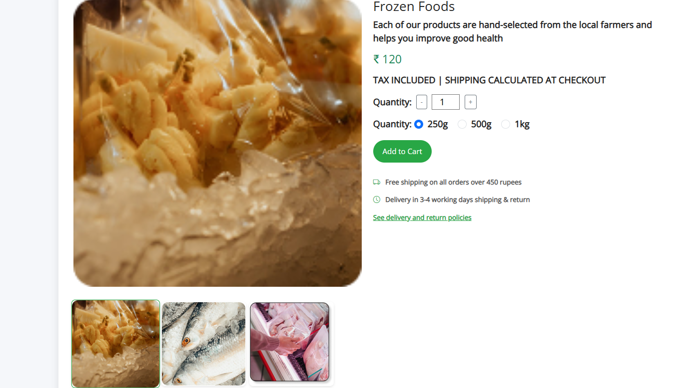

**Dairy and Eggs:**

**<!DOCTYPE html>**

**<html lang="en">**

**<head>**

**<meta charset="UTF-8" />**

**<meta name="viewport" content="width=device-width, initial-scale=1.0" />**

**<title>Grocery Navbar</title>**

**<!-- Bootstrap CSS -->**

**<link href="https://cdn.jsdelivr.net/npm/bootstrap@5.3.3/dist/css/bootstrap.min.css" rel="stylesheet">**

**<!-- Font Awesome CDN -->**

**<link rel="stylesheet" href="https://cdnjs.cloudflare.com/ajax/libs/font-awesome/6.5.0/css/all.min.css">**

**<!--  Open Sans -->**

**<link href="https://fonts.googleapis.com/css2?family=Open+Sans&display=swap" rel="stylesheet">**

**<!-- Custom CSS -->**

**<link rel="stylesheet" href="headerfooter.css">**

**<style>**

**body {**

**background-color: #f5f7fa;**

**font-family: 'Open Sans', sans-serif;**

**font-weight: bolder;**

**font-size:larger;**

**padding: 20px;**

**color: #222;**

**}**

**.product-card {**

**background: white;**

**border-radius: 12px;**

**box-shadow: 0 6px 16px rgba(0, 0, 0, 0.1);**

**padding: 20px;**

**margin-bottom: 30px;**

**}**

**.product-image {**

**width: 100%;**

**border-radius: 8px;**

**object-fit: cover;**

**}**

**.thumbnail {**

**cursor: pointer;**

**border: 2px solid transparent;**

**border-radius: 8px;**

**transition: border 0.3s ease, transform 0.3s ease;**

**width: 180px;**

**height: 180px;**

**object-fit: cover;**

**box-shadow: 0 2px 5px rgba(0, 0, 0, 0.1);**

**}**

**.thumbnail.active {**

**border-color: #28a745;**

**transform: scale(1.05);**

**}**

**.quantity-selector {**

**display: flex;**

**align-items: center;**

**gap: 10px;**

**margin-bottom: 15px;**

**}**

**.quantity-selector input {**

**width: 60px;**

**text-align: center;**

**}**

**.add-to-cart {**

**background-color: #28a745;**

**color: white;**

**padding: 12px 20px;**

**font-size: 1rem;**

**border: none;**

**border-radius: 25px;**

**transition: background-color 0.3s ease;**

**}**

**.add-to-cart:hover {**

**background-color: #218838;**

**}**

**.shipping-info {**

**font-size: 0.9rem;**

**color: #555;**

**margin-top: 15px;**

**}**

**.shipping-info i {**

**color: #28a745;**

**margin-right: 8px;**

**}**

**.policy-link {**

**color: #28a745;**

**font-size: 0.9rem;**

**text-decoration: underline;**

**cursor: pointer;**

**}**

**/* Description styles matching your example */**

**.description-section {**

**max-width: 700px;**

**margin-top: 20px;**

**color: #222;**

**}**

**.description-section h5 {**

**font-size: 1rem;**

**font-weight: bold;**

**margin-top: 16px;**

**margin-bottom: 8px;**

**}**

**.description-section ul {**

**padding-left: 1.2rem;**

**margin-bottom: 0;**

**}**

**.description-section ul li {**

**margin-bottom: 8px;**

**}**

**.description-title {**

**font-weight: bold;**

**font-size: 0.95rem;**

**margin-bottom: 12px;**

**text-transform: uppercase;**

**color: #222;**

**border-bottom: 1px solid #aaa;**

**display: inline-block;**

**padding-bottom: 2px;**

**}**

**</style>**

**</head>**

**<body>**

**<!-- header -->**

**<header class="header-section">**

**<!-- Top Green Banner -->**

**<div class="top-banner text-center py-2">**

**<span class="text-white fw-semibold">Fresh & Organic produce from our farmers to your kitchen</span>**

**</div>**

**<!-- Main Container -->**

**<div class="container py-3">**

**<div class="row align-items-center text-center text-lg-start">**

**<!-- Logo Column -->**

**<div class="col-lg-2 mb-3 mb-lg-0 d-flex flex-column align-items-center">**

**<img class="logoimg" src="./assets/images/home/logo.png" />**

**</div>**

**<!-- Search Bar Column -->**

**<div class="col-lg-7 mb-3 mb-lg-0">**

**<form class="d-flex w-100" role="search">**

**<input class="form-control rounded-0 border-end-0" type="search" placeholder="Search for products" aria-label="Search">**

**<button class="btn btn-warning rounded-0 border-start-0" type="submit">**

**<i class="fas fa-search me-1"></i> Search**

**</button>**

**</form>**

**</div>**

**<!-- Empty Column to Align -->**

**<div class="col-lg-3 d-none d-lg-block"></div>**

**</div>**

**<!-- Nav Links Row -->**

**<div class="row mt-3">**

**<div class="col d-flex justify-content-center gap-4 flex-wrap align-items-center">**

**<a href="home.html" class="nav-link fw-semibold">Home</a>**

**<a href="category.html" class="nav-link fw-semibold">Categories</a>**

**<a href="bestsales.html" class="nav-link fw-semibold">Best Sales</a>**

**<a href="blog.html" class="nav-link fw-semibold">Blogs</a>**

**<a href="addtocart.html" class="nav-link">**

**<img class="logoimg" src="./assets/images/home/cart icon.png" />**

**</a>**

**<a href="registernow.html" class="btn btn-success text-white fw-semibold px-3">Register Now</a>**

**</div>**

**</div>**

**</div>**

**</header>**

**<div class="container">**

**<!-- Product Card -->**

**<div class="row product-card">**

**<!-- Left Column -->**

**<div class="col-md-6">**

**<img id="mainImage" src="./assets/images/dairy/dairy des 1.png" class="product-image mb-3" alt="Radish">**

**<!-- Thumbnails -->**

**<div class="d-flex align-items-center mt-3 flex-wrap gap-2">**

**<img src="./assets/images/dairy/dairy des 1.png" class="thumbnail active" alt="Radish Thumbnail">**

**<img src="./assets/images/dairy/dairy des 2.png" class="thumbnail" alt="Radish Thumbnail 2">**

**<img src="./assets/images/dairy/dairy des 3.png" class="thumbnail" alt="Radish Thumbnail 3">**

**</div>**

**</div>**

**<!-- Right Column -->**

**<div class="col-md-6">**

**<h3 class="mb-2">Dairy and eggs</h3>**

**<p>Each of our products are hand-selected from the local farmers and helps you improve good health</p>**

**<h4 class="text-success mb-3">₹ 120</h4>**

**<p><strong>TAX INCLUDED | SHIPPING CALCULATED AT CHECKOUT</strong></p>**

**<!-- Quantity Selector -->**

**<div class="quantity-selector mb-3">**

**<label for="quantity" class="form-label mb-0">Quantity:</label>**

**<button class="btn btn-outline-secondary btn-sm" id="decreaseQty">-</button>**

**<input type="number" id="quantity" value="1" min="1" />**

**<button class="btn btn-outline-secondary btn-sm" id="increaseQty">+</button>**

**</div>**

**<!-- Size / Weight Selector -->**

**<div class="mb-3">**

**<label class="form-label mb-1">Quantity:</label>**

**<div class="form-check form-check-inline">**

**<input class="form-check-input" type="radio" name="size" id="size250" value="250g" checked>**

**<label class="form-check-label" for="size250">250g</label>**

**</div>**

**<div class="form-check form-check-inline">**

**<input class="form-check-input" type="radio" name="size" id="size500" value="500g">**

**<label class="form-check-label" for="size500">500g</label>**

**</div>**

**<div class="form-check form-check-inline">**

**<input class="form-check-input" type="radio" name="size" id="size1kg" value="1kg">**

**<label class="form-check-label" for="size1kg">1kg</label>**

**</div>**

**</div>**

**<!-- Add to Cart -->**

**<button class="add-to-cart mb-3" id="addToCart">Add to Cart</button>**

**<!-- Shipping Info -->**

**<div class="shipping-info">**

**<p><i class="bi bi-truck"></i> Free shipping on all orders over 450 rupees</p>**

**<p><i class="bi bi-clock"></i> Delivery in 3-4 working days shipping & return</p>**

**<p class="policy-link">See delivery and return policies</p>**

**</div>**

**</div>**

**</div>**

**<!-- Description Section -->**

**<div class="description-section">**

**<div class="description-title">DESCRIPTION</div>**

**<p>**

**Strawberries are often described as sweet, juicy, and bright red berries with a fragrant, fruity aroma.**

**They are typically sold fresh in containers or boxes and are a popular addition to various recipes and snacks.**

**</p>**

**<p>**

**Here’s a more detailed look at how strawberries might be described in a grocery store setting:**

**</p>**

**<h5>Appearance:</h5>**

**<ul>**

**<li>Color: Bright red, with variations depending on the variety.</li>**

**<li>Shape: Typically round or oval, with a smooth surface.</li>**

**<li>Seeds: The seeds are small, whitish or brownish specks that cover the surface of the fruit.</li>**

**<li>Freshness: Shiny, firm, and free from blemishes or mold.</li>**

**</ul>**

**<h5>Taste and Aroma:</h5>**

**<ul>**

**<li>Flavor: Sweet and juicy, with a slightly tart or sour note in some varieties.</li>**

**<li>Aroma: A pleasant, fruity, and fragrant aroma.</li>**

**</ul>**

**<h5>Nutrition:</h5>**

**<ul>**

**<li>Vitamin C: Rich in vitamin C, an important antioxidant.</li>**

**<li>Fiber: A good source of fiber.</li>**

**<li>Other nutrients: Contains other vitamins, minerals, and antioxidants.</li>**

**<li>Low in calories: A healthy and low-calorie fruit.</li>**

**</ul>**

**<h5>Uses:</h5>**

**<ul>**

**<li>Fresh consumption: Enjoyed as a snack or added to salads, desserts, or smoothies.</li>**

**<li>Culinary applications: Used in jams, sauces, desserts, and other dishes.</li>**

**</ul>**

**<h5>Storage:</h5>**

**<ul>**

**<li>Refrigeration: Should be refrigerated to maintain freshness.</li>**

**<li>Humidity: Best stored in the refrigerator at high humidity.</li>**

**</ul>**

**</div>**

**</div>**

**<!--Footer-->**

**<div class="info-strip">**

**<!-- Left Orange Contact Banner -->**

**<div class="contact-banner">**

**Get in Touch with us**

**<span>+91 91010 90000</span>**

**</div>**

**<!-- Right Features Section -->**

**<div class="features-container">**

**<div class="feature-item">**

**<div class="icon-circle">**

**<img src="./assets/images/home/free shipping icon.png" alt="Free Shipping">**

**</div>**

**<div class="feature-text">**

**<p>Free Shipping</p>**

**<p>For Orders Above 500</p>**

**</div>**

**</div>**

**<div class="feature-item">**

**<div class="icon-circle">**

**<img src="./assets/images/home/fresh produce icon.png" alt="Fresh Produce">**

**</div>**

**<div class="feature-text">**

**<p>Fresh Produce</p>**

**<p>Guaranteed Product Warranty</p>**

**</div>**

**</div>**

**<div class="feature-item">**

**<div class="icon-circle">**

**<img src="./assets/images/home/safety icon.png" alt="Safety">**

**</div>**

**<div class="feature-text">**

**<p>100% Safety & Security</p>**

**<p>Your Data is Highly Secured</p>**

**</div>**

**</div>**

**</div>**

**</div>**

**<footer class="footer">**

**<div class="container">**

**<div class="footer-content row gy-4">**

**<!-- Logo & Description -->**

**<div class="col-md-4 footer-logo">**

**<img src="./assets/images/home/logo.png"  alt="Logo">**

**<p class="description">**

**Fresh groceries, particularly fruits, vegetables,<br>**

**whole grains, and lean proteins, play a crucial<br>**

**role in nourishing our bodies and promoting<br>**

**overall well-being**

**</p>**

**</div>**

**<!-- Navigation -->**

**<div class="col-md-4">**

**<h5>NAVIGATE</h5>**

**<a href="#">Privacy Policy</a>**

**<a href="#">Terms & Conditions</a>**

**<a href="#">How to Order</a>**

**<a href="#">About Us</a>**

**</div>**

**<!-- G-Store Info -->**

**<div class="col-md-4">**

**<h5>G-STORE</h5>**

**<p>Reg: T21542GST548</p>**

**<p>TIN: 14578452884</p>**

**<p>Email: groceries at doorstep@gmail.com</p>**

**</div>**

**</div>**

**<!-- Footer Bottom -->**

**<div class="footer-bottom mt-4">**

**Copyrights 2022© Groceries At Doorstep Ltd**

**</div>**

**</div>**

**</footer>**

**<!-- Bootstrap JS -->**

**<script src="https://cdn.jsdelivr.net/npm/bootstrap@5.3.0/dist/js/bootstrap.bundle.min.js"></script>**

**<!-- Icons (Optional, for truck and clock icons) -->**

**<link href="https://cdn.jsdelivr.net/npm/bootstrap-icons@1.10.5/font/bootstrap-icons.css" rel="stylesheet">**

**<!-- Custom JS -->**

**<script>**

**// Quantity Increase/Decrease**

**document.getElementById('increaseQty').addEventListener('click', function() {**

**const qtyInput = document.getElementById('quantity');**

**qtyInput.value = parseInt(qtyInput.value) + 1;**

**});**

**document.getElementById('decreaseQty').addEventListener('click', function() {**

**const qtyInput = document.getElementById('quantity');**

**if (parseInt(qtyInput.value) > 1) {**

**qtyInput.value = parseInt(qtyInput.value) - 1;**

**}**

**});**

**// Add to Cart Button**

**document.getElementById('addToCart').addEventListener('click', function() {**

**const qty = document.getElementById('quantity').value;**

**const size = document.querySelector('input[name="size"]:checked').value;**

**alert(`Added to cart:\nRadish - ${qty} item(s), Size: ${size}`);**

**});**

**// Thumbnail click to change main image**

**const thumbnails = document.querySelectorAll('.thumbnail');**

**const mainImage = document.getElementById('mainImage');**

**thumbnails.forEach(thumbnail => {**

**thumbnail.addEventListener('click', function() {**

**thumbnails.forEach(t => t.classList.remove('active'));**

**this.classList.add('active');**

**mainImage.src = this.src;**

**});**

**});**

**</script>**

**</body>**

**</html>**

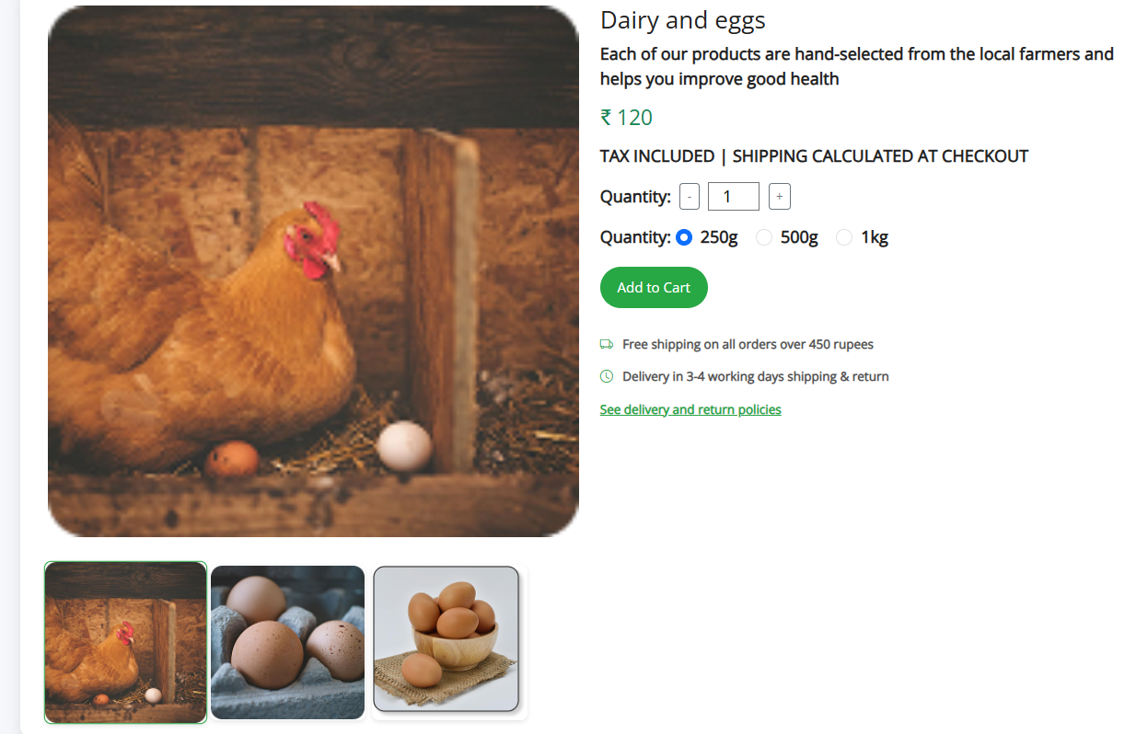

**Snacks:**

**<!DOCTYPE html>**

**<html lang="en">**

**<head>**

**<meta charset="UTF-8" />**

**<meta name="viewport" content="width=device-width, initial-scale=1.0" />**

**<title>Grocery Navbar</title>**

**<!-- Bootstrap CSS -->**

**<link href="https://cdn.jsdelivr.net/npm/bootstrap@5.3.3/dist/css/bootstrap.min.css" rel="stylesheet">**

**<!-- Font Awesome CDN -->**

**<link rel="stylesheet" href="https://cdnjs.cloudflare.com/ajax/libs/font-awesome/6.5.0/css/all.min.css">**

**<!--  Open Sans -->**

**<link href="https://fonts.googleapis.com/css2?family=Open+Sans&display=swap" rel="stylesheet">**

**<!-- Custom CSS -->**

**<link rel="stylesheet" href="headerfooter.css">**

**<style>**

**body {**

**background-color: #f5f7fa;**

**font-family: 'Open Sans', sans-serif;**

**font-weight: bolder;**

**font-size:larger;**

**padding: 20px;**

**color: #222;**

**}**

**.product-card {**

**background: white;**

**border-radius: 12px;**

**box-shadow: 0 6px 16px rgba(0, 0, 0, 0.1);**

**padding: 20px;**

**margin-bottom: 30px;**

**}**

**.product-image {**

**width: 100%;**

**border-radius: 8px;**

**object-fit: cover;**

**}**

**.thumbnail {**

**cursor: pointer;**

**border: 2px solid transparent;**

**border-radius: 8px;**

**transition: border 0.3s ease, transform 0.3s ease;**

**width: 180px;**

**height: 180px;**

**object-fit: cover;**

**box-shadow: 0 2px 5px rgba(0, 0, 0, 0.1);**

**}**

**.thumbnail.active {**

**border-color: #28a745;**

**transform: scale(1.05);**

**}**

**.quantity-selector {**

**display: flex;**

**align-items: center;**

**gap: 10px;**

**margin-bottom: 15px;**

**}**

**.quantity-selector input {**

**width: 60px;**

**text-align: center;**

**}**

**.add-to-cart {**

**background-color: #28a745;**

**color: white;**

**padding: 12px 20px;**

**font-size: 1rem;**

**border: none;**

**border-radius: 25px;**

**transition: background-color 0.3s ease;**

**}**

**.add-to-cart:hover {**

**background-color: #218838;**

**}**

**.shipping-info {**

**font-size: 0.9rem;**

**color: #555;**

**margin-top: 15px;**

**}**

**.shipping-info i {**

**color: #28a745;**

**margin-right: 8px;**

**}**

**.policy-link {**

**color: #28a745;**

**font-size: 0.9rem;**

**text-decoration: underline;**

**cursor: pointer;**

**}**

**/* Description styles matching your example */**

**.description-section {**

**max-width: 700px;**

**margin-top: 20px;**

**color: #222;**

**}**

**.description-section h5 {**

**font-size: 1rem;**

**font-weight: bold;**

**margin-top: 16px;**

**margin-bottom: 8px;**

**}**

**.description-section ul {**

**padding-left: 1.2rem;**

**margin-bottom: 0;**

**}**

**.description-section ul li {**

**margin-bottom: 8px;**

**}**

**.description-title {**

**font-weight: bold;**

**font-size: 0.95rem;**

**margin-bottom: 12px;**

**text-transform: uppercase;**

**color: #222;**

**border-bottom: 1px solid #aaa;**

**display: inline-block;**

**padding-bottom: 2px;**

**}**

**</style>**

**</head>**

**<body>**

**<!-- header -->**

**<header class="header-section">**

**<!-- Top Green Banner -->**

**<div class="top-banner text-center py-2">**

**<span class="text-white fw-semibold">Fresh & Organic produce from our farmers to your kitchen</span>**

**</div>**

**<!-- Main Container -->**

**<div class="container py-3">**

**<div class="row align-items-center text-center text-lg-start">**

**<!-- Logo Column -->**

**<div class="col-lg-2 mb-3 mb-lg-0 d-flex flex-column align-items-center">**

**<img class="logoimg" src="./assets/images/home/logo.png" />**

**</div>**

**<!-- Search Bar Column -->**

**<div class="col-lg-7 mb-3 mb-lg-0">**

**<form class="d-flex w-100" role="search">**

**<input class="form-control rounded-0 border-end-0" type="search" placeholder="Search for products" aria-label="Search">**

**<button class="btn btn-warning rounded-0 border-start-0" type="submit">**

**<i class="fas fa-search me-1"></i> Search**

**</button>**

**</form>**

**</div>**

**<!-- Empty Column to Align -->**

**<div class="col-lg-3 d-none d-lg-block"></div>**

**</div>**

**<!-- Nav Links Row -->**

**<div class="row mt-3">**

**<div class="col d-flex justify-content-center gap-4 flex-wrap align-items-center">**

**<a href="home.html" class="nav-link fw-semibold">Home</a>**

**<a href="category.html" class="nav-link fw-semibold">Categories</a>**

**<a href="bestsales.html" class="nav-link fw-semibold">Best Sales</a>**

**<a href="blog.html" class="nav-link fw-semibold">Blogs</a>**

**<a href="addtocart.html" class="nav-link">**

**<img class="logoimg" src="./assets/images/home/cart icon.png" />**

**</a>**

**<a href="registernow.html" class="btn btn-success text-white fw-semibold px-3">Register Now</a>**

**</div>**

**</div>**

**</div>**

**</header>**

**<div class="container">**

**<!-- Product Card -->**

**<div class="row product-card">**

**<!-- Left Column -->**

**<div class="col-md-6">**

**<img id="mainImage" src="./assets/images/snacks/snack des 1.png" class="product-image mb-3" alt="Radish">**

**<!-- Thumbnails -->**

**<div class="d-flex align-items-center mt-3 flex-wrap gap-2">**

**<img src="./assets/images/snacks/snack des 1.png" class="thumbnail active" alt="Radish Thumbnail">**

**<img src="./assets/images/snacks/snack des 2.png" class="thumbnail" alt="Radish Thumbnail 2">**

**<img src="./assets/images/snacks/snack des 3.png" class="thumbnail" alt="Radish Thumbnail 3">**

**</div>**

**</div>**

**<!-- Right Column -->**

**<div class="col-md-6">**

**<h3 class="mb-2">Radish</h3>**

**<p>Each of our products are hand-selected from the local farmers and helps you improve good health</p>**

**<h4 class="text-success mb-3">₹ 120</h4>**

**<p><strong>TAX INCLUDED | SHIPPING CALCULATED AT CHECKOUT</strong></p>**

**<!-- Quantity Selector -->**

**<div class="quantity-selector mb-3">**

**<label for="quantity" class="form-label mb-0">Quantity:</label>**

**<button class="btn btn-outline-secondary btn-sm" id="decreaseQty">-</button>**

**<input type="number" id="quantity" value="1" min="1" />**

**<button class="btn btn-outline-secondary btn-sm" id="increaseQty">+</button>**

**</div>**

**<!-- Size / Weight Selector -->**

**<div class="mb-3">**

**<label class="form-label mb-1">Quantity:</label>**

**<div class="form-check form-check-inline">**

**<input class="form-check-input" type="radio" name="size" id="size250" value="250g" checked>**

**<label class="form-check-label" for="size250">250g</label>**

**</div>**

**<div class="form-check form-check-inline">**

**<input class="form-check-input" type="radio" name="size" id="size500" value="500g">**

**<label class="form-check-label" for="size500">500g</label>**

**</div>**

**<div class="form-check form-check-inline">**

**<input class="form-check-input" type="radio" name="size" id="size1kg" value="1kg">**

**<label class="form-check-label" for="size1kg">1kg</label>**

**</div>**

**</div>**

**<!-- Add to Cart -->**

**<button class="add-to-cart mb-3" id="addToCart">Add to Cart</button>**

**<!-- Shipping Info -->**

**<div class="shipping-info">**

**<p><i class="bi bi-truck"></i> Free shipping on all orders over 450 rupees</p>**

**<p><i class="bi bi-clock"></i> Delivery in 3-4 working days shipping & return</p>**

**<p class="policy-link">See delivery and return policies</p>**

**</div>**

**</div>**

**</div>**

**<!-- Description Section -->**

**<div class="description-section">**

**<div class="description-title">DESCRIPTION</div>**

**<p>**

**Strawberries are often described as sweet, juicy, and bright red berries with a fragrant, fruity aroma.**

**They are typically sold fresh in containers or boxes and are a popular addition to various recipes and snacks.**

**</p>**

**<p>**

**Here’s a more detailed look at how strawberries might be described in a grocery store setting:**

**</p>**

**<h5>Appearance:</h5>**

**<ul>**

**<li>Color: Bright red, with variations depending on the variety.</li>**

**<li>Shape: Typically round or oval, with a smooth surface.</li>**

**<li>Seeds: The seeds are small, whitish or brownish specks that cover the surface of the fruit.</li>**

**<li>Freshness: Shiny, firm, and free from blemishes or mold.</li>**

**</ul>**

**<h5>Taste and Aroma:</h5>**

**<ul>**

**<li>Flavor: Sweet and juicy, with a slightly tart or sour note in some varieties.</li>**

**<li>Aroma: A pleasant, fruity, and fragrant aroma.</li>**

**</ul>**

**<h5>Nutrition:</h5>**

**<ul>**

**<li>Vitamin C: Rich in vitamin C, an important antioxidant.</li>**

**<li>Fiber: A good source of fiber.</li>**

**<li>Other nutrients: Contains other vitamins, minerals, and antioxidants.</li>**

**<li>Low in calories: A healthy and low-calorie fruit.</li>**

**</ul>**

**<h5>Uses:</h5>**

**<ul>**

**<li>Fresh consumption: Enjoyed as a snack or added to salads, desserts, or smoothies.</li>**

**<li>Culinary applications: Used in jams, sauces, desserts, and other dishes.</li>**

**</ul>**

**<h5>Storage:</h5>**

**<ul>**

**<li>Refrigeration: Should be refrigerated to maintain freshness.</li>**

**<li>Humidity: Best stored in the refrigerator at high humidity.</li>**

**</ul>**

**</div>**

**</div>**

**<!--Footer-->**

**<div class="info-strip">**

**<!-- Left Orange Contact Banner -->**

**<div class="contact-banner">**

**Get in Touch with us**

**<span>+91 91010 90000</span>**

**</div>**

**<!-- Right Features Section -->**

**<div class="features-container">**

**<div class="feature-item">**

**<div class="icon-circle">**

**<img src="./assets/images/home/free shipping icon.png" alt="Free Shipping">**

**</div>**

**<div class="feature-text">**

**<p>Free Shipping</p>**

**<p>For Orders Above 500</p>**

**</div>**

**</div>**

**<div class="feature-item">**

**<div class="icon-circle">**

**<img src="./assets/images/home/fresh produce icon.png" alt="Fresh Produce">**

**</div>**

**<div class="feature-text">**

**<p>Fresh Produce</p>**

**<p>Guaranteed Product Warranty</p>**

**</div>**

**</div>**

**<div class="feature-item">**

**<div class="icon-circle">**

**<img src="./assets/images/home/safety icon.png" alt="Safety">**

**</div>**

**<div class="feature-text">**

**<p>100% Safety & Security</p>**

**<p>Your Data is Highly Secured</p>**

**</div>**

**</div>**

**</div>**

**</div>**

**<footer class="footer">**

**<div class="container">**

**<div class="footer-content row gy-4">**

**<!-- Logo & Description -->**

**<div class="col-md-4 footer-logo">**

**<img src="./assets/images/home/logo.png"  alt="Logo">**

**<p class="description">**

**Fresh groceries, particularly fruits, vegetables,<br>**

**whole grains, and lean proteins, play a crucial<br>**

**role in nourishing our bodies and promoting<br>**

**overall well-being**

**</p>**

**</div>**

**<!-- Navigation -->**

**<div class="col-md-4">**

**<h5>NAVIGATE</h5>**

**<a href="#">Privacy Policy</a>**

**<a href="#">Terms & Conditions</a>**

**<a href="#">How to Order</a>**

**<a href="#">About Us</a>**

**</div>**

**<!-- G-Store Info -->**

**<div class="col-md-4">**

**<h5>G-STORE</h5>**

**<p>Reg: T21542GST548</p>**

**<p>TIN: 14578452884</p>**

**<p>Email: groceries at doorstep@gmail.com</p>**

**</div>**

**</div>**

**<!-- Footer Bottom -->**

**<div class="footer-bottom mt-4">**

**Copyrights 2022© Groceries At Doorstep Ltd**

**</div>**

**</div>**

**</footer>**

**<!-- Bootstrap JS -->**

**<script src="https://cdn.jsdelivr.net/npm/bootstrap@5.3.0/dist/js/bootstrap.bundle.min.js"></script>**

**<!-- Icons (Optional, for truck and clock icons) -->**

**<link href="https://cdn.jsdelivr.net/npm/bootstrap-icons@1.10.5/font/bootstrap-icons.css" rel="stylesheet">**

**<!-- Custom JS -->**

**<script>**

**// Quantity Increase/Decrease**

**document.getElementById('increaseQty').addEventListener('click', function() {**

**const qtyInput = document.getElementById('quantity');**

**qtyInput.value = parseInt(qtyInput.value) + 1;**

**});**

**document.getElementById('decreaseQty').addEventListener('click', function() {**

**const qtyInput = document.getElementById('quantity');**

**if (parseInt(qtyInput.value) > 1) {**

**qtyInput.value = parseInt(qtyInput.value) - 1;**

**}**

**});**

**// Add to Cart Button**

**document.getElementById('addToCart').addEventListener('click', function() {**

**const qty = document.getElementById('quantity').value;**

**const size = document.querySelector('input[name="size"]:checked').value;**

**alert(`Added to cart:\nRadish - ${qty} item(s), Size: ${size}`);**

**});**

**// Thumbnail click to change main image**

**const thumbnails = document.querySelectorAll('.thumbnail');**

**const mainImage = document.getElementById('mainImage');**

**thumbnails.forEach(thumbnail => {**

**thumbnail.addEventListener('click', function() {**

**thumbnails.forEach(t => t.classList.remove('active'));**

**this.classList.add('active');**

**mainImage.src = this.src;**

**});**

**});**

**</script>**

**</body>**

**</html>**

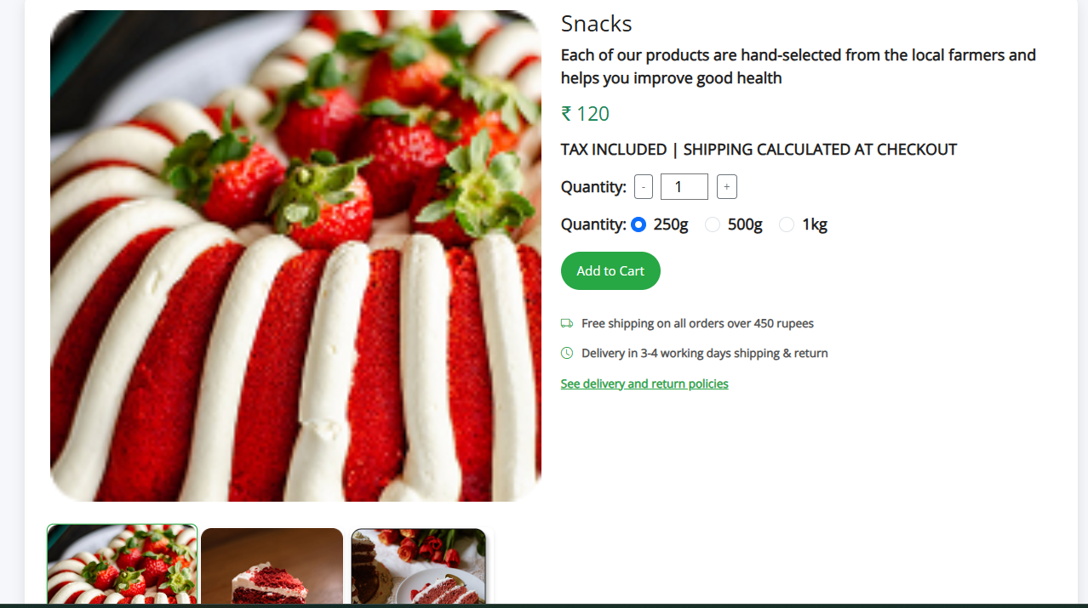

**Meat and Seafoods:**

**<!DOCTYPE html>**

**<html lang="en">**

**<head>**

**<meta charset="UTF-8" />**

**<meta name="viewport" content="width=device-width, initial-scale=1.0" />**

**<title>Grocery Navbar</title>**

**<!-- Bootstrap CSS -->**

**<link href="https://cdn.jsdelivr.net/npm/bootstrap@5.3.3/dist/css/bootstrap.min.css" rel="stylesheet">**

**<!-- Font Awesome CDN -->**

**<link rel="stylesheet" href="https://cdnjs.cloudflare.com/ajax/libs/font-awesome/6.5.0/css/all.min.css">**

**<!--  Open Sans -->**

**<link href="https://fonts.googleapis.com/css2?family=Open+Sans&display=swap" rel="stylesheet">**

**<!-- Custom CSS -->**

**<link rel="stylesheet" href="headerfooter.css">**

**<style>**

**body {**

**background-color: #f5f7fa;**

**font-family: 'Open Sans', sans-serif;**

**font-weight: bolder;**

**font-size:larger;**

**padding: 20px;**

**color: #222;**

**}**

**.product-card {**

**background: white;**

**border-radius: 12px;**

**box-shadow: 0 6px 16px rgba(0, 0, 0, 0.1);**

**padding: 20px;**

**margin-bottom: 30px;**

**}**

**.product-image {**

**width: 100%;**

**border-radius: 8px;**

**object-fit: cover;**

**}**

**.thumbnail {**

**cursor: pointer;**

**border: 2px solid transparent;**

**border-radius: 8px;**

**transition: border 0.3s ease, transform 0.3s ease;**

**width: 180px;**

**height: 180px;**

**object-fit: cover;**

**box-shadow: 0 2px 5px rgba(0, 0, 0, 0.1);**

**}**

**.thumbnail.active {**

**border-color: #28a745;**

**transform: scale(1.05);**

**}**

**.quantity-selector {**

**display: flex;**

**align-items: center;**

**gap: 10px;**

**margin-bottom: 15px;**

**}**

**.quantity-selector input {**

**width: 60px;**

**text-align: center;**

**}**

**.add-to-cart {**

**background-color: #28a745;**

**color: white;**

**padding: 12px 20px;**

**font-size: 1rem;**

**border: none;**

**border-radius: 25px;**

**transition: background-color 0.3s ease;**

**}**

**.add-to-cart:hover {**

**background-color: #218838;**

**}**

**.shipping-info {**

**font-size: 0.9rem;**

**color: #555;**

**margin-top: 15px;**

**}**

**.shipping-info i {**

**color: #28a745;**

**margin-right: 8px;**

**}**

**.policy-link {**

**color: #28a745;**

**font-size: 0.9rem;**

**text-decoration: underline;**

**cursor: pointer;**

**}**

**/* Description styles matching your example */**

**.description-section {**

**max-width: 700px;**

**margin-top: 20px;**

**color: #222;**

**}**

**.description-section h5 {**

**font-size: 1rem;**

**font-weight: bold;**

**margin-top: 16px;**

**margin-bottom: 8px;**

**}**

**.description-section ul {**

**padding-left: 1.2rem;**

**margin-bottom: 0;**

**}**

**.description-section ul li {**

**margin-bottom: 8px;**

**}**

**.description-title {**

**font-weight: bold;**

**font-size: 0.95rem;**

**margin-bottom: 12px;**

**text-transform: uppercase;**

**color: #222;**

**border-bottom: 1px solid #aaa;**

**display: inline-block;**

**padding-bottom: 2px;**

**}**

**</style>**

**</head>**

**<body>**

**<!-- header -->**

**<header class="header-section">**

**<!-- Top Green Banner -->**

**<div class="top-banner text-center py-2">**

**<span class="text-white fw-semibold">Fresh & Organic produce from our farmers to your kitchen</span>**

**</div>**

**<!-- Main Container -->**

**<div class="container py-3">**

**<div class="row align-items-center text-center text-lg-start">**

**<!-- Logo Column -->**

**<div class="col-lg-2 mb-3 mb-lg-0 d-flex flex-column align-items-center">**

**<img class="logoimg" src="./assets/images/home/logo.png" />**

**</div>**

**<!-- Search Bar Column -->**

**<div class="col-lg-7 mb-3 mb-lg-0">**

**<form class="d-flex w-100" role="search">**

**<input class="form-control rounded-0 border-end-0" type="search" placeholder="Search for products" aria-label="Search">**

**<button class="btn btn-warning rounded-0 border-start-0" type="submit">**

**<i class="fas fa-search me-1"></i> Search**

**</button>**

**</form>**

**</div>**

**<!-- Empty Column to Align -->**

**<div class="col-lg-3 d-none d-lg-block"></div>**

**</div>**

**<!-- Nav Links Row -->**

**<div class="row mt-3">**

**<div class="col d-flex justify-content-center gap-4 flex-wrap align-items-center">**

**<a href="home.html" class="nav-link fw-semibold">Home</a>**

**<a href="category.html" class="nav-link fw-semibold">Categories</a>**

**<a href="bestsales.html" class="nav-link fw-semibold">Best Sales</a>**

**<a href="blog.html" class="nav-link fw-semibold">Blogs</a>**

**<a href="addtocart.html" class="nav-link">**

**<img class="logoimg" src="./assets/images/home/cart icon.png" />**

**</a>**

**<a href="registernow.html" class="btn btn-success text-white fw-semibold px-3">Register Now</a>**

**</div>**

**</div>**

**</div>**

**</header>**

**<div class="container">**

**<!-- Product Card -->**

**<div class="row product-card">**

**<!-- Left Column -->**

**<div class="col-md-6">**

**<img id="mainImage" src="./assets/images/meat/meat des 1.png" class="product-image mb-3" alt="Radish">**

**<!-- Thumbnails -->**

**<div class="d-flex align-items-center mt-3 flex-wrap gap-2">**

**<img src="./assets/images/meat/meat des 1.png" class="thumbnail active" alt="Radish Thumbnail">**

**<img src="./assets/images/meat/meat des 2.png" class="thumbnail" alt="Radish Thumbnail 2">**

**<img src="./assets/images/meat/meat des 3.png" class="thumbnail" alt="Radish Thumbnail 3">**

**</div>**

**</div>**

**<!-- Right Column -->**

**<div class="col-md-6">**

**<h3 class="mb-2">Radish</h3>**

**<p>Each of our products are hand-selected from the local farmers and helps you improve good health</p>**

**<h4 class="text-success mb-3">₹ 120</h4>**

**<p><strong>TAX INCLUDED | SHIPPING CALCULATED AT CHECKOUT</strong></p>**

**<!-- Quantity Selector -->**

**<div class="quantity-selector mb-3">**

**<label for="quantity" class="form-label mb-0">Quantity:</label>**

**<button class="btn btn-outline-secondary btn-sm" id="decreaseQty">-</button>**

**<input type="number" id="quantity" value="1" min="1" />**

**<button class="btn btn-outline-secondary btn-sm" id="increaseQty">+</button>**

**</div>**

**<!-- Size / Weight Selector -->**

**<div class="mb-3">**

**<label class="form-label mb-1">Quantity:</label>**

**<div class="form-check form-check-inline">**

**<input class="form-check-input" type="radio" name="size" id="size250" value="250g" checked>**

**<label class="form-check-label" for="size250">250g</label>**

**</div>**

**<div class="form-check form-check-inline">**

**<input class="form-check-input" type="radio" name="size" id="size500" value="500g">**

**<label class="form-check-label" for="size500">500g</label>**

**</div>**

**<div class="form-check form-check-inline">**

**<input class="form-check-input" type="radio" name="size" id="size1kg" value="1kg">**

**<label class="form-check-label" for="size1kg">1kg</label>**

**</div>**

**</div>**

**<!-- Add to Cart -->**

**<button class="add-to-cart mb-3" id="addToCart">Add to Cart</button>**

**<!-- Shipping Info -->**

**<div class="shipping-info">**

**<p><i class="bi bi-truck"></i> Free shipping on all orders over 450 rupees</p>**

**<p><i class="bi bi-clock"></i> Delivery in 3-4 working days shipping & return</p>**

**<p class="policy-link">See delivery and return policies</p>**

**</div>**

**</div>**

**</div>**

**<!-- Description Section -->**

**<div class="description-section">**

**<div class="description-title">DESCRIPTION</div>**

**<p>**

**Strawberries are often described as sweet, juicy, and bright red berries with a fragrant, fruity aroma.**

**They are typically sold fresh in containers or boxes and are a popular addition to various recipes and snacks.**

**</p>**

**<p>**

**Here’s a more detailed look at how strawberries might be described in a grocery store setting:**

**</p>**

**<h5>Appearance:</h5>**

**<ul>**

**<li>Color: Bright red, with variations depending on the variety.</li>**

**<li>Shape: Typically round or oval, with a smooth surface.</li>**

**<li>Seeds: The seeds are small, whitish or brownish specks that cover the surface of the fruit.</li>**

**<li>Freshness: Shiny, firm, and free from blemishes or mold.</li>**

**</ul>**

**<h5>Taste and Aroma:</h5>**

**<ul>**

**<li>Flavor: Sweet and juicy, with a slightly tart or sour note in some varieties.</li>**

**<li>Aroma: A pleasant, fruity, and fragrant aroma.</li>**

**</ul>**

**<h5>Nutrition:</h5>**

**<ul>**

**<li>Vitamin C: Rich in vitamin C, an important antioxidant.</li>**

**<li>Fiber: A good source of fiber.</li>**

**<li>Other nutrients: Contains other vitamins, minerals, and antioxidants.</li>**

**<li>Low in calories: A healthy and low-calorie fruit.</li>**

**</ul>**

**<h5>Uses:</h5>**

**<ul>**

**<li>Fresh consumption: Enjoyed as a snack or added to salads, desserts, or smoothies.</li>**

**<li>Culinary applications: Used in jams, sauces, desserts, and other dishes.</li>**

**</ul>**

**<h5>Storage:</h5>**

**<ul>**

**<li>Refrigeration: Should be refrigerated to maintain freshness.</li>**

**<li>Humidity: Best stored in the refrigerator at high humidity.</li>**

**</ul>**

**</div>**

**</div>**

**<!--Footer-->**

**<div class="info-strip">**

**<!-- Left Orange Contact Banner -->**

**<div class="contact-banner">**

**Get in Touch with us**

**<span>+91 91010 90000</span>**

**</div>**

**<!-- Right Features Section -->**

**<div class="features-container">**

**<div class="feature-item">**

**<div class="icon-circle">**

**<img src="./assets/images/home/free shipping icon.png" alt="Free Shipping">**

**</div>**

**<div class="feature-text">**

**<p>Free Shipping</p>**

**<p>For Orders Above 500</p>**

**</div>**

**</div>**

**<div class="feature-item">**

**<div class="icon-circle">**

**<img src="./assets/images/home/fresh produce icon.png" alt="Fresh Produce">**

**</div>**

**<div class="feature-text">**

**<p>Fresh Produce</p>**

**<p>Guaranteed Product Warranty</p>**

**</div>**

**</div>**

**<div class="feature-item">**

**<div class="icon-circle">**

**<img src="./assets/images/home/safety icon.png" alt="Safety">**

**</div>**

**<div class="feature-text">**

**<p>100% Safety & Security</p>**

**<p>Your Data is Highly Secured</p>**

**</div>**

**</div>**

**</div>**

**</div>**

**<footer class="footer">**

**<div class="container">**

**<div class="footer-content row gy-4">**

**<!-- Logo & Description -->**

**<div class="col-md-4 footer-logo">**

**<img src="./assets/images/home/logo.png"  alt="Logo">**

**<p class="description">**

**Fresh groceries, particularly fruits, vegetables,<br>**

**whole grains, and lean proteins, play a crucial<br>**

**role in nourishing our bodies and promoting<br>**

**overall well-being**

**</p>**

**</div>**

**<!-- Navigation -->**

**<div class="col-md-4">**

**<h5>NAVIGATE</h5>**

**<a href="#">Privacy Policy</a>**

**<a href="#">Terms & Conditions</a>**

**<a href="#">How to Order</a>**

**<a href="#">About Us</a>**

**</div>**

**<!-- G-Store Info -->**

**<div class="col-md-4">**

**<h5>G-STORE</h5>**

**<p>Reg: T21542GST548</p>**

**<p>TIN: 14578452884</p>**

**<p>Email: groceries at doorstep@gmail.com</p>**

**</div>**

**</div>**

**<!-- Footer Bottom -->**

**<div class="footer-bottom mt-4">**

**Copyrights 2022© Groceries At Doorstep Ltd**

**</div>**

**</div>**

**</footer>**

**<!-- Bootstrap JS -->**

**<script src="https://cdn.jsdelivr.net/npm/bootstrap@5.3.0/dist/js/bootstrap.bundle.min.js"></script>**

**<!-- Icons (Optional, for truck and clock icons) -->**

**<link href="https://cdn.jsdelivr.net/npm/bootstrap-icons@1.10.5/font/bootstrap-icons.css" rel="stylesheet">**

**<!-- Custom JS -->**

**<script>**

**// Quantity Increase/Decrease**

**document.getElementById('increaseQty').addEventListener('click', function() {**

**const qtyInput = document.getElementById('quantity');**

**qtyInput.value = parseInt(qtyInput.value) + 1;**

**});**

**document.getElementById('decreaseQty').addEventListener('click', function() {**

**const qtyInput = document.getElementById('quantity');**

**if (parseInt(qtyInput.value) > 1) {**

**qtyInput.value = parseInt(qtyInput.value) - 1;**

**}**

**});**

**// Add to Cart Button**

**document.getElementById('addToCart').addEventListener('click', function() {**

**const qty = document.getElementById('quantity').value;**

**const size = document.querySelector('input[name="size"]:checked').value;**

**alert(`Added to cart:\nRadish - ${qty} item(s), Size: ${size}`);**

**});**

**// Thumbnail click to change main image**

**const thumbnails = document.querySelectorAll('.thumbnail');**

**const mainImage = document.getElementById('mainImage');**

**thumbnails.forEach(thumbnail => {**

**thumbnail.addEventListener('click', function() {**

**thumbnails.forEach(t => t.classList.remove('active'));**

**this.classList.add('active');**

**mainImage.src = this.src;**

**});**

**});**

**</script>**

**</body>**

**</html>**

**Meat and Seafoods:**

**<!DOCTYPE html>**

**<html lang="en">**

**<head>**

**<meta charset="UTF-8" />**

**<meta name="viewport" content="width=device-width, initial-scale=1.0" />**

**<title>Grocery Navbar</title>**

**<!-- Bootstrap CSS -->**

**<link href="https://cdn.jsdelivr.net/npm/bootstrap@5.3.3/dist/css/bootstrap.min.css" rel="stylesheet">**

**<!-- Font Awesome CDN -->**

**<link rel="stylesheet" href="https://cdnjs.cloudflare.com/ajax/libs/font-awesome/6.5.0/css/all.min.css">**

**<!--  Open Sans -->**

**<link href="https://fonts.googleapis.com/css2?family=Open+Sans&display=swap" rel="stylesheet">**

**<!-- Custom CSS -->**

**<link rel="stylesheet" href="headerfooter.css">**

**<style>**

**body {**

**background-color: #f5f7fa;**

**font-family: 'Open Sans', sans-serif;**

**font-weight: bolder;**

**font-size:larger;**

**padding: 20px;**

**color: #222;**

**}**

**.product-card {**

**background: white;**

**border-radius: 12px;**

**box-shadow: 0 6px 16px rgba(0, 0, 0, 0.1);**

**padding: 20px;**

**margin-bottom: 30px;**

**}**

**.product-image {**

**width: 100%;**

**border-radius: 8px;**

**object-fit: cover;**

**}**

**.thumbnail {**

**cursor: pointer;**

**border: 2px solid transparent;**

**border-radius: 8px;**

**transition: border 0.3s ease, transform 0.3s ease;**

**width: 180px;**

**height: 180px;**

**object-fit: cover;**

**box-shadow: 0 2px 5px rgba(0, 0, 0, 0.1);**

**}**

**.thumbnail.active {**

**border-color: #28a745;**

**transform: scale(1.05);**

**}**

**.quantity-selector {**

**display: flex;**

**align-items: center;**

**gap: 10px;**

**margin-bottom: 15px;**

**}**

**.quantity-selector input {**

**width: 60px;**

**text-align: center;**

**}**

**.add-to-cart {**

**background-color: #28a745;**

**color: white;**

**padding: 12px 20px;**

**font-size: 1rem;**

**border: none;**

**border-radius: 25px;**

**transition: background-color 0.3s ease;**

**}**

**.add-to-cart:hover {**

**background-color: #218838;**

**}**

**.shipping-info {**

**font-size: 0.9rem;**

**color: #555;**

**margin-top: 15px;**

**}**

**.shipping-info i {**

**color: #28a745;**

**margin-right: 8px;**

**}**

**.policy-link {**

**color: #28a745;**

**font-size: 0.9rem;**

**text-decoration: underline;**

**cursor: pointer;**

**}**

**/* Description styles matching your example */**

**.description-section {**

**max-width: 700px;**

**margin-top: 20px;**

**color: #222;**

**}**

**.description-section h5 {**

**font-size: 1rem;**

**font-weight: bold;**

**margin-top: 16px;**

**margin-bottom: 8px;**

**}**

**.description-section ul {**

**padding-left: 1.2rem;**

**margin-bottom: 0;**

**}**

**.description-section ul li {**

**margin-bottom: 8px;**

**}**

**.description-title {**

**font-weight: bold;**

**font-size: 0.95rem;**

**margin-bottom: 12px;**

**text-transform: uppercase;**

**color: #222;**

**border-bottom: 1px solid #aaa;**

**display: inline-block;**

**padding-bottom: 2px;**

**}**

**</style>**

**</head>**

**<body>**

**<!-- header -->**

**<header class="header-section">**

**<!-- Top Green Banner -->**

**<div class="top-banner text-center py-2">**

**<span class="text-white fw-semibold">Fresh & Organic produce from our farmers to your kitchen</span>**

**</div>**

**<!-- Main Container -->**

**<div class="container py-3">**

**<div class="row align-items-center text-center text-lg-start">**

**<!-- Logo Column -->**

**<div class="col-lg-2 mb-3 mb-lg-0 d-flex flex-column align-items-center">**

**<img class="logoimg" src="./assets/images/home/logo.png" />**

**</div>**

**<!-- Search Bar Column -->**

**<div class="col-lg-7 mb-3 mb-lg-0">**

**<form class="d-flex w-100" role="search">**

**<input class="form-control rounded-0 border-end-0" type="search" placeholder="Search for products" aria-label="Search">**

**<button class="btn btn-warning rounded-0 border-start-0" type="submit">**

**<i class="fas fa-search me-1"></i> Search**

**</button>**

**</form>**

**</div>**

**<!-- Empty Column to Align -->**

**<div class="col-lg-3 d-none d-lg-block"></div>**

**</div>**

**<!-- Nav Links Row -->**

**<div class="row mt-3">**

**<div class="col d-flex justify-content-center gap-4 flex-wrap align-items-center">**

**<a href="home.html" class="nav-link fw-semibold">Home</a>**

**<a href="category.html" class="nav-link fw-semibold">Categories</a>**

**<a href="bestsales.html" class="nav-link fw-semibold">Best Sales</a>**

**<a href="blog.html" class="nav-link fw-semibold">Blogs</a>**

**<a href="addtocart.html" class="nav-link">**

**<img class="logoimg" src="./assets/images/home/cart icon.png" />**

**</a>**

**<a href="registernow.html" class="btn btn-success text-white fw-semibold px-3">Register Now</a>**

**</div>**

**</div>**

**</div>**

**</header>**

**<div class="container">**

**<!-- Product Card -->**

**<div class="row product-card">**

**<!-- Left Column -->**

**<div class="col-md-6">**

**<img id="mainImage" src="./assets/images/meat/meat des 1.png" class="product-image mb-3" alt="Radish">**

**<!-- Thumbnails -->**

**<div class="d-flex align-items-center mt-3 flex-wrap gap-2">**

**<img src="./assets/images/meat/meat des 1.png" class="thumbnail active" alt="Radish Thumbnail">**

**<img src="./assets/images/meat/meat des 2.png" class="thumbnail" alt="Radish Thumbnail 2">**

**<img src="./assets/images/meat/meat des 3.png" class="thumbnail" alt="Radish Thumbnail 3">**

**</div>**

**</div>**

**<!-- Right Column -->**

**<div class="col-md-6">**

**<h3 class="mb-2">Radish</h3>**

**<p>Each of our products are hand-selected from the local farmers and helps you improve good health</p>**

**<h4 class="text-success mb-3">₹ 120</h4>**

**<p><strong>TAX INCLUDED | SHIPPING CALCULATED AT CHECKOUT</strong></p>**

**<!-- Quantity Selector -->**

**<div class="quantity-selector mb-3">**

**<label for="quantity" class="form-label mb-0">Quantity:</label>**

**<button class="btn btn-outline-secondary btn-sm" id="decreaseQty">-</button>**

**<input type="number" id="quantity" value="1" min="1" />**

**<button class="btn btn-outline-secondary btn-sm" id="increaseQty">+</button>**

**</div>**

**<!-- Size / Weight Selector -->**

**<div class="mb-3">**

**<label class="form-label mb-1">Quantity:</label>**

**<div class="form-check form-check-inline">**

**<input class="form-check-input" type="radio" name="size" id="size250" value="250g" checked>**

**<label class="form-check-label" for="size250">250g</label>**

**</div>**

**<div class="form-check form-check-inline">**

**<input class="form-check-input" type="radio" name="size" id="size500" value="500g">**

**<label class="form-check-label" for="size500">500g</label>**

**</div>**

**<div class="form-check form-check-inline">**

**<input class="form-check-input" type="radio" name="size" id="size1kg" value="1kg">**

**<label class="form-check-label" for="size1kg">1kg</label>**

**</div>**

**</div>**

**<!-- Add to Cart -->**

**<button class="add-to-cart mb-3" id="addToCart">Add to Cart</button>**

**<!-- Shipping Info -->**

**<div class="shipping-info">**

**<p><i class="bi bi-truck"></i> Free shipping on all orders over 450 rupees</p>**

**<p><i class="bi bi-clock"></i> Delivery in 3-4 working days shipping & return</p>**

**<p class="policy-link">See delivery and return policies</p>**

**</div>**

**</div>**

**</div>**

**<!-- Description Section -->**

**<div class="description-section">**

**<div class="description-title">DESCRIPTION</div>**

**<p>**

**Strawberries are often described as sweet, juicy, and bright red berries with a fragrant, fruity aroma.**

**They are typically sold fresh in containers or boxes and are a popular addition to various recipes and snacks.**

**</p>**

**<p>**

**Here’s a more detailed look at how strawberries might be described in a grocery store setting:**

**</p>**

**<h5>Appearance:</h5>**

**<ul>**

**<li>Color: Bright red, with variations depending on the variety.</li>**

**<li>Shape: Typically round or oval, with a smooth surface.</li>**

**<li>Seeds: The seeds are small, whitish or brownish specks that cover the surface of the fruit.</li>**

**<li>Freshness: Shiny, firm, and free from blemishes or mold.</li>**

**</ul>**

**<h5>Taste and Aroma:</h5>**

**<ul>**

**<li>Flavor: Sweet and juicy, with a slightly tart or sour note in some varieties.</li>**

**<li>Aroma: A pleasant, fruity, and fragrant aroma.</li>**

**</ul>**

**<h5>Nutrition:</h5>**

**<ul>**

**<li>Vitamin C: Rich in vitamin C, an important antioxidant.</li>**

**<li>Fiber: A good source of fiber.</li>**

**<li>Other nutrients: Contains other vitamins, minerals, and antioxidants.</li>**

**<li>Low in calories: A healthy and low-calorie fruit.</li>**

**</ul>**

**<h5>Uses:</h5>**

**<ul>**

**<li>Fresh consumption: Enjoyed as a snack or added to salads, desserts, or smoothies.</li>**

**<li>Culinary applications: Used in jams, sauces, desserts, and other dishes.</li>**

**</ul>**

**<h5>Storage:</h5>**

**<ul>**

**<li>Refrigeration: Should be refrigerated to maintain freshness.</li>**

**<li>Humidity: Best stored in the refrigerator at high humidity.</li>**

**</ul>**

**</div>**

**</div>**

**<!--Footer-->**

**<div class="info-strip">**

**<!-- Left Orange Contact Banner -->**

**<div class="contact-banner">**

**Get in Touch with us**

**<span>+91 91010 90000</span>**

**</div>**

**<!-- Right Features Section -->**

**<div class="features-container">**

**<div class="feature-item">**

**<div class="icon-circle">**

**<img src="./assets/images/home/free shipping icon.png" alt="Free Shipping">**

**</div>**

**<div class="feature-text">**

**<p>Free Shipping</p>**

**<p>For Orders Above 500</p>**

**</div>**

**</div>**

**<div class="feature-item">**

**<div class="icon-circle">**

**<img src="./assets/images/home/fresh produce icon.png" alt="Fresh Produce">**

**</div>**

**<div class="feature-text">**

**<p>Fresh Produce</p>**

**<p>Guaranteed Product Warranty</p>**

**</div>**

**</div>**

**<div class="feature-item">**

**<div class="icon-circle">**

**<img src="./assets/images/home/safety icon.png" alt="Safety">**

**</div>**

**<div class="feature-text">**

**<p>100% Safety & Security</p>**

**<p>Your Data is Highly Secured</p>**

**</div>**

**</div>**

**</div>**

**</div>**

**<footer class="footer">**

**<div class="container">**

**<div class="footer-content row gy-4">**

**<!-- Logo & Description -->**

**<div class="col-md-4 footer-logo">**

**<img src="./assets/images/home/logo.png"  alt="Logo">**

**<p class="description">**

**Fresh groceries, particularly fruits, vegetables,<br>**

**whole grains, and lean proteins, play a crucial<br>**

**role in nourishing our bodies and promoting<br>**

**overall well-being**

**</p>**

**</div>**

**<!-- Navigation -->**

**<div class="col-md-4">**

**<h5>NAVIGATE</h5>**

**<a href="#">Privacy Policy</a>**

**<a href="#">Terms & Conditions</a>**

**<a href="#">How to Order</a>**

**<a href="#">About Us</a>**

**</div>**

**<!-- G-Store Info -->**

**<div class="col-md-4">**

**<h5>G-STORE</h5>**

**<p>Reg: T21542GST548</p>**

**<p>TIN: 14578452884</p>**

**<p>Email: groceries at doorstep@gmail.com</p>**

**</div>**

**</div>**

**<!-- Footer Bottom -->**

**<div class="footer-bottom mt-4">**

**Copyrights 2022© Groceries At Doorstep Ltd**

**</div>**

**</div>**

**</footer>**

**<!-- Bootstrap JS -->**

**<script src="https://cdn.jsdelivr.net/npm/bootstrap@5.3.0/dist/js/bootstrap.bundle.min.js"></script>**

**<!-- Icons (Optional, for truck and clock icons) -->**

**<link href="https://cdn.jsdelivr.net/npm/bootstrap-icons@1.10.5/font/bootstrap-icons.css" rel="stylesheet">**

**<!-- Custom JS -->**

**<script>**

**// Quantity Increase/Decrease**

**document.getElementById('increaseQty').addEventListener('click', function() {**

**const qtyInput = document.getElementById('quantity');**

**qtyInput.value = parseInt(qtyInput.value) + 1;**

**});**

**document.getElementById('decreaseQty').addEventListener('click', function() {**

**const qtyInput = document.getElementById('quantity');**

**if (parseInt(qtyInput.value) > 1) {**

**qtyInput.value = parseInt(qtyInput.value) - 1;**

**}**

**});**

**// Add to Cart Button**

**document.getElementById('addToCart').addEventListener('click', function() {**

**const qty = document.getElementById('quantity').value;**

**const size = document.querySelector('input[name="size"]:checked').value;**

**alert(`Added to cart:\nRadish - ${qty} item(s), Size: ${size}`);**

**});**

**// Thumbnail click to change main image**

**const thumbnails = document.querySelectorAll('.thumbnail');**

**const mainImage = document.getElementById('mainImage');**

**thumbnails.forEach(thumbnail => {**

**thumbnail.addEventListener('click', function() {**

**thumbnails.forEach(t => t.classList.remove('active'));**

**this.classList.add('active');**

**mainImage.src = this.src;**

**});**

**});**

**</script>**

**</body>**

**</html>**

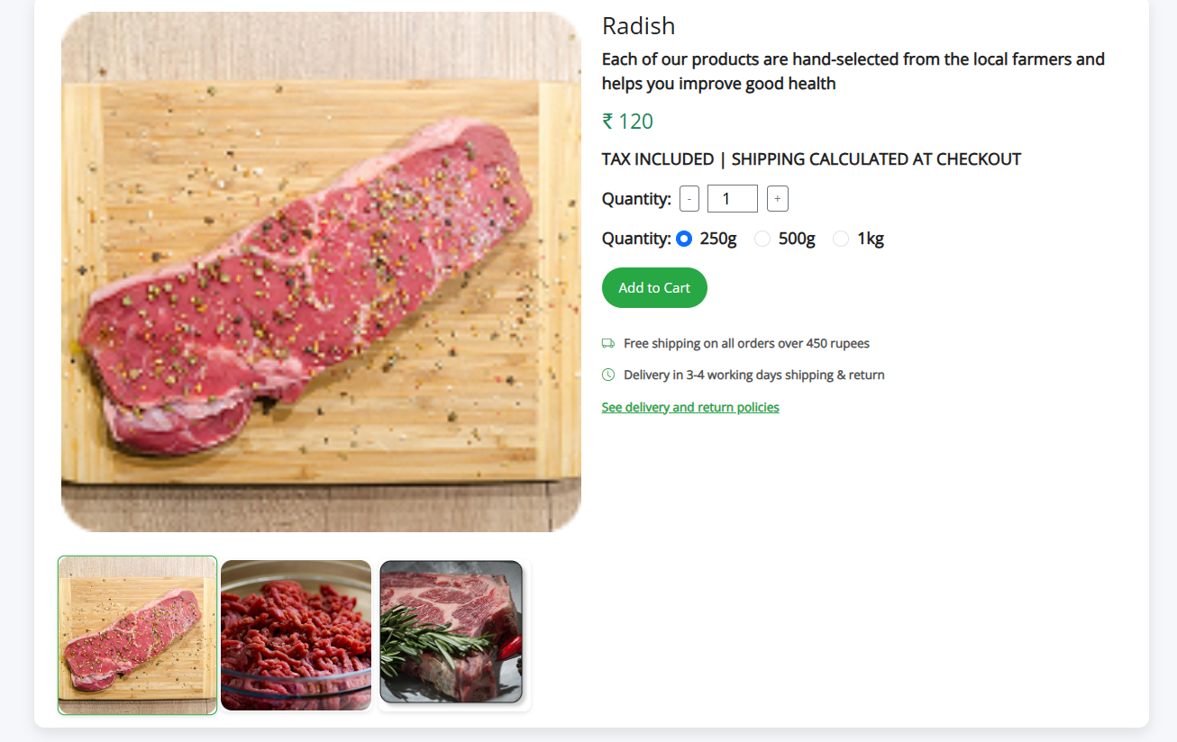

**Pantry and Staples:**



**7. Output & Screenshots(Add your website screenshots here)**





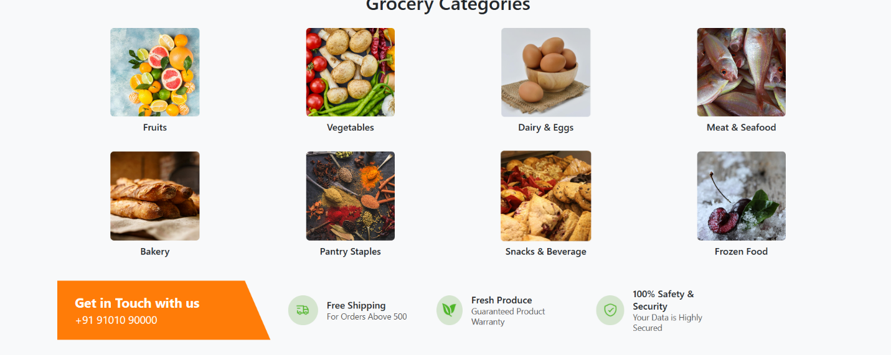





* **Homepage:** Displays featured electronic products.
* **Product Page:** Shows detailed descriptions and prices.
* **Cart & Checkout:** Users can add items and proceed with secure payments.
* **Admin Dashboard:** Displays sales statistics, user data, and order status.

**8. Conclusion**

The E-Commerce website project serves as a comprehensive digital solution for buying and selling products online. It brings together modern web technologies to deliver a seamless user experience and efficient admin management.

Through well-defined modules like **User Authentication**, **Product Display**, **Cart & Checkout**, **Order Management**, and **Admin Panel**, the platform ensures that users can explore products, make secure transactions, and track their orders with ease. Meanwhile, the admin can efficiently manage inventory, view analytics, and respond to customer needs.

**Prepared By:** Sasikala Thennarasu  
**Date:** 09-06-2025  
**Reviewed By:** Mahesh Samuthiram  
**Approved By:** Mahesh Samuthiram